**Memorandum of Cooperation signed with the Agency for Communication Networks and Services of the Republic of Slovenia**

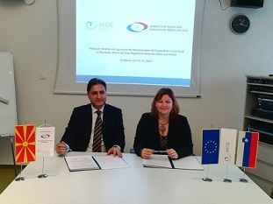

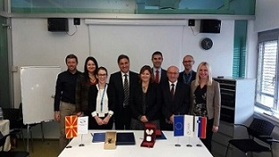

As part of their bilateral meeting held in Ljubljana today, the Agency for Audio and Audiovisual Media Services and the Agency for Communication Networks and Services of the Republic of Slovenia signed a Memorandum of Cooperation. The purpose of this Memorandum is to enhance cooperation between the two regulatory authorities and help undertake activities of joint interest together.

The activities set forth in this document include exchange of information about the development of policies and strategies in the area of electronic media services regulation, the implementation of the parties’ national legal regulations, as well as their amendment and modification, and taking, where appropriate, joint actions and positions before the European and other international organizations related to the sphere of electronic media services.

.

The two regulators also shared experiences on a number of issues, focusing on both the previous and the future activities in the sphere of media literacy, the process of issuing licenses to broadcasters and the monitoring of media content.

The Coalition on Sexual and Healthcare Rights of the Marginalized Communities presented the results obtained from the Analysis of the Reporting Frames Used in Media Coverage of Topics Related to the LGBT Community. The conclusions of the Analysis pointed to the need to open a public and focused debate with the expert public when preparing the new legal solutions related to these issues; to introduce a sanction within the Law on Audio and Audiovisual Media Services against media outlets that disseminate hate speech, and explicitly state the consequences of spreading hate or derogative speech against the members of the LGBT community. Furthermore, a more active engagement was requested on the part of the regulatory and self-regulatory authorities, while the media should specify reporting guidelines concerning the marginalized groups, including the LGBT community, and abide by the same. It was stressed that the issue of deconstructing discrimination should be given the central spot in the issue of media literacy within the civic education curricula.

.

On 22 December 2017, the Agency held its last public meeting in 2017, at which it presented the activities that had been carried out during the past quarter in line with the Annual Work Programme, including the supervisions conducted, the measures imposed, monitoring of the media coverage of the 2017 Local Elections, actions taken in the sphere of international cooperation and the prepared analyses.

Also presented at the meeting were the results of the Agency had undertaken to promote media literacy, and the new Recommendation of the Council of Europe on Gender Equality in the Audiovisual Media Sector (CM/Rec(2017)9), which the Agency had had translated into the Macedonian and Albanian languages. The occasion was also used to launch the new website on media literacy, [www.mediumskapismenost.mk](http://www.mediumskapismenost.mk), which will be publishing news about the relevant activities of the Agency and the Media Literacy Network, as well as the third adapted video spot about Jove’s journey through media literacy.

**December 2017 No. 12/2017**

**Fourth Public Meeting held in 2017**

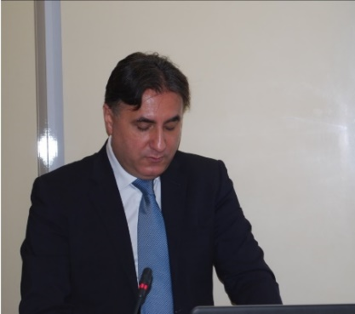

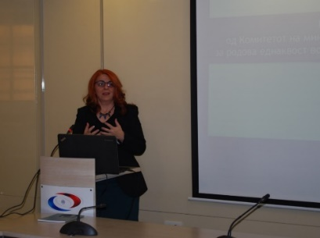

**Students Pay Visit to the Agency**

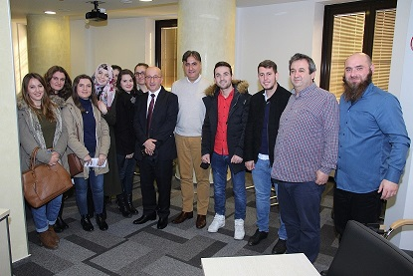

In December, the Agency hosted a visit by students from the Faculty of Law and Journalism Studies at the Tetovo State University and the Faculty of Law, Journalism and Public Relations, “Goce Delcev” University in Shtip.

The students were acquainted with the media-related legislation, including the pending proposals to amend and supplement the Law on Audio and Audiovisual Media Services, the competences; the Agency’s modus operandi and obligations regarding the implementation of relevant laws; the activities it undertakes regarding media literacy; the treatment of gender issues in the media, and the conducted analyses and researches.

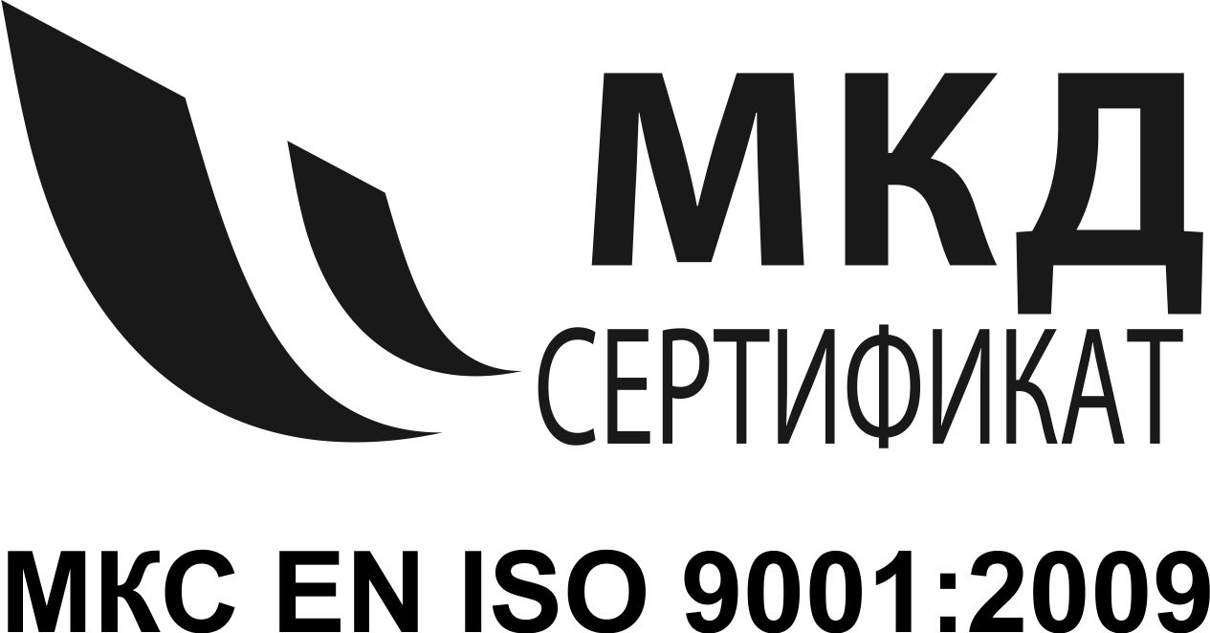



**AGENCY FOR AUDIO AND AUDIOVISUAL MEDIA SERVICES**

**OF THE REPUBLIC OF MACEDONIA**

**Address: Makedonija 38, 1000 Skopje**

**е-mail:** [**contact@avmu.mk**](mailto:contact@avmu.mk) **website:** [**www.avmu.mk**](http://www.avmu.mk)

**Supervision over Broadcasters**

With regard to the obligations to air music and original programme created in the Republic of Macedonia, the use of languages in the programmes and the airing of at least 12 hours of programme on television daily, and the product placement rules, the Agency conducted regular programme supervision over the work of 24 Vesti TV, Kanal 5 Plus TV, Nasha TV, Sitel 3 TV, and Sonce TV, as well as administrative supervision regarding the obligations to air Impressums, information that should be made available to the users and broadcaster’s identification. Only Sonce TV was found to have violated the product placement rules and was issued a warning measure.

As regards the obligations to air Impressums, information that should be made available to the users and broadcaster’s identification, a control administrative supervision was conducted over the MRT 2. Subjected to control administrative supervision were also DIBRA TV and HEPI Radio, concerning their obligation to air data about their ownership structure, editorship and financing sources during the previous year. Control programme supervision was carried out over the MT 2 and MRA 2 in terms of the language use in their programmes, the programmes in foreign languages or parts thereof that need to be translated into Macedonian or the language of the community that does not constitute a majority, as well as the obligation to air at least 60 % original programme created in the RM. The supervision showed that the broadcasters had acted in line with the legal provisions.

**Supervision over Print Media**

The Agency conducted ad hoc administrative supervision over the publisher of the “Shtipski Glas” Magazine with regard to its obligation to publish an Impressum, and found that the magazine’s November 2017 edition No. 77, did not contain the address of the media publisher’s headquarters, the name of the responsible person, the address of the printing plant, the date of printing and reprinting and the circulation. An ad hoc administrative supervision was also carried out over the “Nezavisen” (Independent) daily, during which it was found that it had not met in full the obligation to publish an Impressum, as stipulated by the Media Law. The Agency warned the publisher “Independent Balkan News Agency DOO Skopje” in writing and set a deadline for removing the violation.

**Supervision over Operators of Public Electronic Communication Networks**

The Agency conducted an ad hoc programme supervision over the ”Makedonski Telecom” and “ROBI” operators concerning their observance of the legal requirements to air or retransmit programming services containing pornography in a coded form, subtitling, registering the programme services in line with Article 141 and retransmitting programming services by domestic broadcasters only within the service zone specified in the TV or radio licenses obtained by the broadcasters, based on regulated author’s rights. Both operators had been abiding by the relevant legal regulations.

Also conducted was control programme supervision over the work of “ONE.VIP“, in order to establish if the operator had been retransmitting programming services that had not been registered with the Agency, and the same found that the legal obligations had been observed in full.

**Notification from the Higher Public Prosecutor’s Office on December 2016 SITEL TV Hate Speech Case**

The Higher Public Prosecutor’s Office rejected the Agency’s demand to inspect the decision of the First-Instance Public Prosecutor’s Office in Skopje with regard to the Agency’s claims against the Trade and Broadcasting Company “SITEL DOOEL Skopje” for stirring and propagating discrimination, intolerance and hatred in its editions of the daily information programme “Dnevnik” at 19:00 hrs and 23:00 hrs, respectively, aired on 2, 3, 4 and 5 December 2016. The Prosecution’s explanation was that the Primary Public Prosecution in Skopje had been right to conclude that there had been no room for intervention on its part, “considering the fact that the items at issue contain statements aired during an election campaign with the aim to achieve a certain political aim, and not to provoke national, racial or religious hatred, discord and intolerance”, and that its conclusion had been based on the fact that the specified news items did not contain actions of coercion, abuse, jeopardy to one’s safety, etc.