**Agency for Audio and Audiovisual Media Services**

**Analysis of Employee Structure**

**in the Audio and Audiovisual Media Sector in 2014**

**Skopje, September 2015**

**INTRODUCTION**

The analysis of employee structure in the audio and audiovisual media sector in 2014 contains data about the total number of employees in the public broadcasting service and commercial television and radio stations at the state, regional and local levels. These data have been analysed in terms of the status (regular or part-time employment), gender and level of education of the employees hired in every segment of the television and radio broadcasting market.

The Agency for Audio and Audiovisual Media Services obtained the data for this yearly analysis from the broadcasters as part of their compliance with the legal obligation for operational transparency arising under Article 13, Paragraph 1 of the Media Law. In line with this obligation, broadcasters are obligated to submit to the Agency, by 31 March of the current year at the latest, previous year’s data about their ownership structure, editor/s in charge, sources of financing, total revenues and expenditures, as well as data about the average viewership or listenership during the previous year.

### **TELEVISION BROADCASTING INDUSTRY**

In 2014, television broadcasting industry as a whole employed a total of 2,169 persons – 228 persons more than the previous year (the number of regularly employed persons increased by 138, and the number of part-time employees – by 90).

Of the total number of employees in the television broadcasting industry, 1,683 were regularly employed, while 486 were part-time employees.

# Table 1: Employee structure in the television broadcasting industry

|  |  |  |  |  |  |  |  |  |  |  |  |  |  |
| --- | --- | --- | --- | --- | --- | --- | --- | --- | --- | --- | --- | --- | --- |
|  |  | Status as on 31.12.2014 | | | | | | | | | | | |
|  | Staff | Total | | Education | | | | | | Status | | | |
| Higher Education | | Secondary education | | Other | | Regular employment | | Part-time | |
| F | M | F | M | F | M | F | M | F | M | F | M |
| 1 | Journalists | 385 | 298 | 308 | 225 | 71 | 71 | 6 | 2 | 284 | 201 | 101 | 97 |
| 2 | Editors | 65 | 61 | 52 | 38 | 12 | 21 | 1 | 2 | 63 | 50 | 2 | 11 |
| 3 | Managers/  Executives | 17 | 49 | 9 | 35 | 6 | 14 | 2 | 0 | 16 | 41 | 1 | 8 |
| 4 | Technical staff  (engineers and technicians) | 17 | 180 | 7 | 33 | 10 | 144 | 0 | 3 | 12 | 133 | 5 | 47 |
| 5 | Production staff (directors, camera operators/radio recorders, video/audio editors, etc.) | 139 | 597 | 41 | 106 | 82 | 467 | 16 | 24 | 126 | 510 | 13 | 87 |
| 6 | Marketing | 38 | 34 | 21 | 13 | 16 | 21 | 1 | 0 | 28 | 20 | 10 | 14 |
| 7 | Other personnel | 161 | 128 | 52 | 47 | 94 | 64 | 15 | 17 | 109 | 90 | 52 | 38 |
|  | **TOTAL** | **822** | **1347** | **490** | **497** | **291** | **802** | **41** | **48** | **638** | **1045** | **184** | **302** |

The Macedonian Television (*Makedonska televizija,* MTV) employed 27% of the total number of employees in the television broadcasting industry; the television stations broadcasting programme at the state level via a terrestrial transmitter employed 31%; the satellite and local television broadcasters employed 11% each, while the regional television broadcasters employed 20% of the employees.

## Picture 1: Number of employees of the MTV and the commercial television stations

## at the state level

## 

The majority of employees were hired as directors, camera operators, audio/video editors and other production staff (736 persons). Of these, 86% were regularly employed; wheras 14% were part-time employees. Among the more significant participation rates was also that of the persons hired as journalists (683 persons), of whom 71% were regularly employed, whereas 29% were part-time employees.

Picture 2: Employee structure in the TV broadcasting industry by post

The majority of employees in the television broadcasting industry were males (62%). They were the most numerous among the production staff, which included 4.3 times more men than women (hired as directors, camera operators, audio/video editors and other production staff were 597 men, as opposed to 139 women). Men outnumbered women in the categories of managers and technical staff as well.

## 

## Picture 3: Employee structure in the TV broadcasting industry by gender

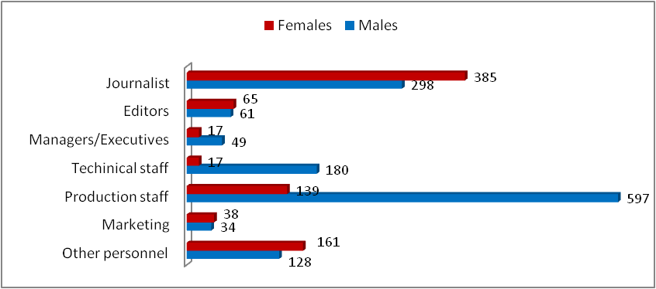

Females prevailed among the journalists (by 87 persons), editors and the marketing staff (by four persons in each) as well as the category of ‘other personnel’ (by 33 persons).

As regards the level of employees’ education, 46% had completed higher education, 50% had completed secondary education, while 4% had completed other levels of educaton. As many as 31% of the higher-educated employees were females hired as journalists. Among the persons who had completed secondary education, males employed as directors, camera operators, audio/video editors and other production staffs were the most numerous (43%).

**Picture 4: Employee structure in the TV broadcasting industry by education**

## 

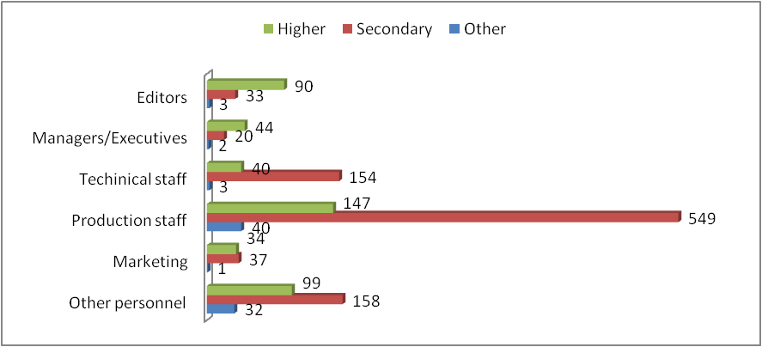

The terrestrial television broadcasters at the state level had the highest number of employees who had completed higher and secondary education (312 and 348, respectively). Most of the employees who had completed other levels of education were employed by the MTV (61 persons).

### **1.1. The Macedonian Television (*Makedonska televizija,* MTV)**

In the year under review, the MTV had a total of 597 employees (21 more than in 2013) and all of these were regularly employed.

# Table 2: Employee structure of the MTV

|  |  |  |  |  |  |  |  |  |  |  |  |  |  |
| --- | --- | --- | --- | --- | --- | --- | --- | --- | --- | --- | --- | --- | --- |
|  |  | Status as on 31.12.2014 | | | | | | | | | | | |
|  | Staff | Total | | Education | | | | | | Status | | | |
| Higher Education | | Secondary education | | Other | | Regular employment | | Part-time | |
| F | M | F | M | F | M | F | M | F | M | F | M |
| 1 | Journalists | 87 | 68 | 55 | 42 | 27 | 24 | 5 | 2 | 87 | 68 | 0 | 0 |
| 2 | Editors | 27 | 16 | 24 | 13 | 3 | 3 | 0 | 0 | 27 | 16 | 0 | 0 |
| 3 | Managers/  Executives | 0 | 3 | 0 | 3 | 0 | 0 | 0 | 0 | 0 | 3 | 0 | 0 |
| 4 | Technical staff  (engineers and technicians) | 0 | 17 | 0 | 1 | 0 | 16 | 0 | 0 | 0 | 17 | 0 | 0 |
| 5 | Production staff (directors, camera operators, video/ audio editors, etc.) | 75 | 210 | 22 | 39 | 40 | 152 | 13 | 19 | 75 | 210 | 0 | 0 |
| 6 | Marketing | 2 | 2 | 2 | 1 | 0 | 1 | 0 | 0 | 2 | 2 | 0 | 0 |
| 7 | Other personnel | 53 | 37 | 12 | 11 | 32 | 13 | 9 | 13 | 53 | 37 | 0 | 0 |
|  | **TOTAL** | **244** | **353** | **115** | **110** | **102** | **209** | **27** | **34** | **244** | **353** | **0** | **0** |

The most numerous in the structure of employees was the production staff (48%), with the journalists having a considerable participation rate as well (26%). Compared to the year before, the number of journalists increased by ten, and that of the production staff – by four.

## Picture 5: Employee structure of the MTV by post

Of the total number of employees in the Macedonian Television, 244 were women and 353 were men. Females had the highest participation rate among the journalists (36%), while males had the highest participation rate among the production staff (59%).

Women were more numerous than men among the journalists (by 19), editors (by 11) and in the category of ‘other personnel’ (by 16). Men prevailed significantly among the directors, camera operators and audio/video editors, outnumbering women by 135. In the ‘marketing’ category, there was an equal number of men and women (two of each), however, not a single female was employed as technical staff or as manager.

Picture 6: Employee structure of the MTV by gender

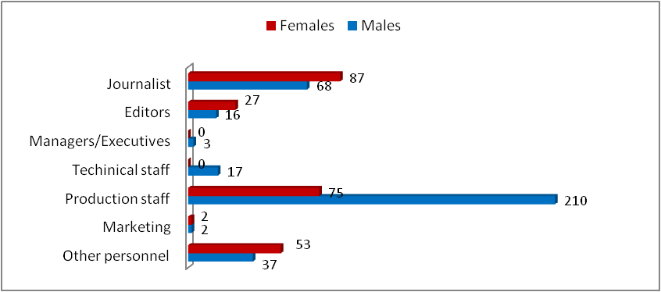

Of the total number of employees, 52% had completed secondary education, 38% had completed higher education, while 10% had completed other levels of education.

Picture 7: Employee structure of the MTV by education

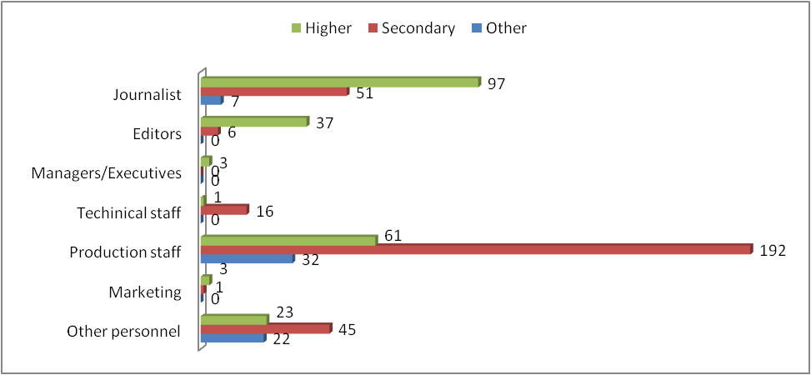

The majority of persons who had completed secondary education were hired as production staff (62%), while most of the persons who had completed higher education worked as journalists (43%). More than half of the persons who had completed other levels of education were engaged as directors, camera operators, audio/video editors and other production staff (52%).

### **1.2. Terrestrial television stations at the state level**

The five television stations that broadcasted programme at the state level via a digital terrestrial multiplex employed 663 persons. Of these, 532 were regularly employed, while 131 were part-time employees.

# Table 3: Employee structure of the terrestrial television stations at the state level

|  |  |  |  |  |  |  |  |  |  |  |  |  |  |
| --- | --- | --- | --- | --- | --- | --- | --- | --- | --- | --- | --- | --- | --- |
|  |  | Status as on 31.12.2014 | | | | | | | | | | | |
|  | Staff | Total | | Education | | | | | | Status | | | |
| Higher Education | | Secondary education | | Other | | Regular employment | | Part-time | |
| F | M | F | M | F | M | F | M | F | M | F | M |
| 1 | Journalists | 113 | 82 | 104 | 68 | 9 | 14 | 0 | 0 | 91 | 69 | 22 | 13 |
| 2 | Editors | 9 | 13 | 8 | 12 | 1 | 1 | 0 | 0 | 9 | 11 | 0 | 2 |
| 3 | Managers/  Executives | 1 | 6 | 1 | 6 | 0 | 0 | 0 | 0 | 1 | 6 | 0 | 0 |
| 4 | Technical staff  (engineers and technicians) | 7 | 67 | 2 | 16 | 5 | 50 | 0 | 1 | 7 | 55 | 0 | 12 |
| 5 | Production staff (directors, camera operators, video/audio editors, etc.) | 30 | 191 | 9 | 23 | 21 | 168 | 0 | 0 | 26 | 160 | 4 | 31 |
| 6 | Marketing | 15 | 14 | 9 | 4 | 6 | 10 | 0 | 0 | 15 | 12 | 0 | 2 |
| 7 | Other personnel | 58 | 57 | 23 | 27 | 34 | 29 | 1 | 1 | 31 | 39 | 27 | 18 |
|  | **TOTAL** | **233** | **430** | **156** | **156** | **76** | **272** | **1** | **2** | **180** | **352** | **53** | **78** |

Compared to the previous year, when a total of 592 persons had been engaged, the rise in the number of employees in this segment of the television broadcasting industry was owing mostly to the increase in the number of employees of Kanal 5 TV (by 65).The number of employees of Alsat-M TV and Sitel TV increased by four each, and of Alfa TV – by eight. Only in Telma TV was there a decline in the number of employees, by 10.

The highest participation rates in the structure of employees were those of the production staff (33%) and the journalists (30%). Most of the production staff worked at SItel TV (64 persons), while the largest number of journalists worked at Telma TV (55 persons).

Picture 8: Employee structure of the terrestrial television stations at the state level

Compared to the previous year, the number of directors, camera operators, audio/video editors and other production staff increased only at Kanal 5 TV (by 21) and Alfa TV (by 5). At Alsat-M, their number dropped by seven, at Sitel TV – by one, while, at Telma TV, it remained the same.

The number of journalists increased only at Kanal 5 TV (by 13) and Sitel TV (by seven). Their number at Telma TV dropped by eight persons, at Alfa TV – by three, whereas at Alsat-M TV, it remained the same (26 persons).

## Picture 9: Number of journalists and production staff in the terrestrial television stations at the state level

Alsat-M TV reported the highest number of editors (nine persons), the highest number of managers (three persons), and the highest number of persons in charge of marketing (six persons), while Kanal 5 TV reported the highest number of persons engaged in the categories of ‘technical staff’ (25 persons) and ‘other personnel’ (52 persons).

# Table 4: Distribution of employees’ posts in the terrestrial television stations at the state level

|  |  |  |  |  |  |  |
| --- | --- | --- | --- | --- | --- | --- |
|  |  | Alsat-M TV | Alfa TV | Kanal 5 TV | Sitel  TV | Telma TV |
| **Post** | |  |  |  |  |  |
| Editors |  | 9 | 6 | 2 | 1 | 4 |
| Managers/Executives | | 3 | 1 | 1 | 1 | 1 |
| Technical staff |  | 16 | 6 | 25 | 17 | 10 |
| Marketing |  | 6 | 4 | 2 | 0 | 2 |
| Other personnel |  | 24 | 31 | 52 | 15 | 8 |

Sixty-five per cent of the employees in this segment of the television broadcasting industry were men, while 35 % were women. Most of the men were hired as production staff (44% of the total number of men), while most of the women were hired as journalists (48% of the total number of women).

The largest difference between the number of hired males and females was present among the production staff, where the number of men was six times higher than that of women.

Males prevailed among the employees of all five television stations. However, the difference with regard to women was the largest among the employees of Sitel TV (102 men, as opposed to 38 women). The Alfa TV employed 82 men and 53 women, Kanal 5 TV – 94 men and 63 women, Alsat TV – 88 men and 28 women, and Telma TV – 64 men and 51 women.

**Picture 10: Employee structure of the terrestrial television stations at the state level by gender**

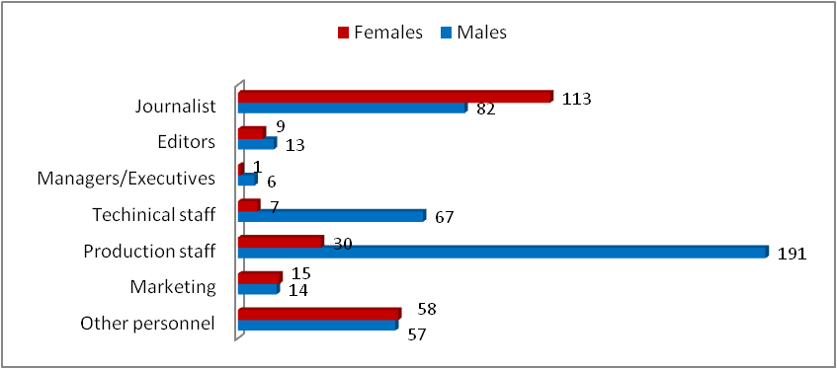

More than half of the emoloyees of these television stations had completed secondary education (52%). Most of these, or, more precisely, 54%, were employed as production staff. Of the total number of employees, 47 % had completed higher education. Most of these persons were engaged as journalists (55%).

Only three of the hired persons had completed another level of education – one in the category of ‘technical staff’, and two as ‘other personnel’.

**Picture 11: Employee structure of the terrestrial television stations at the state level by education**

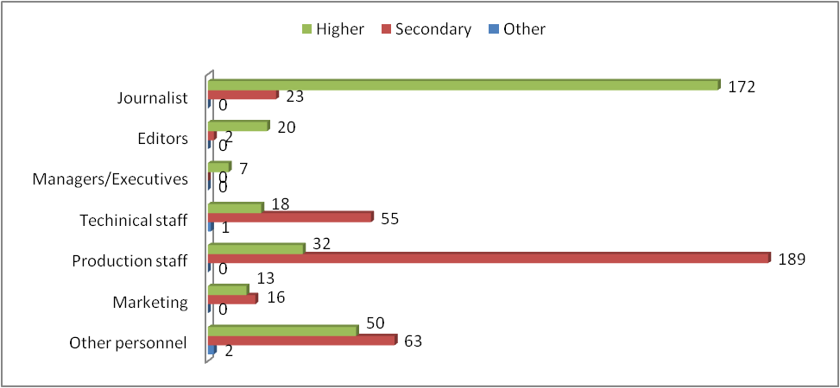

As regards each television station in particular, nearly 63% of the persons engaged in the Telma TV had completed higher education, while 37% had completed secondary education. At Alsat-M TV, 52% of the employees had completed higher education, while 48% had completed secondary education. At Alfa TV, this ratio was 46 % higher-educated employees as opposed to 54% employees who had completed secondary education. At Sitel TV, 32% had completed higher education, as opposed to 68% who had completed secondary education, while, at Kanal TV, 46% were higher-educated, 52% had completed secondary education and 2% had completed other levels of education.

### **1.3. Satellite television stations**

The total number of employees in the satellite television stations in 2014 amounted to 242 persons, of whom 131 were regularly employed, while 111 were part-time employees.

The 24 Vesti TV reported the highest number of employees (both full-time and part-time) – 78 persons. The Kanal 5 TV employed 60 persons, Nasha TV – 41 persons, Sonce TV – 33 persons and Sitel 3 TV – 30 persons.

The 24 Vesti TV had the highest number of regular employees (69), whereas all the persons engaged by Sitel 3 TV were part-time employees.

# Table 5: Employee structure of the satellite television stations

|  |  |  |  |  |  |  |  |  |  |  |  |  |  |
| --- | --- | --- | --- | --- | --- | --- | --- | --- | --- | --- | --- | --- | --- |
|  |  | Status as on 31.12.2014 | | | | | | | | | | | |
|  | Staff | Total | | Education | | | | | | Status | | | |
| Higher Education | | Secondary education | | Other | | Regular employment | | Part-time | |
| F | M | F | M | F | M | F | M | F | M | F | M |
| 1 | Journalists | 43 | 47 | 39 | 39 | 4 | 8 | 0 | 0 | 20 | 19 | 23 | 28 |
| 2 | Editors | 5 | 2 | 5 | 1 | 0 | 0 | 0 | 1 | 4 | 2 | 1 | 0 |
| 3 | Managers/  Executives | 3 | 4 | 1 | 3 | 2 | 1 | 0 | 0 | 2 | 3 | 1 | 1 |
| 4 | Technical staff  (engineers and technicians) | 2 | 27 | 2 | 3 | 0 | 24 | 0 | 0 | 0 | 15 | 2 | 12 |
| 5 | Production staff (directors, camera operators, video/audio editors, etc.) | 14 | 51 | 4 | 13 | 10 | 38 | 0 | 0 | 9 | 37 | 5 | 14 |
| 6 | Marketing | 3 | 5 | 3 | 3 | 0 | 2 | 0 | 0 | 1 | 4 | 2 | 1 |
| 7 | Other personnel | 20 | 16 | 8 | 3 | 12 | 13 | 0 | 0 | 10 | 5 | 10 | 11 |
|  | **TOTAL** | **90** | **152** | **62** | **65** | **28** | **86** | **0** | **1** | **46** | **85** | **44** | **67** |

The journalists had the highest participation rate in the structure of employees (37%), followed by the production staff (27%).

## Picture 12: Employee structure of the satellite television stations



Most of the journalists in the year under review were engaged by the 24 Vesti TV (39% of the total number of journalists). This television station employed the highest number of directors, camera operators, audio/video editors and other production staff (49% of the entire production staff).

## Picture 13: Number of journalists and production staff in the satellite television stations

Compared to 2013, the number of journalists at the 24 Vesti TV increased by seven, at Nasha TV by four, at Kanal 5 Plus TV by 12, and at Sitel 3 TV – by 15 (this television station had not reported any employee in 2013, either full-time or part-time). Their number decreased only at Sonce TV and this by 11 persons.

In the year under review, the number of production staff increased with all five satellite television stations, as follows: 24 Vesti TV – by two, Kanal 5 Plus TV – by five, Nasha TV – by one, Sonce TV – by three and Sitel 3 TV – by six.

The highest number of editors was presented by 24 Vesti TV (three); Nasha TV had the highest number of managers (three), while Kanal 5 Plus TV reported the highest number of employees engaged as technical staff and other personnel (15 and 18, respectively).

# Table 6: Distribution of employees’ posts at the satellite television stations

|  |  |  |  |  |  |  |  |
| --- | --- | --- | --- | --- | --- | --- | --- |
|  |  | **24 Vesti TV** | **Kanal 5 Plus**  **TV** | **Nasha TV** | **Sonce TV** | **Sitel 3**  **TV** | |
| **Post** | |  |  |  |  |  |  |
| Editors |  | 3 | 0 | 2 | 1 | 1 |  |
| Managers/Executives | | 1 | 1 | 3 | 1 | 1 |  |
| Technical staff |  | 3 | 15 | 3 | 1 | 7 |  |
| Marketing |  | 1 | 3 | 3 | 1 | 0 |  |
| Other personnel |  | 3 | 18 | 9 | 6 | 0 |  |
|  |  |  |  |  |  |  |  |

Male employees were more numerous than females in most of the categories of employees (152 men as opposed to 90 women).

Men were the most numerous among the production staff and the journalists. A total of 51 males were employed as production staff, and 47 as journalists. Women, for their part, prevailed among the editors (three women more than men) and other personnel (four women more than men).

## Picture 14: Employee structure of the satellite television stations by gender

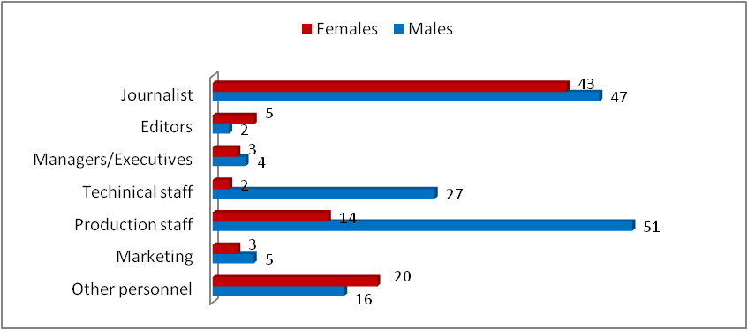

More than half of the employees of the satellite television stations had completed higher education (52 %). Most of these – more precisely, 61% – were employed as journalists.

## Picture 15: Employee structure of the satellite television stations by education

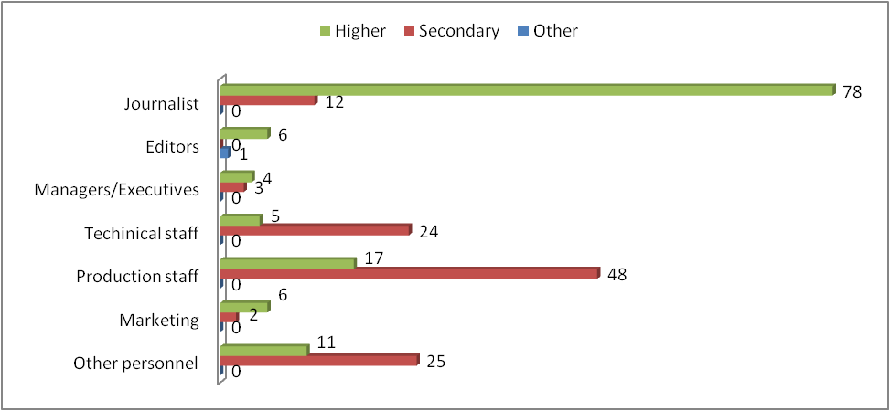

A total of 47% of the employees had completed secondary education, of whom as many as 42% worked as directors, camera operators, audio/video editors and other production personnel.

Only one person had completed another level of education and the same was engaged as an editor at the 24 Vesti TV.

### **1.4. Television stations at the regional level**

The total number of employees in the regional television stations[1] in 2014 amounted to 432. Of these, 295 were regularly employed, while 137 were part-time employees. Compared to the previous year, the total number of employees increased by 83 persons.

The largest number of employees was presented by the Telekanal A1 TV (33) and Mega HDTV (30 persons), and the smallest number – by the Skopje TV (eight persons).

# Table 7: Employee structure of the regional television stations

|  |  |  |  |  |  |  |  |  |  |  |  |  |  |
| --- | --- | --- | --- | --- | --- | --- | --- | --- | --- | --- | --- | --- | --- |
|  |  | Status as on 31.12.2014 | | | | | | | | | | | |
|  | Staff | Total | | Education | | | | | | Status | | | |
| Higher Education | | Secondary education | | Other | | Regular employment | | Part-time | |
| F | M | F | M | F | M | F | M | F | M | F | M |
| 1 | Journalists | 92 | 58 | 73 | 43 | 18 | 15 | 1 | 0 | 59 | 32 | 33 | 26 |
| 2 | Editors | 19 | 13 | 13 | 5 | 5 | 8 | 1 | 0 | 18 | 10 | 1 | 3 |
| 3 | Managers/  Executives | 5 | 19 | 4 | 15 | 1 | 4 | 0 | 0 | 5 | 15 | 0 | 4 |
| 4 | Technical staff  (engineers and technicians) | 6 | 36 | 3 | 3 | 3 | 33 | 0 | 0 | 3 | 26 | 3 | 10 |
| 5 | Production staff (directors, camera operators, video/audio editors, etc.) | 17 | 115 | 6 | 26 | 9 | 84 | 2 | 5 | 14 | 84 | 3 | 31 |
| 6 | Marketing | 12 | 6 | 7 | 3 | 5 | 3 | 0 | 0 | 8 | 1 | 4 | 5 |
| 7 | Other personnel | 19 | 15 | 6 | 6 | 10 | 8 | 3 | 1 | 11 | 9 | 8 | 6 |
|  | **TOTAL** | **170** | **262** | **112** | **101** | **51** | **155** | **7** | **6** | **118** | **177** | **52** | **85** |

Journalists had the highest participation rate in the employee structure, totaling 150 persons. Of these, 91 were regularly employed, whereas 59 were part-time employees.

As many as 33% of the total number of journalists were hired by only five regional television stations, as follows: Telekanal A1 TV – 11, K Tri TV and Regionalna 02 – 10 each, and Vis TV and Mega HDTV – nine each. Skopje TV was the only one not to have reported a single employee in this category.

The production staff had a more considerable participation rate as well. A total of 132 persons were engaged as directors, camera operators, audio/video editors and other production personnel. The Telekanal A1 TV and Mega HDTV presented the highest number of employees in this category (16 each).

## Picture 16: Employee structure of the regional television stations



Sixty-one per cent of the employees in this segment of the television industry were men, and 39% were women. Most of the men were employed in the category of ‘production staff’ (44%), whereas the majority of women worked as journalists (54%).

Women were more numerous in four categories of employees, as follows: journalists, editors, marketing and other personnel. Men prevailed in the other categories.

## Picture 17: Employee structure of the regional television stations by gender

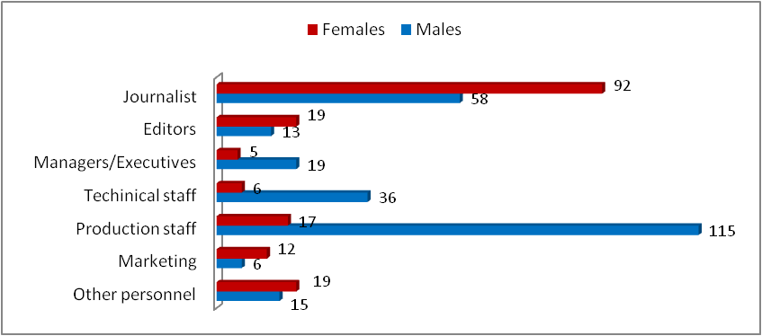

The K Tri TV, Era TV and Mega HDTV presented the largest number of female employees (12 each), whereas the largest number of male employees was presented by the Telekanal A1 TV (23), Regionalna 02 TV and Ultra TV (20 each).

Of the employees of the regional television stations, 49% had completed higher education, 48% had completed secondary education, while 3% had other levels of education. More precisely, 66 % of the women had completed higher education, 30% had completed secondary education and 4% had completed other levels of education. With men, the ratio was as follows: 39% had completed higher education, 59% had completed secondary education and 2% had completed other levels of education.

Prevailing among the higher-educated employees were women engaged as journalists (34%), and among the employees who had completed secondary education – men engaged as ‘production staff’ (41%).

## Picture 18: Employee structure of the regional television stations by education

## 

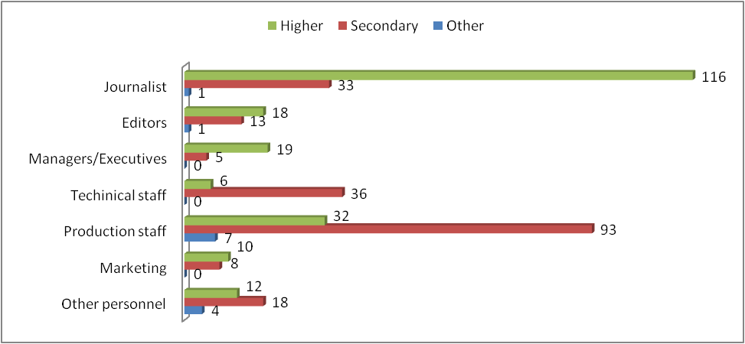

More than half of the employees who had completed higher education (52%) were engaged by eight regional televisions, as follows: Regional 02 TV (20), Telekanal A1 TV (18), K Tri TV and Mega HDTV (14 each), Edo TV (13), Kobra TV (12), Vis TV (10) and Iris TV (9).

The highest number of employees who had completed secondary education was presented by the Era TV (23) and Ultra TV (17).

### **1.5. Television stations at the local level**

In 2014, the local television stations[2] employed a total of 235 employees, 128 of whom were regularly employed, while 1207 were part-time employees.

The Art TV from Tetovo hired the highest number of employees (32), whereas the Super Skaj TV from Tetovo hired the smallest number (four employees). The Tera TV from Bitola had the largest number of regular employees (18), followed by the TVМ from Ohrid (13), while the Art TV from Tetovo had the highest number of part-time employees (27).

# Table 8: Employee structure of the local television stations

|  |  |  |  |  |  |  |  |  |  |  |  |  |  |
| --- | --- | --- | --- | --- | --- | --- | --- | --- | --- | --- | --- | --- | --- |
|  |  | Status as on 31.12.2014 | | | | | | | | | | | |
|  | Staff | Total | | Education | | | | | | Status | | | |
| Higher Education | | Secondary education | | Other | | Regular employment | | Part-time | |
| F | M | F | M | F | M | F | M | F | M | F | M |
| 1 | Journalists | 50 | 43 | 37 | 33 | 13 | 10 | 0 | 0 | 27 | 13 | 23 | 30 |
| 2 | Editors | 5 | 17 | 2 | 7 | 3 | 9 | 0 | 1 | 5 | 11 | 0 | 6 |
| 3 | Managers/  Executives | 8 | 17 | 3 | 8 | 3 | 9 | 2 | 0 | 8 | 14 | 0 | 3 |
| 4 | Technical staff  (engineers and technicians) | 2 | 33 | 0 | 10 | 2 | 21 | 0 | 2 | 2 | 20 | 0 | 13 |
| 5 | Production staff (directors, camera operators, video/audio editors, etc.) | 3 | 30 | 0 | 5 | 2 | 25 | 1 | 0 | 2 | 19 | 1 | 11 |
| 6 | Marketing | 6 | 7 | 0 | 2 | 5 | 5 | 1 | 0 | 2 | 1 | 4 | 6 |
| 7 | Other personnel | 11 | 3 | 3 | 0 | 6 | 1 | 2 | 2 | 4 | 0 | 7 | 3 |
|  | **TOTAL** | **85** | **150** | **45** | **65** | **34** | **80** | **6** | **5** | **50** | **78** | **35** | **72** |

Journalists were the most numerous staff in the employee structure, comprising 40% of the total number of employees on the local television broadcasting market. Of the total number of journalists, 43% were regularly employed, while 57 % were part-time employees. The Art TV from Tetovo employed the highest number of journalists (13).

## 

## Picture 19: Employee structure of the local television stations



Looking at the employee structure by gender, one can notice that there were nearly twice as many male employees as females (150 men were employed, as opposed to 85 women).

Picture 20: Employee structure of the local television stations by gender

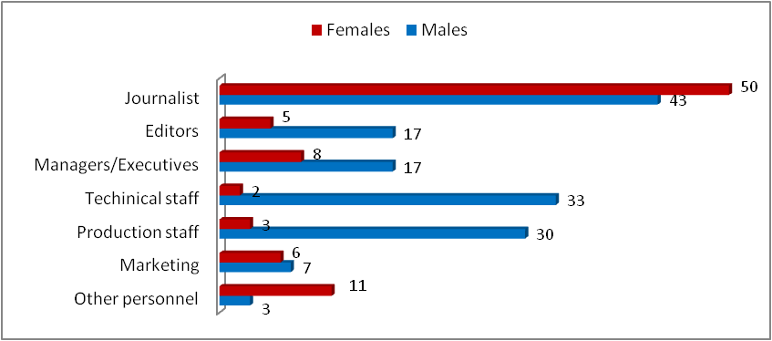

Except among the journalists and in the group of ‘other personnel’, males prevailed in all other categories. However, their number was considerably larger than that of women in the categories of technical and production staff, which engaged 33 and 30 men, respectively, as opposed to two and three women, respectively. Among the journalists, women were more numerous than men by seven, and among other personnel – by eight.

The Art TV from Tetovo reported the highet number of employed males (27), while the TVM from Ohrid had the highest number of employed women (12).

A total of 47% of the employees had completed higher education, 48% had completed secondary education, and 5% of the total number of employees had completed other levels of education.

## Picture 21: Employee structure of the local television stations by education

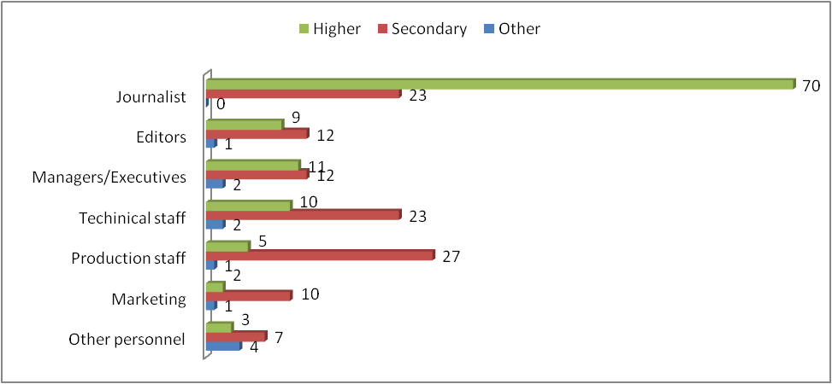

Higher-educated persons were more numerous only among the journalists, whereas the persons who had completed secondary education prevailed in all other categories of employees. Only 11 persons had other level of education. Of these, two were engaged as managers and another two as technicians, the categories of ‘editors’, ‘production staff’ and ‘marketing’ employed one each, while four were employed as ‘other personnel’.

### **2.** **RADIO BROADCASTING INDUSTRY**

In 2014, the radio broadcasting industry employed 677 persons, i.e. 36 persons more than in the year before. Compared to 2013, the number of regular employees increased by six, while the number of part-time employees grew by 30.

# Table 9: Employee structure in the radio broadcasting industry

|  |  |  |  |  |  |  |  |  |  |  |  |  |  |
| --- | --- | --- | --- | --- | --- | --- | --- | --- | --- | --- | --- | --- | --- |
|  |  | Status as on 31.12.2014 | | | | | | | | | | | |
|  | Staff | Total | | Education | | | | | | Status | | | |
| Higher Education | | Secondary education | | Other | | Regular employment | | Part-time | |
| F | M | F | M | F | M | F | M | F | M | F | M |
| 1 | Journalists | 140 | 117 | 114 | 84 | 25 | 31 | 1 | 2 | 81 | 55 | 59 | 62 |
| 2 | Editors | 37 | 52 | 26 | 31 | 9 | 20 | 2 | 1 | 31 | 42 | 6 | 10 |
| 3 | Managers/  Executives | 21 | 42 | 8 | 17 | 13 | 25 | 0 | 0 | 17 | 40 | 4 | 2 |
| 4 | Technical staff  (engineers and technicians) | 14 | 59 | 4 | 9 | 10 | 50 | 0 | 0 | 5 | 38 | 9 | 21 |
| 5 | Production staff (directors, radio recorders, audio editors, etc.) | 28 | 93 | 7 | 11 | 20 | 78 | 1 | 4 | 26 | 82 | 2 | 11 |
| 6 | Marketing | 14 | 5 | 10 | 2 | 4 | 3 | 0 | 0 | 5 | 2 | 9 | 3 |
| 7 | Other personnel | 35 | 20 | 8 | 8 | 24 | 7 | 3 | 5 | 30 | 13 | 5 | 7 |
|  | **TOTAL** | **289** | **388** | **177** | **162** | **105** | **214** | **7** | **12** | **195** | **272** | **94** | **116** |

The Macedonian Radio (*Makedonsko Radio,* MRA*)* employed 255 persons, the radio stations broadcasting programme at the state level hired 112 persons, the regional radio stations – 105 persons and the local radio stations – 205 persons.

## Picture 22: Number of employees of the MRA and the commercial radio stations

The majority of employees (257) were engaged as journalists.Compared to the previous year, their number increased by as many as 50 persons.

Compared to the year before, the number of persons engaged as directors, radio recorders, audio editors and other production personnel increased as well (by eight persons).

## Picture 23: Employee structure in the radio broadcasting industry by post

The radio stations as a whole employed 388 men, as opposed to 289 women.



Fifty-four per cent of men in the radio broadcasting industry worked as production staff and journalists. Apart from the production staff, where there were 65 men more than women, men outnumbered women in the categories of technical staff (by 45), managers (by 21) and editors (by 15), as well.

## Picture 24: Employee structure in the radio broadcasting industry by gender

## 

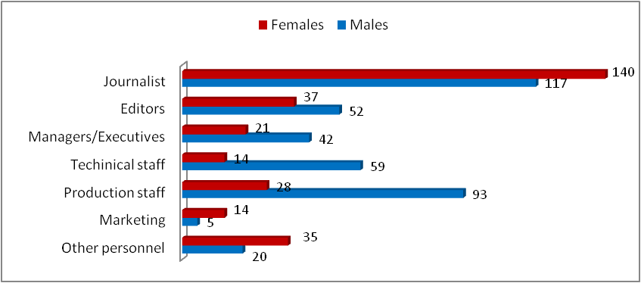

Women prevailed among the journalists (23 women more than men), the marketing staff (nine women more then men), and the category of ‘other personnel’ (15 women more then men). As many as 48% of women were employed as journalists.

As regards the level of employees’ education, 50% had completed higher education, 47% – secondary education, while 3% had completed other levels of education.

## Picture 25: Employee structure in the radio broadcasting industry by gender

## 

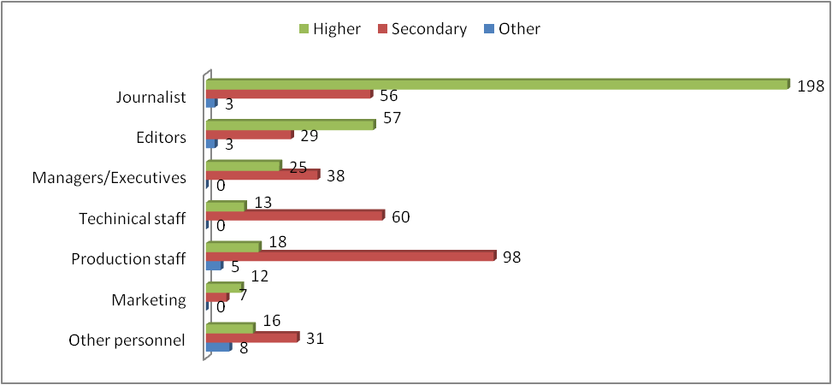

As many as 58% of the persons who had completed higher educaton were employed as journalists, while the majority of persons who had completed secondary education (31%) were engaged as production staff. Eight of the persons who had completed other levels of education were engaged in the category of ‘other personnel’, five worked as production staff, three as editors and another three as journalists.

### **2.1. The Macedonian Radio (*Makedonsko Radio,* MRA)**

The total number of employees in the MRA in 2014 amounted to 255 persons, all of them regularly employed. Compared to the previous year, their number decreased by 15 persons, mostly due to the journalists’ downsizing (by eight).

# Table 10: Employee structure of the MRA

|  |  |  |  |  |  |  |  |  |  |  |  |  |  |
| --- | --- | --- | --- | --- | --- | --- | --- | --- | --- | --- | --- | --- | --- |
|  |  | Status as on 31.12.2014 | | | | | | | | | | | |
|  | Staff | Total | | Education | | | | | | Status | | | |
| Higher Education | | Secondary education | | Other | | Regular employment | | Part-time | |
| F | M | F | M | F | M | F | M | F | M | F | M |
| 1 | Journalists | 46 | 28 | 34 | 17 | 12 | 9 | 0 | 2 | 46 | 28 | 0 | 0 |
| 2 | Editors | 22 | 23 | 19 | 20 | 1 | 2 | 2 | 1 | 22 | 23 | 0 | 0 |
| 3 | Managers/  Executives | 1 | 1 | 1 | 1 | 0 | 0 | 0 | 0 | 1 | 1 | 0 | 0 |
| 4 | Technical staff  (engineers and technicians) | 0 | 4 | 0 | 1 | 0 | 3 | 0 | 0 | 0 | 4 | 0 | 0 |
| 5 | Production staff (directors, radio recorders, audio editors, etc.) | 26 | 62 | 7 | 5 | 18 | 53 | 1 | 4 | 26 | 62 | 0 | 0 |
| 6 | Marketing | 2 | 0 | 2 | 0 | 0 | 0 | 0 | 0 | 2 | 0 | 0 | 0 |
| 7 | Other personnel | 29 | 11 | 6 | 3 | 20 | 3 | 3 | 5 | 29 | 11 | 0 | 0 |
|  | **TOTAL** | **126** | **129** | **69** | **47** | **51** | **70** | **6** | **12** | **126** | **129** | **0** | **0** |

The production staff had the highest participation rate in the employee structure (34%). Compared to the year before, the number of production staff dropped by two persons (engaged as directors, radio recorders, audio editors and other production staff were 88 persons). Another more significant participation rate was that of the journalists (29%).

**Picture 26: Employee structure of the MRA by posts**



Most of the male employees were engaged as production staff (48% of the total number of men), while the majority of females were employed as journalists (37% of the total number of women).

## Picture 27: Employee structure of the MRA by gender

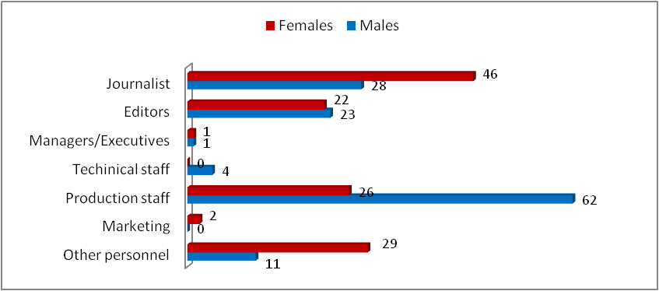

A total of 46% of the employees had completed higher education, 47% had completed secondary education, while 7% of the total number of employees had completed other levels of education.

The higher-educated employees were the most numerous among the journalists and the editors (51 and 39, respectively), while the persons who had completed secondary education were the most numerous among the production staff. Namely, 59% of these persons were engaged as directors, radio recorders, audio editors and other production staff. Most of the employees who had completed other levels of education were engaged in the category of other personnel (eight persons).

## Picture 28: Employee structure of the MRA by education

## 

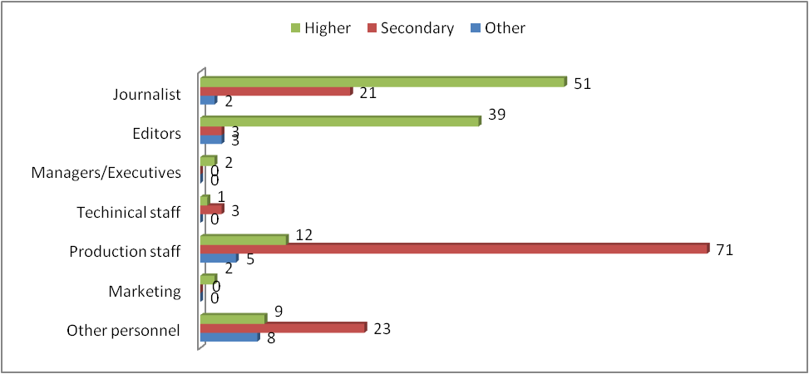

### **2.2. Radio broadcasting stations at the state level**

The total number of employees in the four commercial radio stations in 2014 amounted to 112 persons, of whom 47 were regularly employed, while 65 were part-time employees. Compared to the previous year, the number of regular employees increased by 17, while the number of part-time employees grew by 13.

The highest number of employees was presented by the Slobodna Makedonija RA (43 persons). The Kanal 77RA engaged 32 persons, Antena 5 RA – 24, and Ros Metropolis RA – 13. Slobodna Makedonija RA also had the highest numbers of both regular and part-time employees (15 and 28, respectively).

# Table 11: Employee structure of the national radio stations

|  |  |  |  |  |  |  |  |  |  |  |  |  |  |
| --- | --- | --- | --- | --- | --- | --- | --- | --- | --- | --- | --- | --- | --- |
|  |  | Status as on 31.12.2014 | | | | | | | | | | | |
|  | Staff | Total | | Education | | | | | | Status | | | |
| Higher Education | | Secondary education | | Other | | Regular employment | | Part-time | |
| F | M | F | M | F | M | F | M | F | M | F | M |
| 1 | Journalists | 25 | 39 | 20 | 24 | 4 | 15 | 1 | 0 | 10 | 7 | 15 | 32 |
| 2 | Editors | 2 | 4 | 1 | 1 | 1 | 3 | 0 | 0 | 2 | 4 | 0 | 0 |
| 3 | Managers/  Executives | 4 | 2 | 3 | 2 | 1 | 0 | 0 | 0 | 2 | 2 | 2 | 0 |
| 4 | Technical staff  (engineers and technicians) | 0 | 11 | 0 | 2 | 0 | 9 | 0 | 0 | 0 | 6 | 0 | 5 |
| 5 | Production staff (directors, radio recorders, audio editors, etc.) | 0 | 14 | 0 | 2 | 0 | 12 | 0 | 0 | 0 | 10 | 0 | 4 |
| 6 | Marketing | 4 | 1 | 4 | 0 | 0 | 1 | 0 | 0 | 2 | 0 | 2 | 1 |
| 7 | Other personnel | 3 | 3 | 1 | 1 | 2 | 2 | 0 | 0 | 1 | 1 | 2 | 2 |
|  | **TOTAL** | **38** | **74** | **29** | **32** | **8** | **42** | **1** | **0** | **17** | **30** | **21** | **44** |

Just as in 2013, journalists continued to have the highest participation rate in the employee structure (57% of the total number of employees). The majority of journalists were engaged by the Slobodna Makedonija RA (33 persons, i.e. 52% of the journalists in all four radio stations). Kanal 77 RA employed 16 journalists, Antena 5 RA – ten, and Ros Metropolis RA – five.

**Picture 29: Employee structure of the national radio stations by post**



The regional radio stations employed twice as many men as women. Men were more numerous than women in each of these four radio stations, as follows: at Antena 5 RA – by 12, at Kanal 77 RA – by six, at Ros Metropolis RA – by one, and at Slobodna Makedonija RA – by 17.

Analysed by post, female employees were more numerous only among the managers (by two) and the staff in charge of the marketing (by three).

## Picture 30: Employee structure of the national radio stations by gender

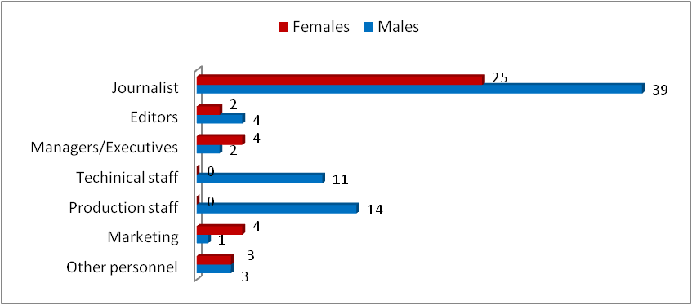

Out of the total number of employees, 54% had completed higher educaton, 45% – secondary education, while 1% had completed other levels of education.

As many as 72% of the higher-educated employees were engaged as journalists. The situation was similar among the persons who had completed secondary education. Namely, 19 of a total of 50 persons who had completed secondary education were engaged as journalists. Only one employee had another level of education completed, and the same was engaged as a journalist by the Slobodna Makedonija RA.

## Picture 31: Employee structure of the national radio stations by education

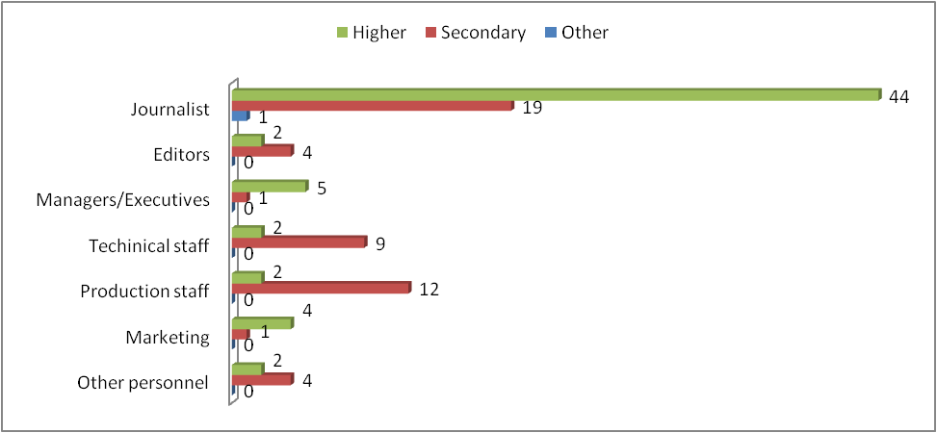

### **2.3. Radio stations at the regional level**

In the year under review, the number of employees in the 17 radio stations that broadcasted programme at the regional level amounted to 105, of whom 53 were regularly employed, while 52 were part-time employees.

The Zona-M1 RA presented the highest number of employees (11), whereas the Urban RA did not report a single employee, be it full-time or part-time.

The highest number of regular employees was reported by the Fortuna RA (eight), whereas Zona-M1 RA conveyed the highest number of part-time employees (ten).

# Table 12: Employee structure of the regional radio stations

|  |  |  |  |  |  |  |  |  |  |  |  |  |  |
| --- | --- | --- | --- | --- | --- | --- | --- | --- | --- | --- | --- | --- | --- |
|  |  | Status as on 31.12.2014 | | | | | | | | | | | |
|  | Staff | Total | | Education | | | | | | Status | | | |
| Higher Education | | Secondary education | | Other | | Regular employment | | Part-time | |
| F | M | F | M | F | M | F | M | F | M | F | M |
| 1 | Journalists | 25 | 17 | 22 | 12 | 3 | 5 | 0 | 0 | 7 | 10 | 18 | 7 |
| 2 | Editors | 5 | 7 | 4 | 4 | 1 | 3 | 0 | 0 | 3 | 2 | 2 | 5 |
| 3 | Managers/  Executives | 2 | 11 | 0 | 4 | 2 | 7 | 0 | 0 | 2 | 10 | 0 | 1 |
| 4 | Technical staff  (engineers and technicians) | 2 | 15 | 0 | 0 | 2 | 15 | 0 | 0 | 0 | 12 | 2 | 3 |
| 5 | Production staff (directors, radio recorders, audio editors, etc.) | 2 | 10 | 0 | 1 | 2 | 9 | 0 | 0 | 0 | 5 | 2 | 5 |
| 6 | Marketing | 3 | 2 | 1 | 1 | 2 | 1 | 0 | 0 | 0 | 1 | 3 | 1 |
| 7 | Other personnel | 1 | 3 | 1 | 1 | 0 | 2 | 0 | 0 | 0 | 1 | 1 | 2 |
|  | **TOTAL** | **40** | **65** | **28** | **23** | **12** | **42** | **0** | **0** | **12** | **41** | **28** | **24** |

Journalist staff had the highest participation rate, having increased by six percent compared to 2013, and, in the year under review, comprised 40 % of the total number of employees in this segment of the radio broadcasting market.

## Picture 32: Employee structure of the regional radio stations by post



The highest number of journalists were employed by the Sportsko FM RA (five). Two regional radio stations hired four journalists each (Rosa AB RA and Univerzitetsko Student FM RA), another six employed three each (Vat RA, Zona-M1 RA, Klub FM RA, RFM RA, Siti RA and Fortuna RA), five employed two each (Аracina RA, Buba Mara RA, Skaj RA, Strit RA and Kapitol RA), and one employed one journalist (Lajf RA). The Urban RA and Djez FM RA did not report any employees in this category.

Thirty-eight per cent of the employees were women, while 62% were men. Most of both women and men worked as journalists – 25 and 17, respectively. Male employees’ participation was more considerable among the technical staff (15 persons).

Most women were employed by the Zona-M1 RA (seven), while the Buba Mara RA hired most men (eight).

## Picture 33: Employee structure of the regional radio stations by gender

## 

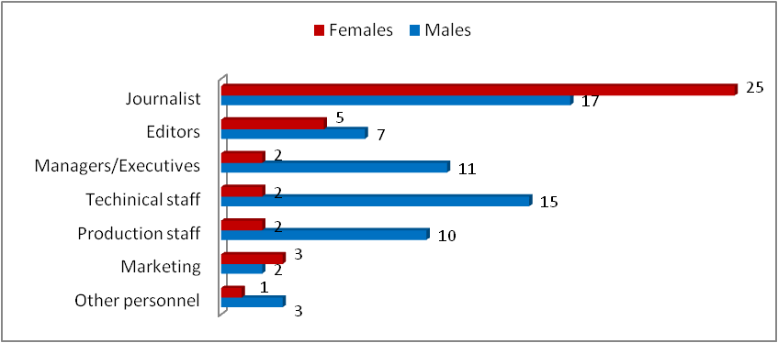

Fourty-nine per cent of the employees in the regional radio stations had completed higher education, while 51% had completed secondary education. None of the regional radio stations reported employees who had completed other levels of education.

## Picture 34: Employee structure of the regional radio stations by education

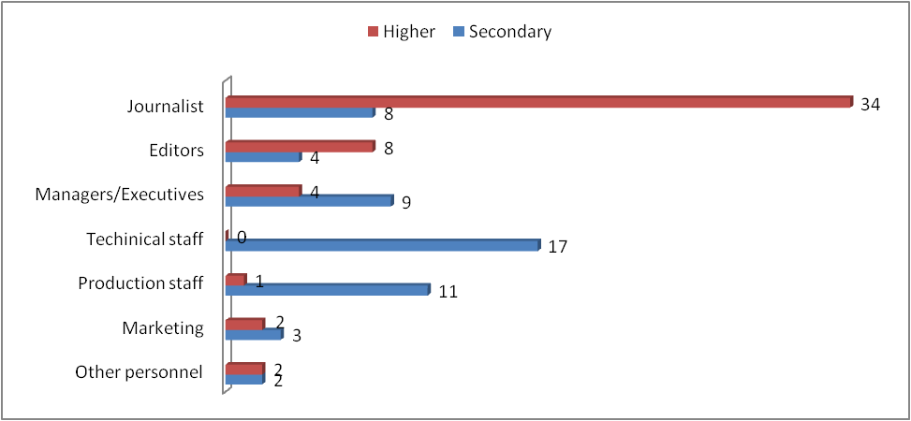

As many as 67% of the higher-educated employees were engaged as journalists. Of these, 22 were women and 12 were men. The persons who had completed secondary education were the most numerous among the technical staff.Namely, 31% of the persons who had completed secondary education were employed as engineers and technicians.

### **2.4. Radio stations at the local level**

The total number of employees in the 52 local radio stations in 2014 amounted to 205 persons, 112 of whom were regularly employed, while 93 were part-time employees. Compared to the previous year, the number of regular employees grew by two, while the number of part-time employees increased by as many as 23.

The radio stations that presented the highest number of employees were the Red FM RA from Tetovo (12) and Skaj Radio Plus from Berovo (eight persons). The Red FM RA also presented the highest number of part-time employees (11), whereas the highest numbers of regular employees were engaged by the Endјels RA and Univerzitetsko UGD FM RA, both from Stip (six persons each).

Тhе Di-Djej RA from Struga did not have any employees, either regular or part-time.

# Table 13: Employee structure of the local radio stations

|  |  |  |  |  |  |  |  |  |  |  |  |  |  |
| --- | --- | --- | --- | --- | --- | --- | --- | --- | --- | --- | --- | --- | --- |
|  |  | Status as on 31.12.2014 | | | | | | | | | | | |
|  | Staff | Total | | Education | | | | | | Status | | | |
| Higher Education | | Secondary education | | Other | | Regular employment | | Part-time | |
| F | M | F | M | F | M | F | M | F | M | F | M |
| 1 | Journalists | 44 | 33 | 38 | 31 | 6 | 2 | 0 | 0 | 18 | 10 | 26 | 23 |
| 2 | Editors | 8 | 18 | 2 | 6 | 6 | 12 | 0 | 0 | 4 | 13 | 4 | 5 |
| 3 | Managers/  Executives | 14 | 28 | 4 | 10 | 10 | 18 | 0 | 0 | 12 | 27 | 2 | 1 |
| 4 | Technical staff  (engineers and technicians) | 12 | 29 | 4 | 6 | 8 | 23 | 0 | 0 | 5 | 16 | 7 | 13 |
| 5 | Production staff (directors, radio recorders, audio editors, etc.) | 0 | 7 | 0 | 3 | 0 | 4 | 0 | 0 | 0 | 5 | 0 | 2 |
| 6 | Marketing | 5 | 2 | 3 | 1 | 2 | 1 | 0 | 0 | 1 | 1 | 4 | 1 |
| 7 | Other personnel | 2 | 3 | 0 | 3 | 2 | 0 | 0 | 0 | 0 | 0 | 2 | 3 |
|  | **TOTAL** | **85** | **120** | **51** | **60** | **34** | **60** | **0** | **0** | **40** | **72** | **45** | **48** |

Just as in the year before, the most numerous in the employee structure were the persons who worked as journalists in these radio stations. Their number in the year under review increased by as many as 25. In particular, the number of regularly employed journalists rose by four, while the number of part-time journalists increased by 21.

## Picture 35: Employee structure of the local radio stations by post



The Ekspres RA from Strumica, Plus Forte RA from Negotino, Red FM RA from Tetovo and Endjels RA from Stip presented the highest numbers of journalists (three each). Twenty-six local radio stations employed two journalists each, 14 employed one each, whereas eight radio stations did not present any employees in this category at all.

## 

## Picture 36: Employee structure of the local radio stations by gender

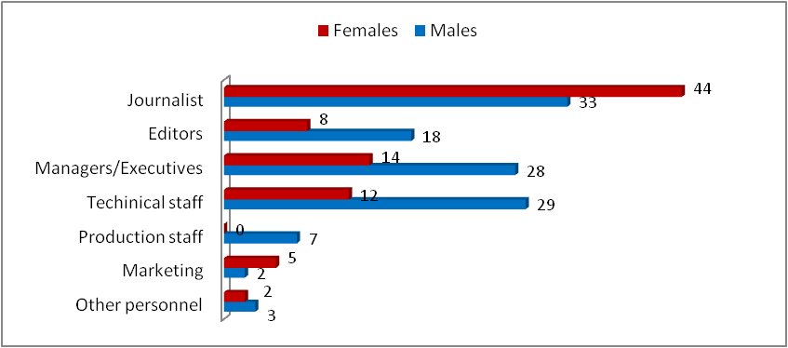

As regards the employees’ gender structure, 41% were women, while 59% were men. More than half of the female employees worked as journalists (44). Men, too, were mostly employed as journalists (33). Not a single female was employed as director, radio recorder, audio editor or other production staff. Among the managers, there were twice fewer women than men.

In this segment of the radio broadcasting industry, the persons who had completed higher education prevailed (54%). More than half of these were engaged as journalists (62%).

Most numerous among the persons who had completed secondary education were the technicians and the engineers. Engaged in this category were 33% of the total number of employees who had completed secondary education.

**Picture 37: Employee structure of the local radio stations by education**

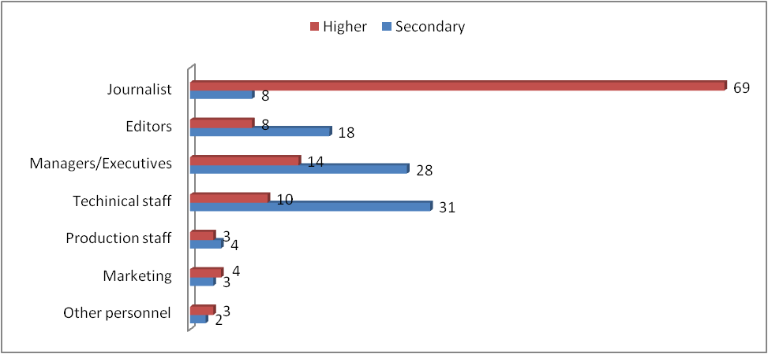

In particular, 60% of women and 50% of man had completed higher education, while 40% of women and 50% of men had completed secondary education. The local radio stations did not employ any persons who had completed other levels of education.

# Table 14: Overview of the employees of all television and radio stations

|  |  |  |  |  |  |  |  |  |  |  |  |  |
| --- | --- | --- | --- | --- | --- | --- | --- | --- | --- | --- | --- | --- |
| No. | Area | Name | Journalists | Editors | Managers/Executives | Technical staff (engineers and technicians) | Production staff (еxecutives, radio recorders, audio editors, etc.) | Marketing | Other personnel | Total | Regularly employed | Part-time employees |
| 1 | national | MTV | 155 | 43 | 3 | 17 | 285 | 4 | 90 | 597 | 597 | 0 |
| 2 | national | TV Alsat-M | 26 | 9 | 3 | 16 | 32 | 6 | 24 | 116 | 98 | 18 |
| 3 | national | TV Alfa | 33 | 6 | 1 | 6 | 54 | 4 | 31 | 135 | 106 | 29 |
| 4 | national | TV Kanal 5 | 39 | 2 | 1 | 25 | 36 | 2 | 52 | 157 | 103 | 54 |
| 5 | national | TV Sitel | 42 | 1 | 1 | 17 | 64 | 0 | 15 | 140 | 140 | 0 |
| 6 | national | TV Telma | 55 | 4 | 1 | 10 | 35 | 2 | 8 | 115 | 85 | 30 |
| 7 | satellite | TV 24 Vesti | 35 | 3 | 1 | 3 | 32 | 1 | 3 | 78 | 69 | 9 |
| 8 | satellite | TV Sitel 3 | 15 | 1 | 1 | 7 | 6 | 0 | 0 | 30 | 0 | 30 |
| 9 | satellite | TV Nasha TV | 14 | 2 | 3 | 3 | 7 | 3 | 9 | 41 | 17 | 24 |
| 10 | satellite | TV Kanal 5 Plus | 14 | 0 | 1 | 15 | 9 | 3 | 18 | 60 | 25 | 35 |
| 11 | satellite | TV Sonce | 12 | 1 | 1 | 1 | 11 | 1 | 6 | 33 | 20 | 13 |
| 12 | regional | TV Amazon | 6 | 0 | 1 | 1 | 2 | 0 | 1 | 11 | 5 | 6 |
| 13 | regional | TV Skajnet | 5 | 1 | 1 | 0 | 3 | 0 | 1 | 11 | 2 | 9 |
| 14 | regional | TV Edo | 5 | 1 | 1 | 1 | 4 | 1 | 0 | 13 | 6 | 7 |
| 15 | regional | TV ERA | 3 | 1 | 0 | 2 | 11 | 4 | 5 | 26 | 13 | 13 |
| 16 | regional | TV MTM | 5 | 1 | 1 | 1 | 2 | 1 | 0 | 11 | 11 | 0 |
| 17 | regional | TV Skopje | 0 | 1 | 0 | 1 | 3 | 0 | 3 | 8 | 8 | 0 |
| 18 | regional | TV Šutel | 5 | 3 | 0 | 2 | 2 | 0 | 2 | 14 | 1 | 13 |
| 19 | regional | TV KTV | 6 | 1 | 1 | 3 | 3 | 1 | 0 | 15 | 12 | 3 |
| 20 | regional | TV Kanal 1 | 3 | 1 | 1 | 1 | 2 | 1 | 3 | 12 | 9 | 3 |
| 21 | regional | TV K Tri | 10 | 2 | 1 | 2 | 5 | 1 | 0 | 21 | 12 | 9 |
| 22 | regional | TV Sitel 2 | 5 | 1 | 1 | 2 | 2 | 0 | 0 | 11 | 6 | 5 |
| 23 | regional | HDTV Kanal Plus | 8 | 1 | 1 | 0 | 2 | 0 | 0 | 12 | 8 | 4 |
| 24 | regional | TV Iris | 7 | 1 | 1 | 5 | 1 | 0 | 4 | 19 | 17 | 2 |
| 25 | regional | TV Star | 6 | 2 | 1 | 1 | 3 | 1 | 1 | 15 | 9 | 6 |
| 26 | regional | TV Vis | 9 | 1 | 1 | 2 | 6 | 1 | 4 | 24 | 10 | 14 |
| 27 | regional | TV Telekanal A1 | 11 | 2 | 1 | 0 | 16 | 0 | 3 | 33 | 30 | 3 |
| 28 | regional | TV Kobra | 5 | 1 | 1 | 2 | 2 | 1 | 1 | 13 | 5 | 8 |
| 29 | regional | HDTV Mega | 9 | 2 | 2 | 0 | 16 | 0 | 1 | 30 | 25 | 5 |
| 30 | regional | TV Vizhn-BM | 4 | 1 | 1 | 3 | 3 | 1 | 0 | 13 | 11 | 2 |
| 31 | regional | TV Uskana | 5 | 1 | 1 | 1 | 1 | 1 | 0 | 10 | 5 | 5 |
| 32 | regional | TV Regionalna TV 02 | 10 | 1 | 1 | 0 | 15 | 0 | 2 | 29 | 29 | 0 |
| 33 | regional | TV Kanal tri | 6 | 1 | 1 | 1 | 10 | 0 | 0 | 19 | 17 | 2 |
| 34 | regional | TV Kiss | 4 | 1 | 1 | 5 | 2 | 0 | 2 | 15 | 15 | 0 |
| 35 | regional | TV Koha | 5 | 1 | 1 | 3 | 2 | 1 | 0 | 13 | 10 | 3 |
| 36 | regional | TV Ultra | 6 | 1 | 1 | 2 | 13 | 0 | 1 | 24 | 14 | 10 |
| 37 | regional | TV Chegrani Media | 2 | 2 | 1 | 1 | 1 | 1 | 2 | 10 | 5 | 5 |
| 38 | Kumanovo | TV Dalga-Krt | 2 | 1 | 1 | 2 | 0 | 1 | 1 | 8 | 4 | 4 |
| 39 | Kumanovo | TV Festa | 3 | 0 | 1 | 1 | 0 | 0 | 0 | 5 | 1 | 4 |
| 40 | Kumanovo | TV Hana | 1 | 1 | 1 | 2 | 0 | 0 | 0 | 5 | 1 | 4 |
| 41 | Kochani | TV Kochani-LD | 3 | 1 | 1 | 1 | 1 | 0 | 0 | 7 | 5 | 2 |
| 42 | Kochani | TV Kanal 8 | 2 | 1 | 1 | 1 | 2 | 1 | 0 | 8 | 8 | 0 |
| 43 | Probishtip | TV Protel | 5 | 0 | 0 | 0 | 1 | 0 | 0 | 6 | 3 | 3 |
| 44 | Radovish | TV Emi | 2 | 1 | 1 | 1 | 0 | 1 | 0 | 6 | 4 | 2 |
| 45 | Strumica | TV Intel | 5 | 2 | 2 | 2 | 2 | 1 | 0 | 14 | 6 | 8 |
| 46 | Gevgelija | TV Nova | 4 | 1 | 1 | 1 | 0 | 0 | 1 | 8 | 3 | 5 |
| 47 | Veles | TV Kanal 21 | 5 | 0 | 0 | 1 | 2 | 1 | 1 | 10 | 6 | 4 |
| 48 | Veles | TV Zdravkin | 3 | 0 | 1 | 1 | 1 | 1 | 0 | 7 | 3 | 4 |
| 49 | Sveti Nikole | TV Svet | 3 | 2 | 1 | 1 | 1 | 0 | 0 | 8 | 6 | 2 |
| 50 | Lazhani | TV Lazhani | 3 | 0 | 1 | 1 | 0 | 0 | 0 | 5 | 2 | 3 |
| 51 | Bitola | TV Orbis | 4 | 1 | 1 | 1 | 2 | 0 | 0 | 9 | 9 | 0 |
| 52 | Bitola | TV Tera | 7 | 1 | 1 | 3 | 6 | 1 | 3 | 22 | 18 | 4 |
| 53 | Ohrid | TV Moris | 4 | 0 | 1 | 0 | 1 | 2 | 0 | 8 | 3 | 5 |
| 54 | Ohrid | TV M | 6 | 2 | 1 | 3 | 3 | 1 | 5 | 21 | 13 | 8 |
| 55 | Struga | TV Kaltrina | 4 | 0 | 1 | 2 | 0 | 0 | 1 | 8 | 5 | 3 |
| 56 | Labunishta | TV Spektra | 1 | 1 | 1 | 0 | 2 | 0 | 0 | 5 | 5 | 0 |
| 57 | Debar | TV Dibra | 3 | 1 | 1 | 1 | 0 | 0 | 0 | 6 | 5 | 1 |
| 58 | Kichevo | TV Gurra | 3 | 1 | 1 | 0 | 1 | 1 | 0 | 7 | 2 | 5 |
| 59 | Plasnica | TV Anisa | 2 | 1 | 1 | 1 | 0 | 0 | 0 | 5 | 2 | 3 |
| 60 | Tetovo | TV Art | 13 | 2 | 1 | 7 | 5 | 2 | 2 | 32 | 5 | 27 |
| 61 | Tetovo | TV Super Skaj | 2 | 0 | 1 | 0 | 1 | 0 | 0 | 4 | 1 | 3 |
| 62 | Gostivar | TV Due | 2 | 1 | 1 | 1 | 1 | 0 | 0 | 6 | 4 | 2 |
| 63 | Gostivar | TV G-TV | 1 | 1 | 1 | 1 | 1 | 0 | 0 | 5 | 4 | 1 |
| 64 | national | MRA | 74 | 45 | 2 | 4 | 88 | 2 | 40 | 255 | 255 | 0 |
| 65 | national | RA Antena 5 | 10 | 1 | 1 | 2 | 7 | 1 | 2 | 24 | 14 | 10 |
| 66 | national | RA Kanal 77 | 16 | 1 | 3 | 5 | 2 | 3 | 2 | 32 | 8 | 24 |
| 67 | national | RA Metropolis | 5 | 2 | 1 | 2 | 2 | 0 | 1 | 13 | 10 | 3 |
| 68 | national | RA Slobodna Makedonija | 33 | 2 | 1 | 2 | 3 | 1 | 1 | 43 | 15 | 28 |
| 69 | Skopje | RA Arachina | 2 | 1 | 1 | 0 | 0 | 0 | 0 | 4 | 1 | 3 |
| 70 | Skopje | RA Buba Mara | 2 | 1 | 1 | 2 | 1 | 1 | 2 | 10 | 5 | 5 |
| 71 | Skopje | RA Vat | 3 | 1 | 1 | 1 | 1 | 1 | 1 | 9 | 2 | 7 |
| 72 | Skopje | RA Zona M-1 | 3 | 1 | 1 | 2 | 2 | 2 | 0 | 11 | 1 | 10 |
| 73 | Skopje | RA Urban | 0 | 0 | 0 | 0 | 0 | 0 | 0 | 0 | 0 | 0 |
| 74 | Skopje | RA Klub FM | 3 | 0 | 1 | 0 | 1 | 0 | 0 | 5 | 5 | 0 |
| 75 | Skopje | RA Lajf FM | 1 | 1 | 1 | 1 | 0 | 0 | 0 | 4 | 4 | 0 |
| 76 | Skopje | RA Rosa AB | 4 | 1 | 1 | 1 | 0 | 0 | 0 | 7 | 6 | 1 |
| 77 | Skopje | RA RFM | 3 | 1 | 1 | 1 | 1 | 0 | 0 | 7 | 0 | 7 |
| 78 | Skopje | RA Siti | 3 | 0 | 0 | 1 | 1 | 0 | 0 | 5 | 5 | 0 |
| 79 | Skopje | RA Skaj | 2 | 1 | 1 | 1 | 1 | 0 | 1 | 7 | 5 | 2 |
| 80 | Skopje | RA Strit | 2 | 1 | 0 | 2 | 0 | 0 | 0 | 5 | 3 | 2 |
| 81 | Skopje | RA Sportsko 90,3 FM | 5 | 1 | 1 | 2 | 0 | 0 | 0 | 9 | 6 | 3 |
| 82 | Skopje | RA Univerzitetsko STUDENT FM 92.9 | 4 | 2 | 0 | 0 | 2 | 0 | 0 | 8 | 0 | 8 |
| 83 | Skopje | RA Kapitol | 2 | 0 | 1 | 1 | 0 | 1 | 0 | 5 | 1 | 4 |
| 84 | Skopje | RA Fortuna | 3 | 0 | 1 | 2 | 2 | 0 | 0 | 8 | 8 | 0 |
| 85 | Skopje | RA Djez FM | 0 | 0 | 1 | 0 | 0 | 0 | 0 | 1 | 1 | 0 |
| 86 | Berovo | Skaj Radio Plus | 1 | 2 | 1 | 2 | 1 | 1 | 0 | 8 | 2 | 6 |
| 87 | Bitola | RA 106 | 2 | 0 | 0 | 2 | 1 | 0 | 0 | 5 | 3 | 2 |
| 88 | Bitola | RA Aktuel | 2 | 1 | 1 | 2 | 0 | 0 | 0 | 6 | 2 | 4 |
| 89 | Bitola | RA B-97 | 1 | 1 | 1 | 2 | 0 | 0 | 0 | 5 | 1 | 4 |
| 90 | Bitola | RA Delfin | 2 | 0 | 1 | 2 | 0 | 0 | 0 | 5 | 1 | 4 |
| 91 | Bitola | RA Univerzitetsko UKLO FM | 1 | 1 | 0 | 1 | 0 | 0 | 0 | 3 | 2 | 1 |
| 92 | Valandovo | RA Valandovo | 0 | 1 | 2 | 0 | 0 | 0 | 0 | 3 | 3 | 0 |
| 93 | Veles | RA Goldi | 2 | 0 | 0 | 1 | 0 | 1 | 0 | 4 | 1 | 3 |
| 94 | Veles | RA Merak 5 FM | 1 | 0 | 1 | 1 | 0 | 0 | 0 | 3 | 3 | 0 |
| 95 | Vinica | RA La Kosta | 0 | 1 | 1 | 1 | 0 | 0 | 0 | 3 | 1 | 2 |
| 96 | Gostivar | RA Kometa | 2 | 0 | 1 | 0 | 0 | 0 | 0 | 3 | 1 | 2 |
| 97 | Gostivar | RA PRO-FM | 2 | 1 | 0 | 1 | 0 | 0 | 0 | 4 | 0 | 4 |
| 98 | Gevgelija | RA Tajm | 2 | 1 | 1 | 2 | 0 | 0 | 0 | 6 | 4 | 2 |
| 99 | Debar | RA Merlin | 1 | 0 | 1 | 1 | 0 | 0 | 0 | 3 | 1 | 2 |
| 100 | Delchevo | RA Zora | 1 | 0 | 1 | 0 | 0 | 0 | 0 | 2 | 2 | 0 |
| 101 | Zhirovnica | RA Emi | 1 | 0 | 1 | 0 | 0 | 0 | 0 | 2 | 0 | 2 |
| 102 | Kavadarci | RA Galaksi-2002 | 2 | 0 | 1 | 0 | 0 | 0 | 0 | 3 | 3 | 0 |
| 103 | Kavadarci | RA Kavadarci | 2 | 0 | 1 | 0 | 0 | 1 | 1 | 5 | 2 | 3 |
| 104 | Kichevo | RA Aleksandar Makedonski | 0 | 0 | 1 | 0 | 0 | 0 | 0 | 1 | 1 | 0 |
| 105 | Kichevo | RA Akord | 2 | 0 | 1 | 1 | 0 | 0 | 0 | 4 | 1 | 3 |
| 106 | Kichevo | RA Medison | 2 | 0 | 1 | 0 | 0 | 0 | 0 | 3 | 2 | 1 |
| 107 | Kichevo | RA Uskana-Plus | 2 | 1 | 1 | 0 | 0 | 0 | 0 | 4 | 3 | 1 |
| 108 | Kochani | RA Kochani FM | 0 | 1 | 1 | 0 | 0 | 0 | 0 | 2 | 2 | 0 |
| 109 | Kumanovo | RA Aljbana | 2 | 1 | 1 | 1 | 0 | 1 | 0 | 6 | 3 | 3 |
| 110 | Kumanovo | RA Bravo | 2 | 0 | 1 | 1 | 0 | 0 | 0 | 4 | 4 | 0 |
| 111 | Kumanovo | RA Jehona | 2 | 1 | 0 | 0 | 0 | 0 | 0 | 3 | 2 | 1 |
| 112 | Kumanovo | RA KMR | 1 | 1 | 1 | 1 | 0 | 0 | 0 | 4 | 2 | 2 |
| 113 | Negotino | RA Puls | 1 | 0 | 1 | 1 | 0 | 0 | 0 | 3 | 1 | 2 |
| 114 | Ohrid | RA Lav | 2 | 0 | 1 | 0 | 0 | 0 | 0 | 3 | 1 | 2 |
| 115 | Ohrid | RA MH | 1 | 2 | 0 | 0 | 0 | 1 | 1 | 5 | 3 | 2 |
| 116 | Ohrid | RA Ohrid | 1 | 1 | 1 | 1 | 1 | 0 | 0 | 5 | 2 | 3 |
| 117 | Ohrid | RA Super | 2 | 0 | 1 | 1 | 0 | 0 | 0 | 4 | 4 | 0 |
| 118 | Pehchevo | RA Pehchevo | 2 | 1 | 0 | 1 | 0 | 0 | 0 | 4 | 1 | 3 |
| 119 | Prilep | RA 5 Choki | 0 | 0 | 1 | 1 | 0 | 0 | 0 | 2 | 2 | 0 |
| 120 | Prilep | RA Meff | 2 | 1 | 1 | 1 | 0 | 0 | 0 | 5 | 1 | 4 |
| 121 | Prilep | RA Holidej | 1 | 0 | 1 | 2 | 0 | 0 | 0 | 4 | 3 | 1 |
| 122 | Probishtip | RA Eko | 2 | 0 | 0 | 0 | 1 | 0 | 0 | 3 | 2 | 1 |
| 123 | Sv. Nikole | RA Modea | 1 | 0 | 1 | 1 | 0 | 0 | 0 | 3 | 2 | 1 |
| 124 | Sv.Nikole | RA Sveti Nikole | 2 | 0 | 0 | 1 | 0 | 0 | 0 | 3 | 3 | 0 |
| 125 | Struga | RA Di-Djej | 0 | 0 | 0 | 0 | 0 | 0 | 0 | 0 | 0 | 0 |
| 126 | Struga | RA Drini | 1 | 0 | 1 | 1 | 0 | 0 | 0 | 3 | 1 | 2 |
| 127 | Struga | RA MI NI | 2 | 0 | 1 | 0 | 0 | 0 | 0 | 3 | 1 | 2 |
| 128 | Struga | RA Rrapi | 2 | 0 | 1 | 0 | 0 | 1 | 0 | 4 | 3 | 1 |
| 129 | Strumica | RA Ekspres | 3 | 0 | 1 | 1 | 0 | 0 | 0 | 5 | 5 | 0 |
| 130 | Strumica | RA Hit | 0 | 1 | 1 | 1 | 0 | 0 | 0 | 3 | 3 | 0 |
| 131 | Tetovo | RA Bleta | 2 | 0 | 1 | 1 | 0 | 0 | 0 | 4 | 2 | 2 |
| 132 | Tetovo | RA Kiss | 0 | 1 | 1 | 1 | 0 | 0 | 0 | 3 | 3 | 0 |
| 133 | Tetovo | RA Plus Forte | 3 | 1 | 0 | 0 | 0 | 0 | 0 | 4 | 1 | 3 |
| 134 | Tetovo | RA Fama | 2 | 0 | 1 | 0 | 1 | 0 | 0 | 4 | 2 | 2 |
| 135 | Tetovo | RA Red FM | 3 | 2 | 1 | 2 | 0 | 1 | 3 | 12 | 1 | 11 |
| 136 | Shtip | RA Endjels FM | 3 | 1 | 1 | 1 | 0 | 0 | 0 | 6 | 6 | 0 |
| 137 | Shtip | RA Univerzitetsko UGD FM | 2 | 1 | 1 | 1 | 1 | 0 | 0 | 6 | 6 | 0 |

Title Analysis of Employee Structure

in the Audio and Audiovisual Media Sector in 2014

Published by: Agency for Audio and Audiovisual Media Services

Address: Palata Panko Brashnarov, ul. Makedonija br. 38, 1000 Skopje

Tel. 02/3103-400

[www.avmu.mk](http://www.avmu.mk)

[contact@avmu.mk](mailto:contact@avmu.mk)

For the publisher: Zoran Trajcevski, PhD, Director

Prepared by: Valide Jashari

Magdalena Davidovska-Dovleva

1. In 2014, a total of 27 television stations broadcasted programme at the regional level. This analysis presents data about 26 of these, due to the fact that the BTR TV lost its television broadcasting license in March 2015.
2. A total of 27 television stations broadcasted programme at the local level throughout the entire 2014. However, this analysis presents data about the employee structure in 26 television stations, due to the fact that the license of the Nova TV from Kumanovo ceased to be valid in January 2015.