**New Broadcaster Report Forms on Meeting the Obligations Laid Down in the TV and Radio Broadcasting Licenses**

At its 7th session held on 1 March 2021, the Agency Council adopted new report forms to be filled in by the broadcasters regarding their meeting of the obligations laid down in their radio and television broadcasting licenses. In accordance with the provisions of Article 15, Paragraph 5, of the Law on Media, broadcasters are obliged to submit reports to the Agency for Audio and Audiovisual Media Services, using special forms, no later than 31 March 2021, on their meeting of the obligations laid down in their radio or television broadcasting licenses, especially those concerning their programme concepts. In addition to the reports, they should submit information on the technical means used to broadcast or transmit their programme services in the country and abroad. The new forms on meeting the obligations laid down in the radio and TV broadcasting licenses are available at [www.avmu.mk](http://www.avmu.mk)

**Financial Support Extended to Compensate Funds Paid for the Radio and TV Broadcasting License Fees**

Based on the Decision of the Government under the fifth package of economic measures providing financial assistance to broadcasters in the amount of MKD 50,000,000.00, at its 7th session held on 1 March 2021, the Agency Council decided to suspend all initiated procedures for revoking licenses due to failures to pay the annual radio and television broadcasting fees. At the same time, it was decided not to initiate new revoking procedures for non-payment of the 2021 license fees.

To all broadcasters, who had made full or partial payment of the radio or television broadcasting license fee for 2021, the Agency refunded the amounts. The broadcasters who have been issued invoices for the annual license fees, but have not paid them yet, as well as broadcasters who are yet to receive an invoice, have no obligation to pay because their obligation is fully met with the funds from the package of economic measures.

Additionally, the Agency informed the broadcasters that the issued invoices for the annual television and radio broadcasting license fee in 2021 would serve for their records only and they would not be able to refund the value added tax, as these had been paid in full from the funds approved under the Decision of the Government of RNM. Within 15 days from the completion of these activities, the Agency will submit a report to the Government of the RNM and the Public Revenue Office regarding the utilised funds from the package of economic measures, while the remaining unused funds shall be returned to the Budget of the Republic of North Macedonia.

**Gender in the 2020 Election Campaign in the Spotlight of AAAVMS’ First Public Meeting in 2021**

**[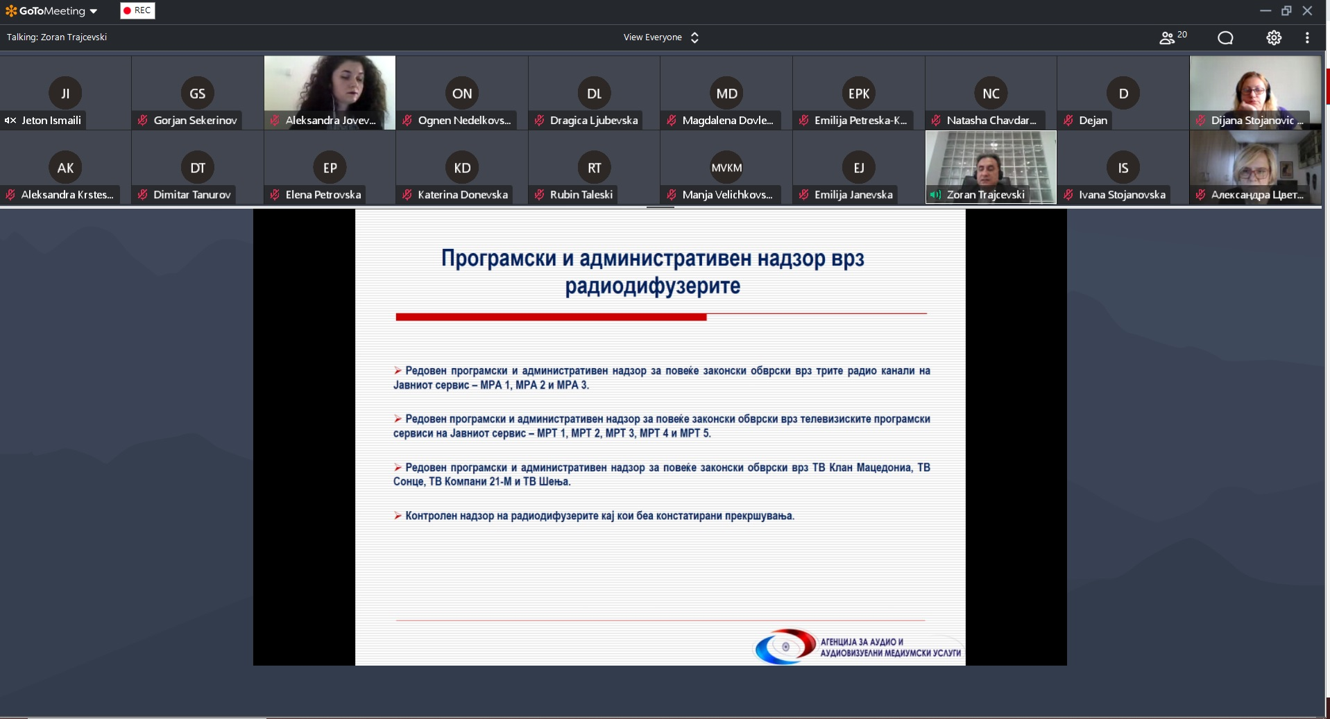](https://avmu.mk/wp-content/uploads/2021/03/%D1%98%D0%B0%D0%B2%D0%B5%D0%BD-%D1%81%D0%BE%D1%81%D1%82%D0%B0%D0%BD%D0%BE%D0%BA-2.jpg)**

Also presented at the meeting were the findings of the analysis of gender issues and the manner of depicting and presenting women and men in the news aired by the national television services – MRT1, MRT2, Alsat-M TV, Alfa TV, Kanal 5 TV, Sitel TV and Telma TV, during the election campaign for the 2020 Early Parliamentary Elections. The analysis was conducted for the needs of the Agency by the “Societas Civilis” Institute for Democracy from Skopje.

The findings of the analysis showed that the media coverage of the election campaign was remarkably prone towards promoting the male MP candidates and the male perspective and expertise on the developments relating to the elections. The female candidates were overshadowed by their male counterparts, had less access to the various forms of promotion for their platforms, and their profiles and messages remained anonymous, i.e. unheard and unseen by the public. In the items reporting on the election campaign, out of a total of 134 political party representatives 128 were men, as opposed to 6 women. In the daily news programmes dedicated to election topics, of those who appeared as primary subjects 86% were men, as opposed to 14% of women. The qualitative analysis of the content of the daily news programmes, among other things, showed that in a total of 9 news items the representation of women was sexually objectified, while 6 reports involved stereotyping based on the gender roles presumed by the society. The entire analysis is available at the following website: [www.avmu.mk](http://www.avmu.mk).

**March 2021 No.3**

On 25 March 2021, the Agency for Audio and Audiovisual Media Services held a public meeting. Due to the ongoing coronavirus pandemic, the meeting was held using video conference connection. At the meeting, the Director of the Agency, Dr. Zoran Trajchevski, presented a summary of the activities implemented in the past three months in line with the Agency’s Annual Work Programme. Those attending had an opportunity to hear about the conducted supervising activities over the broadcasters, operators of public electronic communication networks, the print media publishers, as well as about the imposed public warning measures, conducted research activities and activities in the field of international cooperation.

**Supervisions over Broadcasters, Print Media Outlets and Operators of Public Electronic Communication Networks**

**Broadcasters**

The Agency performed programme supervision for the observance of the rules for juvenile audience protection, regarding the series titled "Angels" which is broadcasted by Sitel TV. The supervision of this programme found that the premieres and reruns of the feature series "Angels" had been incorrectly categorized and marked as Category 2 Programme (+8), and that the reruns had been aired at an inappropriate time of the day.

Regular programme and administrative supervision concerning several legal obligations was performed on TV 24 Vesti, TV Alfa, Nasha TV, TV Telma, TV Alsat-M, TV Kanal 5, TV Alfa, TV Sitel and the programme services of MRT 1, MRT 2, MRT 3 , MRT 4 and MRT 5. Subject to supervision were the rules for broadcasting audiovisual commercial communications, minors’ protection, use of value-added telephone services and telephone voting, broadcasting games of chance and providing quizzes or other forms of prize-winning participation, obligations concerning the language use in the programmes, broadcast of at least 12 hours of programme a day, broadcasting of at least 30% – and, in the case of the Public Broadcaster at least 40% - of originally created programme, publishing of Impressums, information that should be made available to the users, and publishing of the broadcaster’s identification sign.

The supervision detected several violations. The programme services of MRT 2, MRT 3, MRT 4 and MRT 5 had failed to provide the information that should be made available to the users, i.e. data such as their headquarters’ address, contact information, the responsible person, and data on the regulatory body. MRT 3 and MRT 4, in some of the programmes they had broadcasted, had failed to publish data on the authors who had prepared the contents, as well as data on the editorial staff, the origin and date of production of the works, the name of the media outlet where the content had been taken from, and other data that they are obliged to broadcast at an appropriate spot for each content of their programming services. The programme service of MRT 4 had failed to broadcast at least 40% of the programme originally created as Macedonian audiovisual works per day. MTV 2 and MTV 5 were found to have violated the obligation to protect juvenile audience, i.e. they had aired promotional announcements for a feature programme without having marked they by signalization ensuring the protection of minors.

The first part of the episode of the feature series titled "Truths or Lies" was broadcast on the Alpha TV programme, originally in Serbian, without a Macedonian translation being provided.

After the pronounced public warning measure, issued due to failure to comply with the rules for broadcasting audiovisual commercial communications, control programme supervision was performed over Zdravkin TV from Veles. The supervision showed that the decision on imposing a public warning measure had been acted upon in full.

**Print Media Outlets**

In order to determine whether the print media outlets “Ubavina i zdravje” and “Ruski doktor” had published Impressum data, the Agency conducted an ad hoc administrative supervision. During the supervision it was concluded that, in its edition No. 147, Ubavina I Zdravje had not met this obligation under the Law on Media in full, i.e. the address of the printing house had not been published.

**Operators of Public Electronic Communication Networks**

As regards the obligations related to the registration of programme services with the Agency and providing subtitles of the programmes that are retransmitted by the operators, regular programme supervision was performed on the operators Kablekall from Kichevo, Skrembel and Signal-Net from Kumanovo and Telenet Kom from Tetovo. The supervision concluded that the operator Signal-Net from Kumanovo had been retransmitting the programme service of "ZICO TV" which had not been covered by the programme service registration certificate issued by the Agency.

The Agency performed control programme supervision on the operator Infel-KTV from Ohrid to determine whether the operator had acted upon the public warning measure issued due to retransmission of programme services not registered with the Agency, in accordance with Article 141 of LAAVMS. The supervision showed that the operator Infel-CTV had fully acted upon the decision sent by the Agency.

**Public Warning Measures Imposed Against Broadcasters**

The Agency Council adopted 12 Decisions on Imposing Public Warning Measures at its 8th session held on 16 March 2021, based on reports from conducted supervisions that had detected violations against the law.

A public warning for not publishing an Impressum was issued against the programme services of MRT 3, MRT 4 and TV Klan Macedonia. A public warning measure was issued against MRT 2, MRT 5 and Iris TV for non-compliance with the rules for juvenile audience protection. Information that has to be made available to the users was not provided by MRT 2, MRT 3, MRT 4 and MRT 5, while the obligation to meet the quota for programme originally created as Macedonian audiovisual works was not fulfilled by TV Company 21-M and MRT 4.

After the expiration of the deadline for legal compliance, all television services will be subject to control supervision to determine whether they have acted upon the public warning measures that have been issued against them.





**АГЕНЦИЈА ЗА АУДИО И АУДИОВИЗУЕЛНИ МЕДИУМСКИ УСЛУГИ**

**РЕПУБЛИКА СЕВЕРНА МАКЕДОНИЈА**

**ул. Македонија бр. 38, 1000 Скопје**

**тел. (02) 3103400 факс: (02) 3103401**

**е-пошта:** [**contact@avmu.mk**](mailto:contact@avmu.mk) **веб страница:** [**www.avmu.mk**](http://www.avmu.mk)