**LOCAL ELECTIONS 2021**

**Guidelines Adopted on Paid Political Avertising**

**On 1 September 2021**, the Agency Council adopted the Draft Guidelines on Paid Political Advertising for the 2021 Local Elections, which specified the manner of implementing Article 75-f, Paragraphs 1 and 2, of the Electoral Code for this electoral process. A 15-day long public hearing was opened on the Draft Guidelines, until 16 September 2021, in which both the political parties and the independent candidates, as well as the broadcasters and all other interested entities, were asked to express their opinions. The procedure for adopting these Guidelines in their final form, was halted, since, on 15 September, the Parliament adopted amendments to the Electoral Code, including Article 75-f.

In accordance with the amendments to the Electoral Code, on 21 September, the Agency Council adopted new Guidelines on Paid Political Advertising for the 2021 Local Elections. After their adoption and announcement on the Agency’s website, complaints were filed by the Levica (Left) political party and the Liberal Democratic Party (LDP) about Point 3, Paragraph 1, Indent 3 of the Guidelines, concerning the list submitters that could use the 1 minute of air time per clock hour of broadcasted radio and television programme for paid political advertising. Having in mind the complaints received and the diverse interpretations caused by Article 75-f, Paragraph 1, of the Electoral Code, on 24 September, the Agency Council adopted Point 3, Paragraph 1, Indent 3new [Guidelines on Paid Political Advertising for the 2021 Local Elections](https://avmu.mk/wp-content/uploads/2021/09/Upatstvo-za-PPR-za-lokalnite-izbori-2021-precisten-tekst.pdf), which do not name the list submitters that have the right to use the one minute of clock hour for paid political advertising.

**First Monitoring Report on Broadcasters’ Election Coverage Published**

**On 9 September 2021, the** Agency published the First Report on Monitoring the Media Coverage of the Local Elections aired in the period preceding the start of the election campaign (7-31 August 2021). The Report did not state any violations against the provisions of the Electoral Code. It analyzed the 24-hour programmes aired by the first television programme channel of the Public Broadcasting Service – MRT1 and by six commercial television stations at the state level that have an average weekly reach of above 10% – 24 Vesti TV, Alsat-M TV, Alfa TV, Kanal 5 TV, Sitel TV and Telma TV.

The monitoring showed, among other things, that that, in their daily news programmes, the media outlets most often covered current topics in the form of news items (in a series) and in reports, which were clearly structured and stated verifiable sources of information; however, at times, the TV journals of certain television stations also aired items realized through unclear, hybrid genre forms, as combinations of information and attempts to make a summary, anticipate and analyze certain more complex social phenomena. In some of these cases, there was not even a clear distinction between the party views and the professional editorial viewpoints. There was also the noticeable practice of “quoting” statements made on the social networks, which in themselves were often either irrelevant or unverifiable. The details on each media outlet in particular, can be found in [The First Report on Monitoring the Media Coverage of the 2021 Local Elections.](https://avmu.mk/wp-content/uploads/2021/09/%D0%9F%D1%80%D0%B2-%D0%98%D0%97%D0%92%D0%95%D0%A8%D0%A2%D0%90%D0%88-%D0%9F%D1%80%D0%B5%D0%B4%D0%B8%D0%B7%D0%B1%D0%BE%D1%80%D0%B8%D0%B5-%D1%84%D0%B8%D0%BD%D0%B0%D0%BB%D0%B5%D0%BD-1.docx)

**New Rules Announced on the Price Lists for Paid Political Advertising**

**On 17 September 2021,** the Agency informed the broadcasters that the newly adopted amendments and supplements to the Electoral Code had stipulated a new method for establishing the pricelists for broadcasting paid political advertising (PPA), that would apply to the Local Elections 2021 as well. Due to this, an additional deadline was set for submitting the price lists, until 19 September 2021, 24:00 hrs.

According to the amendments to Article 75-f of the Electoral Code, broadcasters should determine their own average price (arithmetic mean) per second per day, obtained based on different advertising-price time periods for broadcasting PPA, as follows: Period 1 – from 00:00 hrs to 08:00 hrs, Period 2 – from 08:00 hrs to 16:00 hrs, and Period 3 – from 16:00 hrs to 24:00 hrs. This price must not exceed the total average price for advertising set by each of the broadcasters separately, calculated by taking into account the last five election cycles held at the level of the entire territory of the country.

The Agency pointed out that broadcasters that had already been registered with the SEC should not submit new requests – they are obliged to submit only their new (amended) price lists. All other broadcasters that had not been included in the SEC’s Register previously, had the right to submit new requests with SEC and to register for PPA broadcasting. Those broadcasters who would fail to act in tune with the new legal amendments on time, would lose their right to be registered for paid political advertising.

**September 2021 No. 9**

**Analysis of the Employee Structure in the Audio and Audiovisual Media Industry in 2020 Published**

The Agency for Audio and Audiovisual Media Services made an [Analysis of the Employee Structure in the Audio and Audiovisual Media Industry in 2020](https://avmu.mk/wp-content/uploads/2021/09/Struktura-na-vrabotenite-vo-2020-godina.pdf),and published it on its website on 29 September 2021.

This analysis presents the number and structure of employees in the audio and audiovisual media industry in 2020. The employee structure has been analyzed in terms of the jobs they had been hired at, their employment status (regular or part-time employment), their sex, level of education and ethnicity.

**AAAVMS Donates Aid to Tetovo Hospital Victims’ Families**

The Agency Council adopted a Conclusion at its 25th session in 2021, to donate one-time financial aid to the families of the deceased in the fire that broke out last night at the modular hospital for Covid-19 patients in Tetovo, to the amount of MKD 60,000 per family.

The funds were transferred to a specially dedicated account opened by the Red Cross of the RNM. The Agency for Audio and Audiovisual Media Services expressed its deepest condolences to the families of the deceased.

# **Market Analysis of TV and Radio Industries in the Spotlight of AAAVMS’ Public Meeting**

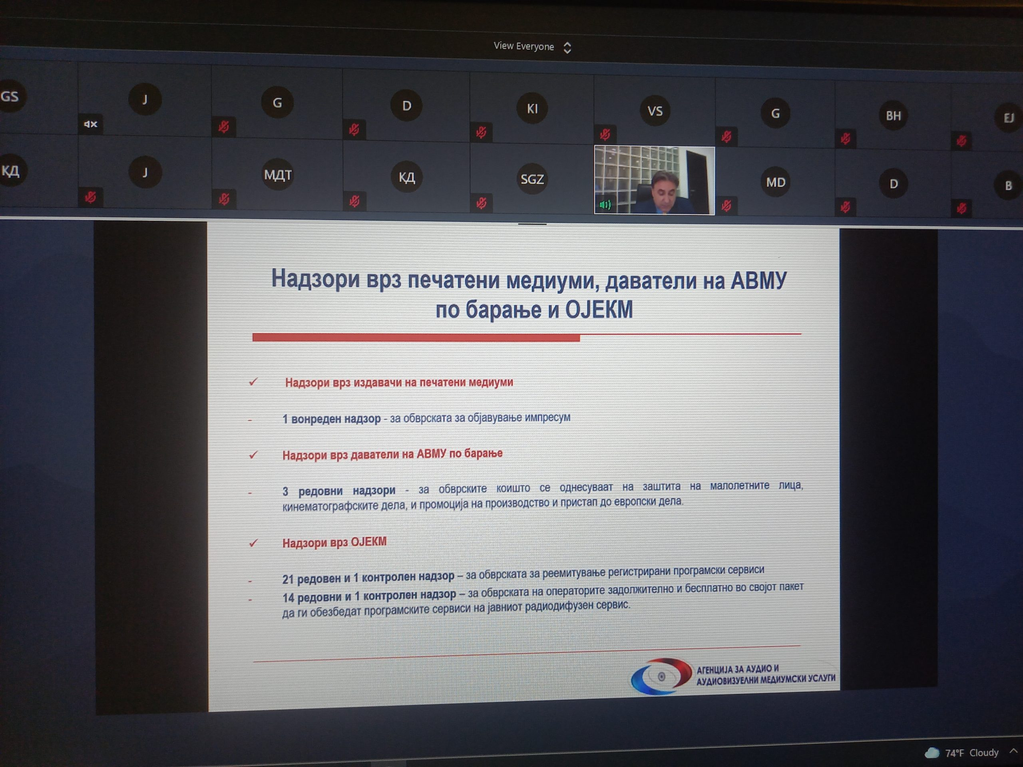The Agency for Audio and Audiovisual Media Services held a public meeting on 28 September 2021, using the video conferencing option due to the Covid-19 pandemic. At the meeting, Agency Director Dr. Zoran Trajcevski presented a summary of the activities carried out in accordance with the Annual Work Programme for the past three months.

Those attending had an opportunity to get acquainted with the activities related to the monitoring of the broadcasters’ coverage of the local elections, the supervisions carried out over certain broadcasters, operators of public electronic communication networks, providers of on-demand AVM services, print media publishers, the public warning measures imposed, the prepared surveys and the activities in the field of international cooperation.

Also presented at the meeting were the findings of the Market Analysis of Audio and Audiovisual Media Services Industry in 2020, which covers the economic operations of the public broadcasting service and the commercial television and radio stations, as well as data obtained from the television and radio audience measurements. According to the data obtained, the revenues that all broadcasters generated together in 2020 amounted to MKD 2,382.61 million, which is the lowest revenue earned in the last five years. More than half of these were revenues earned by the commercial television stations – MKD 1,217.88 million (51.12%). The Public Broadcaster earned revenues amounting to MKD 1,012.19 (42.48%), while the revenues of the commercial radio stations totaled MKD 152.54 million (6.4%). The total expenditures in the industry amounted to Denar 2,415.78 million. The commercial television stations produced negative financial results, whereas the commercial radio stations and the public broadcasting service made profit. The financial results of the operations in the industry in 2020 showed a loss of MKD 34.68 million.

The complete analysis is available on the Agency’s website,  at the following [link.](https://avmu.mk/wp-content/uploads/2021/09/%D0%90%D0%BD%D0%B0%D0%BB%D0%B8%D0%B7%D0%B0-%D0%BD%D0%B0-%D0%BF%D0%B0%D0%B7%D0%B0%D1%80%D0%BE%D1%82-%D0%BD%D0%B0-%D0%B0%D1%83%D0%B4%D0%B8%D0%BE-%D0%B8-%D0%B0%D1%83%D0%B4%D0%B8%D0%BE%D0%B2%D0%B8%D0%B7%D1%83%D0%B5%D0%BB%D0%BD%D0%B8-%D0%BC%D0%B5%D0%B4%D0%B8%D1%83%D0%BC%D1%81%D0%BA%D0%B8-%D1%83%D1%81%D0%BB%D1%83%D0%B3%D0%B8-%D0%B7%D0%B0-2020-%D0%B3%D0%BE%D0%B4%D0%B8%D0%BD%D0%B0.pdf)

денари.

Целата анализа е достапна на веб страницата на Агенцијата на следниот[линк.](https://avmu.mk/wp-content/uploads/2021/09/%D0%90%D0%BD%D0%B0%D0%BB%D0%B8%D0%B7%D0%B0-%D0%BD%D0%B0-%D0%BF%D0%B0%D0%B7%D0%B0%D1%80%D0%BE%D1%82-%D0%BD%D0%B0-%D0%B0%D1%83%D0%B4%D0%B8%D0%BE-%D0%B8-%D0%B0%D1%83%D0%B4%D0%B8%D0%BE%D0%B2%D0%B8%D0%B7%D1%83%D0%B5%D0%BB%D0%BD%D0%B8-%D0%BC%D0%B5%D0%B4%D0%B8%D1%83%D0%BC%D1%81%D0%BA%D0%B8-%D1%83%D1%81%D0%BB%D1%83%D0%B3%D0%B8-%D0%B7%D0%B0-2020-%D0%B3%D0%BE%D0%B4%D0%B8%D0%BD%D0%B0.pdf)

**Press Release – Broadcasters to Adjust their Programmes during the National Days of Mourning**

Due to the tragedy that had taken place in the modular hospital for Covid-19 patients in Tetovo, the Government of the RNM declared September  9, 10 and 11, 2021 as the national days of mourning.

The Agency for Audio and Audiovisual Media Services issued a press release calling on the broadcasters to adjust their programmes to the declared days of mourning in the way that they should reschedule the entertainment shows, comedy shows or feature programme of the comic genre scheduled for these three days on some other days of the week.The press release also stated that the music to be aired during these three days should belong to music genres suitable for days of mourning. If the already concluded contracts allowed so, the Agency recommended that no advertisements be aired during these three days.

**Supervision over Broadcasters, Operators of PECNs, Providers of On-Demand AVMS and Print Media**

**Broadcasters**

An ad hoc administrative supervision was conducted regarding the observance of the obligations arising from Rulebook on Minimum Technical,Spatial, Financial and Staffing Conditions for Obtaining a Radio or Television Broadcasting License, over the following broadcasters: RA Balkan FM, TV G-Television, RA Mapedito-Mef, RA Buba-Mara, RA Holiday, TV Due, TV Kanal 8, City Radio and TV Protel. The supervision showed that these broadcasters had met the minimum staffing conditions set out in the Rulebook.

**Operators of Public Electronic Communication Networks**.

As regards the obligation of the operators of PECNs that retransmit programme services to include, free of charge and as a must, the programme services of the public broadcaster in their own programme packages, regular programme supervision was performed over 14 operators. The supervision found that this obligation had been met on the part of all operators covered by the supervision.

With regard to the obligations related to the operators’ registration of their programme services with the Agency, as well as the provision of subtitles for the programmes they retransmit, regular programme supervision was performed on the following operators: Kabel, Globalsat, Pet Net, Altra Sat 2000, Transped Trade, Makedonski Telekom, A1 Makedonija, Signal-Net and Drim Sat IPTV. The supervision concluded that the operators had acted in accordance with the legal obligations.

The Agency performed control programme supervision over Kabel-Net from Strumica, to determine whether it had acted upon the previously pronounced warning measure for retransmission of programme services that had not been registered with the Agency. The supervision showed that the operator had fully acted upon the previously imposed measure.

**Providers of On-Demand AVMS**

The Agency conducted regular programme supervision over the provider of on-demand audiovisual media services NEOTEL from Skopje, concerning its obligations related to the protection of minors, cinematographic works, and promoting the production of and access to European works. No violations were found during the programme supervision.

**Print Media**

The Antic Media Company for Services from Skopje, publisher of the "Portrait" print media outlet, was subject to control and administrative supervision, in order to verify if it had acted upon the Decision to Impose a Warning Measure, issued by the Agency due to failure to meet the obligation to publish an Impressum. The supervision showed that the outlet had taken action to meet the obligation under the Law on Media.

**A Public Warning Measure Imposed**

At its 24th session in 2021 held on 1 September 2021, based on certain supervision findings, the Agency Council reached a decision to take a public warning measure against the Siti Television from Skopje, due to failure to air at least half of the law-prescribed minimum of originally created programme as Macedonian audiovisual works in the period from 07:00 hrs to 19:00 hrs.

