py

**[Agency Condemns Verbal Insults Against Telma TV Female Reporter](https://avmu.mk/en/2022/07/01/agency-condemns-verbal-insults-against-telma-tv-female-reporter/)**

On 29 June 2022, the Agency for Audio and Audiovisual Media Services condemned the inappropriate behavior of the Ohrid Municipality Councilor Nefi Useini against the Telma TV correspondent. Holders of public offices are subject to public scrutiny and to potentially strong public criticism via the media, which is why they should be aware of their responsibility for every word they say and should refrain from any kind of improper and inappropriate communication.

The Agency has appealed on several occasions so far to allow the journalists to perform their duties professionally, first of all, by taking into account their role in raising issues of public interest and in making sure that the political and public authorities are transparent and accountable.

**Workshop Held on Gender-Based Violence and the Professional Journalistic Reporting Standards**

**[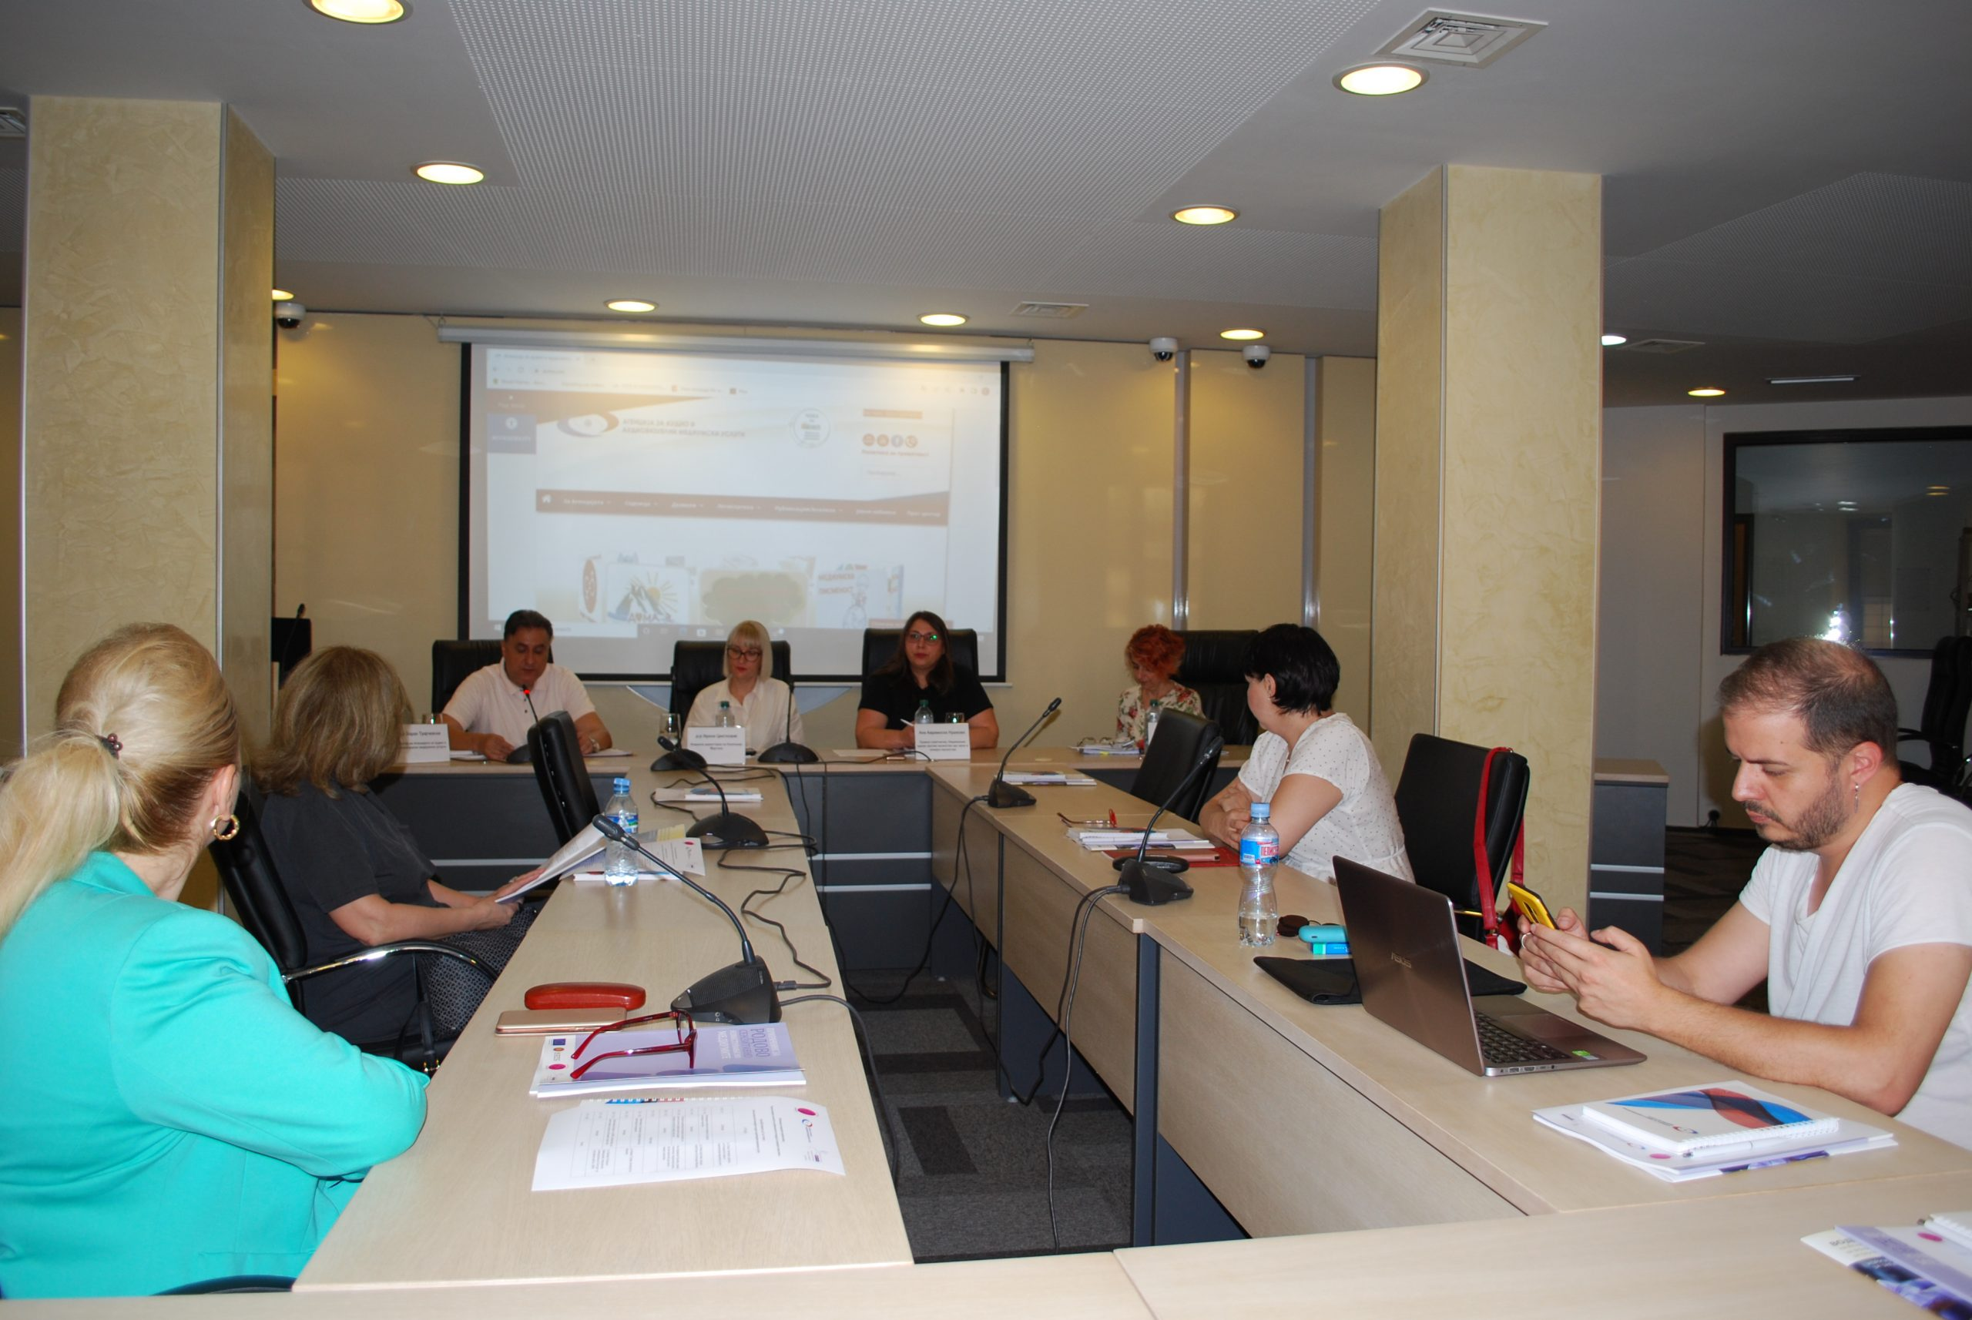](https://avmu.mk/wp-content/uploads/2022/06/Rabotilnica-scaled.jpg)**

The Executive Director of the Margini Coalition, Irena Cvetkovikj, PhD, spoke about the “Intersectional Approach to the Treatment of Gender-Based Violence”. The legal adviser at the National Network to End Violence against Women and Domestic Violence, Ana Avramoska Nushkova, presented the existing national legislation and the system for protecting women and girls victims of gender-based violence and domestic violence. The media expert Marina Tuneva, PhD, presented to the audience the Handbook on Gender Sensitive Reporting in the Media, while the Assistant Head of the Programme Affairs Department at the AAAVMS, Emilija Petreska-Kamenjarova, MA, dwelled on the AAAVMS’ Handbook for Monitoring Reporting on Gender-Based Violence. This workshop was intended for the professional media workers and was attended by representatives of the national radio and television stations.

**On 9 June 2022**, in cooperation with the Margini Coalition and the National Network to End Violence against Women and Domestic Violence, the Agency for Audio and Audiovisual Media Services organized a workshop on “Gender-Based Violence and the Professional Journalistic Reporting Standards”. The event was held at the Agency’s premises. In his welcoming speech, Agency Director Zoran Trajchevski, PhD, dwelled on the Council of Europe Convention on Preventing and Combating Violence against Women and Domestic Violence, known as the Istanbul Convention. Today’s workshop was realized as the regulator’s obligation under the Action Plan for this Convention’s implementation.

On 29 June 2022, the Agency for Audio and Audiovisual Media Services held its Second Public Meeting for this year. On this occasion, Agency Director Zoran Trajchevski presented an overview of the activities carried out in accordance with the Agency’s Annual Work Programme for the past three months. Those present at the meeting had an opportunity to hear about the activities related to the supervisions conducted over the broadcasters, operators of public electronic communication networks, the providers of on-demand AVM services, print media publishers, the research conducted, and the activities in the field of international cooperation.

**OSCE/ODIHR Representatives Pay Working Visit to AAAVMS**

**[](https://avmu.mk/wp-content/uploads/2022/06/%D0%A1%D0%BB%D0%B8%D0%BA%D0%B0-1-scaled.jpg)**

On 23 June 2022, an OSCE/ODIHR delegation paid a working visit to the Agency for Audio and Audiovisual Media Services, to present the observations noted in the Observation Mission’s final report on the 2021 Local Elections 2021 and the recommendations arising from it. Among the other things, the discussion also focused on the campaign’s financing, the provision of access to broadcasters’ programmes for people with sensory disabilities, and the numerous inconsistencies found in the electoral legal framework. The Agency representatives also shared the Agency’s experiences from the monitoring it had conducted over the broadcasters’ coverage of the elections, while the present also discussed the proposals to amend and improve the election-related regulations.

.

**Agency Holds Second Public Meeting in 2022**

[](https://avmu.mk/wp-content/uploads/2022/06/%D0%A1%D0%BB%D0%B8%D0%BA%D0%B0-2-scaled.jpg)

Also presented at the meeting were data on the legal provisions that the broadcasters had violated most often in 2021 and the first half of 2022, and the resulting criminal proceedings the Agency had initiated. The most frequent violations, as indicated by Ivona Mufisheva, MA, from the Agency’s Department of Legal Affairs and Public Procurements, were against the obligations to broadcast originally created programme, provide information that should be made available to the users, and ensure minors’ protection. A discussion was opened on this topic, which, as Deputy President of the Agency Council Selver Aydini pointed out, was aimed at identifying the reasons for the violations and producing recommendations for the radio and television stations as to what they should pay more attention to in the future in order to increase the degree of compliance with the legal obligations. Dimitar Mitsev of Kanal VIS TV spoke about the implementation of media regulation to date and the proposals for its amendment with the aim of improving the conditions of the local and regional media outlets. Special emphasis was placed on the need for creating a media fund, lifting of the ban on advertising under Article 102 of the LAAVMS, the high fines, and the rules for granting radio and TV broadcasting licenses. The issue of the poor financial situation of the media outlets and the possibilities of providing support to their operations was raised as well.

**June 2022 No.6**

**Media Ownership in 2022**

In June, the Agency for Audio and Audiovisual Media Services issued the [publication on the media ownership in 2022](https://avmu.mk/wp-content/uploads/2022/06/1.-%D0%A1%D0%BE%D0%BF%D1%81%D1%82%D0%B2%D0%B5%D0%BD%D0%BE%D1%81%D1%82%D0%B0-%D0%BD%D0%B0-%D0%BC%D0%B5%D0%B4%D0%B8%D1%83%D0%BC%D0%B8%D1%82%D0%B5-%D0%B2%D0%BE-2022-%D0%B3%D0%BE%D0%B4%D0%B8%D0%BD%D0%B0.pdf), with the aim of ensuring greater transparency of media ownership. For this purpose, it used official data on the broadcasters’ ownership structure published in the Central Registry of RN Macedonia and, in the case of print media publishers, the data they had announced in the daily newspapers in tune with legal requirement to ensure transparency of their operations.

In this publication – the fourth of this kind – the 2022 data on the owners of television and radio stations, as well as the print media publishers, have been presented in separate sections, respectively.

**Надзори врз радиодифузери, печатени медиуми и оператори на јавни електронски комуникациски мрежи**

**Радиодифузери**

**Data on Radio Stations Reach and Television Stations’ Share in the Total Viewership for the period January-May 2022**

[A research on the radio stations’ reach and television stations’ share in the total viewership for the period January-May 2022](https://avmu.mk/wp-content/uploads/2022/06/%D0%9F%D0%BE%D0%B4%D0%B0%D1%82%D0%BE%D1%86%D0%B8-%D0%B7%D0%B0-%D0%B4%D0%BE%D1%81%D0%B5%D0%B3%D0%BE%D1%82-%D0%BD%D0%B0-%D1%80%D0%B0%D0%B4%D0%B8%D0%BE%D1%81%D1%82%D0%B0%D0%BD%D0%B8%D1%86%D0%B8%D1%82%D0%B5-%D0%B8-%D0%B7%D0%B0-%D1%83%D0%B4%D0%B5%D0%BB%D0%BE%D1%82-%D0%B2%D0%BE-%D0%B2%D0%BA%D1%83%D0%BF%D0%BD%D0%B0%D1%82%D0%B0-%D0%B3%D0%BB%D0%B5%D0%B4%D0%B0%D0%BD%D0%BE%D1%81%D1%82-%D0%BD%D0%B0-%D1%82%D0%B5%D0%BB%D0%B5%D0%B2%D0%B8%D0%B7%D0%B8%D1%81%D0%BA%D0%B8%D1%82%D0%B5-%D1%81%D1%82%D0%B0%D0%BD%D0%B8%D1%86%D0%B8-%D0%B7%D0%B0-%D0%BF%D0%B5%D1%80%D0%B8%D0%BE%D0%B4%D0%BE%D1%82-%D1%98%D0%B0%D0%BD%D1%83%D0%B0%D1%80%D0%B8-%D0%BC%D0%B0%D1%98-2022-%D0%B3%D0%BE%D0%B4%D0%B8%D0%BD%D0%B0.pdf) was prepared for the needs of the Agency for Audio and Audiovisual Media Services.

The data were obtained through public opinion polls and refer to: the average daily and weekly reach of the radio stations’ listenership, and television stations’ viewership; the period of the day in which the respondents were listening to the radio or watching television; the type of programme content they had been listening to/watching during the previous day; the share in the total viewership the previous day, more specifically the share in the viewership on the territory where the television stations aired the programme and share in the total viewership; the average daily and weekly reach of the foreign television channels, etc.

**Надзори врз радиодифузери, печатени медиуми и оператори на јавни електронски комуникациски мрежи**

**Радиодифузери**

**Supervisions over Broadcasters, Operators of Public Electronic Communication Networks, Print Media Publishers and Providers of On-Demand AVMS**

**Broadcasters**

In accordance with the 2022 Annual Plans for Programme and Administrative Supervision, respectively, in relation to the obligations arising from the LAAVMS and the Law on Media, the Agency carried out regular programme and administrative supervisions over the following five regional radio programme services: Rosa-AB, Zone M-1, Sky Radio, EF-EM 90.3-Sports Radio and RA RFM. The supervision found no violations.

Regular programme supervision was also carried out over 12 television programming services: 24 Vesti TV, Alfa TV, Kanal 5 TV, Klan Makedonija TV, Kompany 21-M TV, Nasha TV, Alsat-M TV, Telma TV, Shenja TV, Sitel TV, Sonce TV and MRT 1. Regarding their obligation to provide European audiovisual works and works from independent producers. The supervisions conducted found no violations.

An ad hoc administrative supervision was conducted ex officio over Radio Lav from Ohrid, which established that this radio station had stopped broadcasting its programme service for more than 30 days due to technical, financial or other reasons, which was ground for revoking its radio broadcasting license, according to Article 82, Paragraph 1, Indent 2, of the LAAVMS.

The Agency carried out several control supervisions as well – control administrative supervision over Alsat-M TV for the obligation to publish an Impressum; control programme supervision over G-TV Televizija from Gostivar for the obligation relating to the use of language in the programme, and over 24 Vesti TV and Sitel TV for the obligations relating to product placement in their programmes. The supervisions showed that the broadcasters had fully complied with the public warning measures.

**Operators of Public Electronic Communication Networks**

As regards the obligation of the operators of PECNs to provide, free of charge and as a must, the programme services of the public broadcasting service as part of the programme packages they retransmit, as well as the obligation to have their programme packages registered with the Agency and the obligation to provide subtites for the programmes they retransmit, regular programme supervisions were conducted over the operators Viva Net, Mtel, Total TV, Kanal 16, Neotel and A1 Makedonija. The supervision found that Total TV had not provided the programming services of the public broadcasting service, "MRT 2", "MRT 3", "MRT 4" and "MRT 5", as part of its programme package, which is contrary to Article 143, Paragraph 3, of the LAAVMS.

The Agency conducted control programme supervision over the Antena AS KTV operator of public electronic communication network from Kichevo, to establish if it had acted upon the previous public warning measure imposed due to retransmission of programme services that had not been registered with the Agency. The supervision found that, contrary to the Law, the operator had been retransmitting the programme service of RTCG Sat, which had not been registered with the Agency as part of iits programme package.

**Providers of On-Demand AVMS**

As for the obligations relating to the broadcasting of cinematographic works, protection of minors and promotion of the production and access to European works, regular programme supervision was conducted over the following providers of on-demand AVM services: Neotel, Makedonski Telecom and Svod Master.The supervision found no violations.

**Print Media Publishers**

The Agency carried out regular administrative supervision over the Repro Print publisher of "Nova Macedonia"; the Sloboden Pechat publisher of "Sloboden Pechat"; Vecher Press, publisher of "Vecher"; Koha Production, publisher of "Koha"; Kapital Media Grup, publisher of "Kapital"; Media Plus Fokus, publisher of "Fokus"; Media Press VM, publisher of "Bitolski Vesnik"; Yeni Balkan, publisher of "Bahce"; ATV Media Kompani, publisher of "Lajm", Euro-Mak Kompani, publisher of "Ekonomija i Business"; Antic Media, publisher of "Portret"; Medium Boja 43, publisher of "Stipski Glas"; Kolor Media Plus, publisher of "Ubavina i Zdravje (Beauty and Health)" and "Ruski Doktor", Biro Pres, publisher of "Porta 3"; Vizn M, publisher of "Shenya"; Zenit Pres Plus, publisher of "Zenit"; Pablik, publisher of "Lice v Lice", and Kliker Marketing, publisher of "Instore", in order to verify if these publishers had published data on the name and address of their headquarters and the editorial staff and office of the print media, data on their responsible persons, editors, the printing plants, date of print or reprint and circulation, in accordance with the obligation arising from the Media Law. The supervision concluded that the print media publishers covered by the supervision had fulfilled this obligation.

**Public Warning Measures Pronounced**

At its 22nd session held on 6 June 2022, the Agency Council adopted a decision to impose a public warning measure, based on the findings of the ad hoc programme supervision ex officio conducted over Kanal 5 TV. The measure was imposed because, in the 21 and 26 April editions of its entertaining and documentary show titled "Mandza" and the informative show specialized in the topic of health, "Po doma so…", the placed products included directly in the actions/scenarios of the show’s editions, had been excessively highlighted visually and verbally as a way to promote them, while in the editions of the talk show titled "Vip Season", aired on 26 April, the placed product had been excessively highlighted visually.

At its 23rd session held on 14 June 2022, the Agency Council issued a public warning against operators A1 Makedonija and Total TV. A1 Makedonija received a public warning due to retransmission of programme services that had not been covered by the programme service registration certificate issued by the Agency. A public warning was issued to Total TV due to the fact that it had not provided the programming services of the public broadcasting service "MRT 2", "MRT 3", "MRT 4" and "MRT 5" in its programme package.

**AGENCY FOR AUDIO AND AUDIOVISUAL MEDIA SERVICES OF THE**

**REPUBLIC OF NORTH MACEDONIA**

**ul. Makedonija br. 38, 1000 Skopje**

**tel (02) 3103400, fax: (02) 3103401**

**е-mail:** [**contact@avmu.mk**](mailto:contact@avmu.mk) **, website:** [**www.avmu.mk**](http://www.avmu.mk)



