Starting from 24 October, until 31 October 2023, the Media Literacy Network organized and held the Media Literacy Days 2023, the fifth in a row, under the motto: “FAST FINGER SPREADS FAKE NEWS”. In this way, our country joined in the UNESCO’s Global Media and Information Literacy Week.

The Media Literacy Days were opened with a Conference dedicated to “Media Literacy in Digital Spaces,”at which Agency Director Zoran Trajchevski underlined that “the motto of the Media Literacy Days reflects what we will be doing during this period: we will be reminding, persistently and again, that what we do not do in reality, we must not do in virtual reality either. In the digital spaces we have the same human rights, our rights’ boundaries are the spot where the rights of others begin, and it is more than necessary to understand and accept how important and necessary media literacy is in the field of education.”

**Code of Conduct in the Online Sphere during Electoral Processes and Referenda Launched**

**[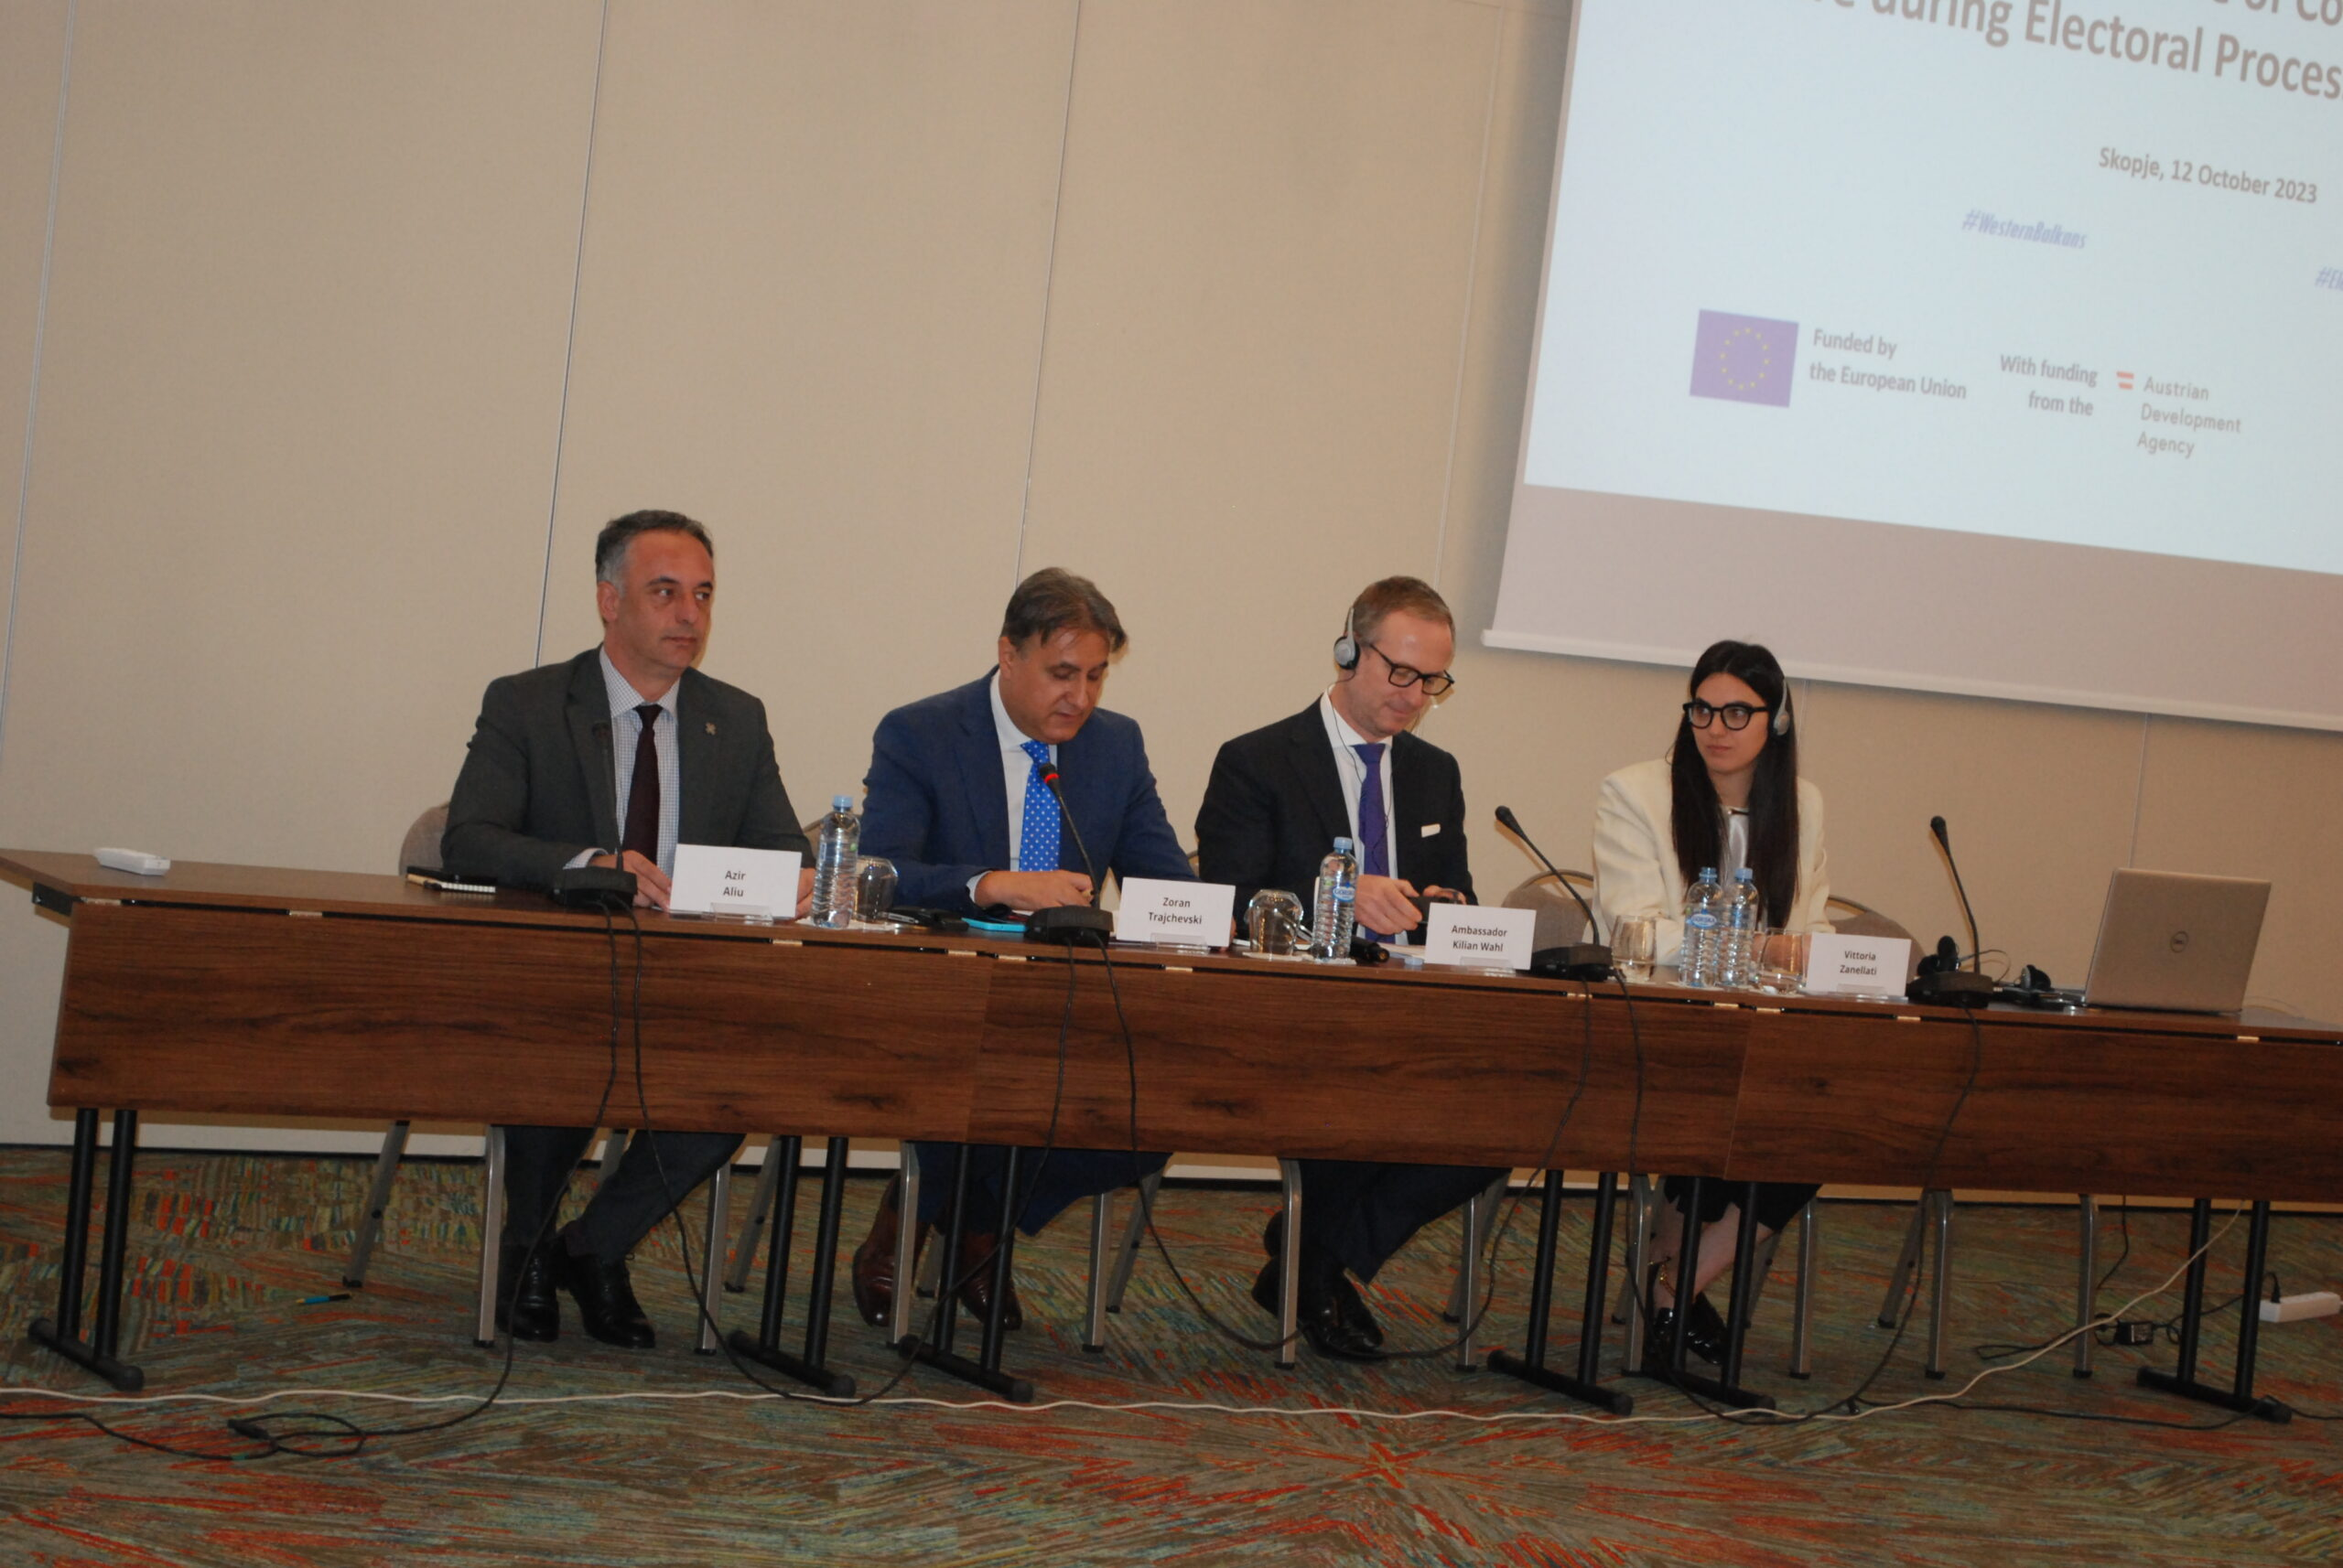](https://avmu.mk/wp-content/uploads/2023/10/DSC_1579-scaled.jpg)**

“The principles and standards the Code prescribes are of an ethical nature, due to which compliance with the Code is voluntary, based on signing an Accession Form. “The digital environment has brought about new trends and numerous challenges: new tactics of political advertising, campaigning, running campaigns and financing, placing incomplete, inaccurate or malicious information. Forms of expression that may incite a climate of intolerance, hatred, violence and discrimination are used more and more often on the social networks and generally in the online sphere, which was the reason for creating this Code,” said AVMU Director Zoran Trajchevski.  Director Trajchevski also highlighted the OSCE/ODIHR experiences and expertise that had been used in the process of drafting the Code. In their respective addresses, the Minister of Information Society and Administration Mr. Azir Aliu and the Ambassador of the OSCE Mission H.E. Mr. Kilian Wahl Code expressed positive assessments and support for the Code.

Also presented at the event was the mode of operating and the role of the Coordinating Body that would be monitoring compliance with the principles and standards laid down in the Code on the part of the political parties, their candidates, the independent candidates, broadcasters’ internet editions, the online media, the fact checkers, the influencers and other entities that may influence the public in favour of a campaign during elections or referenda. On this same occasion, a new website was launched, [www.izborenkodeksonline.mk](http://www.izborenkodeksonline.mk/), created specifically for the purpose of familiarizing the public with the Code and the work of the Coordinating Body. The website is available in Macedonian, Albanian and English, and has been adapted for use by visually impaired persons.

Representatives of the State Election Commission, the State Commission for Preventing Corruption, the Agency for the Protection of the Right to Free Access to Public Information and the Commission for the Prevention of and Protection from Discrimination shared their views on the Code and its implementation in practice. More information about the event, as well as the relevant documents, are available at  [www.izborenkodeksonline.mk](http://www.izborenkodeksonline.mk/).

On 12 October 2023, the Agency for Audio and Audiovisual Media Services launched, with the support from the OSCE’s Office for Democratic Institutions and Human Rights (ODIHR), a Code of Conduct in the Online Sphere during Electoral Processes and Referenda. The Code was prepared at the initiative of the Agency, in cooperation with institutions relevant in the field: the Association of Journalists of Macedonia, the Macedonian Institute for Media, the Council of Media Ethics of Macedonia, the Institute of Communication Studies and the “Metamorphosis” Foundation.

**2023 Media Literacy Days Held**

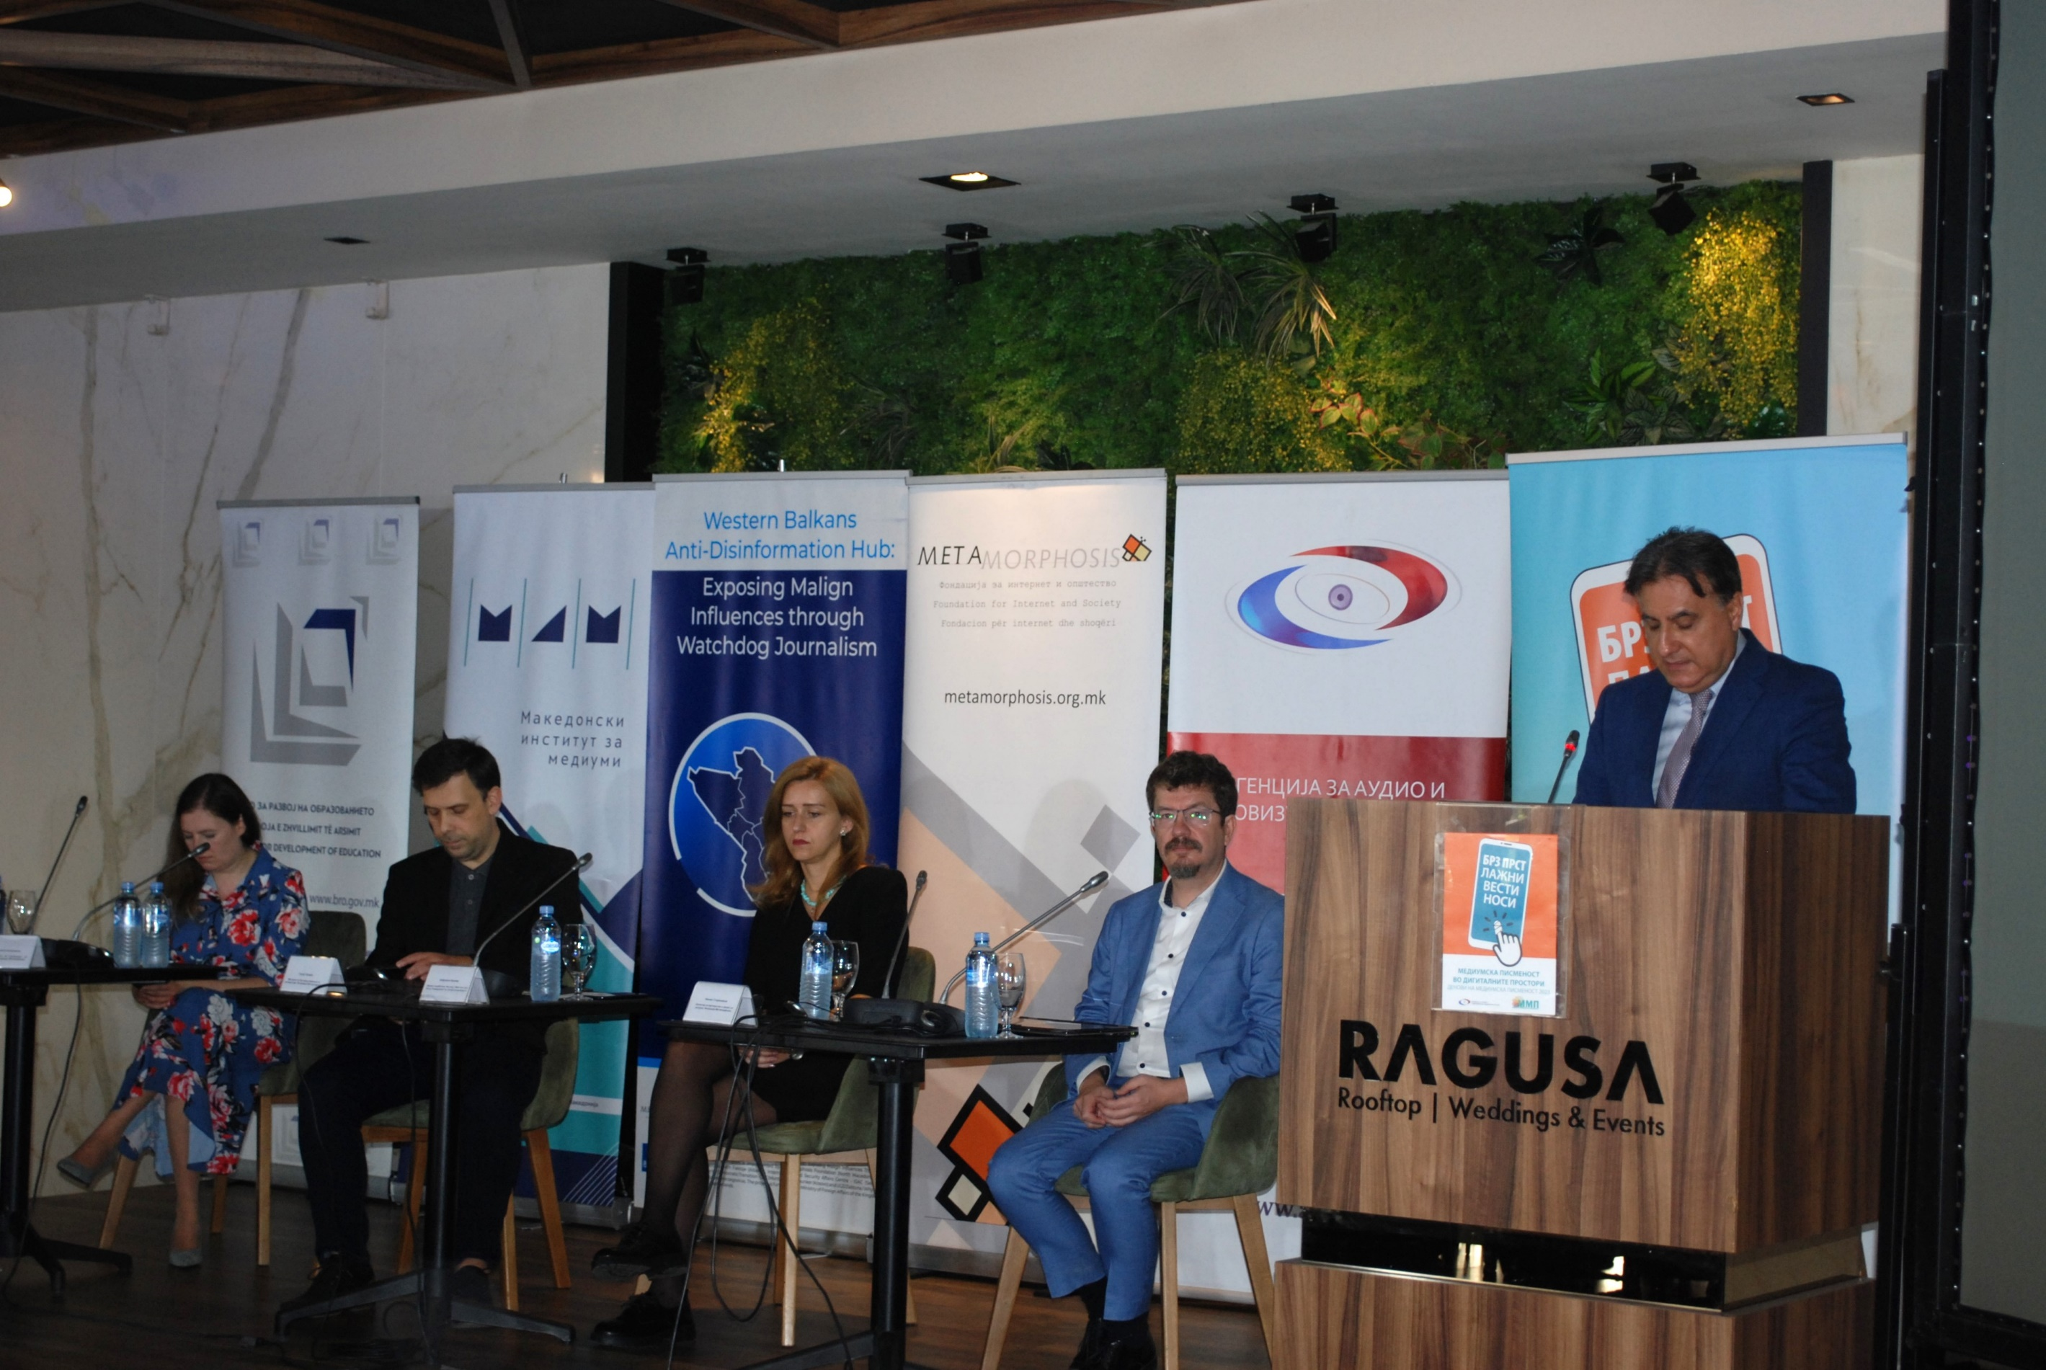

The Conference included two panel discussions and a workshop. The first panel, organized by the Metamorphosis Foundation as part of the “Western Balkans Anti-Disinformation Hub” project, was dedicated to building social resilience against the harmful effects of disinformation, while the second one, organized by MIM and IREX, within the frameworks of the USAID’s Media Literacy Project titled “YouThink,” was about the influence of the digital world on children and young people. The workshop titled “Through the Digital – New Challenges for Media Literacy?” was organized by the Agency for Audio and Audiovisual Media Services, which provided the participation of an expert through the IPA Twinning Project for “Enhancing the Capacities of AVMS and the MRT”.

For the purposes of the Media Literacy Days 2023, a video and audio spots were created in Macedonian, Albanian and in English.

More information about the events that were held live, in a hybrid form or online as part of the MLD, are available on the websites mediumskapismenost.mk and avmu.mk, as well as on the Media Literacy Network’s Facebook, Instagram and Twitter accounts and its Youtube channel.

**October 2023 No.10**

**Government Officials’ Conduct towards ALFA TV Reporter Condemned**

On 14 November 2023, the Agency for Audio and Audiovisual Media Services issued a press release condemning the inappropriate conduct of Prime Minister Kovachevski and Vice Prime Minister for Economic Affairs Fatmir Bytyqi towards Alfa TV reporter Mateja Petrovski.

In the press release, it stressed that media were one of the key pillars of democracy and, as such, played an important role in creating the critical opinion and in reporting on issues of public interest. Hence, there must not be any way of communication that is inappropriate or offensive to journalists and, consequently, to the entire public to whom the information are to be conveyed.Public office holders should make every effort to provide answers to all journalists’ questions that are of public interest, and at the same time show respect for the journalistic profession and media workers’ dignity.

**Supervisions over Broadcasters, Operators of Public Electronic Communication Networks and Print Media Publishers**

**Broadcasters**

Regular programmе and administrative supervisions were conducted concerning several legal obligations - namely, compliance with the rules for broadcasting audiovisual commercial communications; protection of the juvenile audience; use of value-added telephone services and telephone voting; broadcasting games of chance and provision of quizzes or other forms of prize-winning participation; publishing Impressums, information that should be made available to the users and the identification signal of the broadcaster; use of languages in the programmes; broadcasting of at least 12 hours of television programme daily and airing of at least 40% of programme originally created as Macedonian audio or audiovisual works daily. The supervisions covered the TV programmes of the Public Broadcasting Service - MRT 1, MRT 2, MRT 3, MRT 4 and MRT 5, and established that, on 4 October 2023, in some of the programmes it had aired, MRT 3 had failed to publish the data it is obliged to broadcast at an appropriate place for each content of the programme service. MRT 4 and MRT 5 had not abided by the law either, as they had fialed to air at least 40% of programme originally created as Macedonian audiovisual works.

Regular programme and administrative supervisions were also carried out over the following radio stations: Rosa - AB, Zona M-1, RFM, Sky and EF-EM 90.3 Sports Radio, with regard to the legal obligations relating to publishing Impressums, information that should be made available to the users and the broadcaster's identification signal; compliance with the rules for broadcasting audiovisual commercial communications, protection of juvenile audiences, use of value-added telephone services and telephone voting, broadcasting of games of chance, provision of quizzes or other forms of prize-winning participation, use of language in their programmes, broadcasting of at least 12 hours of radio programme daily and broadcasting of the voluntarily registered percentage of Macedonian music. The supervisions found that EF-EM 90.3 Sports Radio had failed to publish Impressum in the announcement and the credits of the its radio news titled: "Sports news on 90.0 EF-EM" on 5 September, while Radio Sky Theodore had failed to air the minimum of 10% of music in the Macedonian language in the period from 6:00 a.m. to 12:00 a.m., in its programme broadcast on 4 September 2023.

In order to determine whether Radio Metropolis had acted upon the decisions imposing public warning measures due to failure to publish an Impressum and non-compliance with the rules for broadcasting audio commercial communications, the Agency conducted control programme and administrative supervision over this broadcaster. The control supervisions established that, in its programme aired on 26 September, Radio Metropolis had failed to publish Impressum data both in the announcement and in the credits of the radio programme pieces titled: "One minute of positive facts – according to the information received from the Directorate of Technological and Industrial Development Zones and the Council of Foreign Investors", as well as in the entertainment and informative pieces titled: "Good morning / Good afternoon with Maya - Maya for breakfast and menopause" and "The world at 4 with Vicky and Stella". On the same day, the news editions were sponsored unlawfully, i.e. the editions of the short daily news shows titled: "Sports on Metropolis" and "One minute of positive facts".

Control supervisions were also carried out over TV Kiss&Menada, to establish whether the broadcaster had acted upon the imposed public warning measures, issued due to failure to publish an Impressum and information that should be made available to the users, and the use of language in the programme contrary to the Law. The supervision showed that the broadcaster had met the respective legal obligations in full.

In its line of duty, the Agency conducted an ad hoc programme supervision over the work of Kanal 77 Radio concerning the assertions presented at the public hearing held at the Agency’s premises on 22 August 2023, in order to verify if the broadcaster had been operating in accordance with Article 68, in relation to Article 3, Paragraph 1, Point 12, of the LAAVMS. The ad hoc supervision established that there were differences in the structure of the programme service of Kanal 77 Radio broadcasted using two frequencies (89.70 Mhz from the peak of Mt.Vodno and 101.90 Mhz from Mt. Popova Shapka, respectively), which are part of the network of frequencies that this broadcaster uses to air its radio service at the state level. This is contrary to the above-mentioned legal provisions, as the broadcaster has received only one license from the Agency for broadcasting a radio programme service at the state level. This means that the same service should be broadcast via all the frequencies used by the broadcaster to cover the area for which it has received the license.

**Operators of Public Electronic Communication Networks**

The Agency carried out regular programme supervision over the operators Drim Sat IPTV, Nafi & Beko, Winsat Kabel, Multimedia Network L, Skupi Cable, Telenet Com, Signal-Net and Skrembl, regarding their obligation to provide, free of charge as part of the programme packages they retransmit, the programme services of the public broadcaster, as well as the obligations to register their programme services with the Agency and to provide subtitles for the programs they retransmit, respectively. The supervision established that the Vinsat Kabel operator from Vinica had been retransmitting the programme service of "Super RTL" for its users although it had not been covered by the programme service registration certificate issued by the Agency.

**Print Media Publishers**

The Agency carried out regular administrative supervision over 22 print media publishers in order to verify if they had published data on the name and address of the head and editorial offices of the print media outlet, data on the responsible person, the editors, the printing house, date of print or reprint and the circulation data, in line with their obligation under the Media Law. The supervision established that the print media outlet of "Nova Makedonija" had failed to meet the obligations under the Media Law, as, in its issue no. 25952 it had not published the correct number of printed copies. The media outlet of "Naroden Lekar" had failed to publish the correct printing date in its issue no. 591, while the print media outlet of "Slovo" had failed to publish data on the address of the headquarters of the publisher of the media, the name of the responsible person of the publisher of the media, the name of the printing house, the address of the printing house, the date of print or reprint and the circulation data.

**Public Warning Measures Imposed**

At its 32nd session held on 9 October and its 33rd session held on 16 October 2023, the Agency Council adopted, based on supervision findings of non-compliance with the Law on Audio and Audiovisual Media Services and the Law on Media, a total of five decisions imposing public warning measures against Plus TV, G-TV Television and Zdravkin TV.

G-TV Television was issued three public warning measures, of which one was due to broadcasting feature programmes without airing minors’ protection signaling before the start and throughout their broadcast, the second – for failing to publish Impressum data, and the third – for failing to air at least 30% of programmes originally created as Macedonian audiovisual works, and at least half of the legal minimum of programme originally created as Macedonian audiovisual works, respectively

.

A public warning measure was issued against PLUS TV due to failure to provide information that should be made available to the users, and against ZDRAVKIN TV – for not having published Impressum data, respectively.

