The Agency for Audio and Audiovisual Media Services held its first Public Meeting for this year on 28 March 2023. On this occasion, Director Zoran Trajchevski presented an overview of the activities carried out in line with the Annual Work Programme in the past three months.

The attendees had an opportunity to hear about the activities related to the supervisions conducted over the radio broadcasters, operators of public electronic communication networks, print media publishers, public warning measures imposed, conducted research, and activities in the field of international cooperation.

The Analysis showed that some of the analyzed television programmes lacked gender sensitivity, while, on the other hand, content had been spotted that questioned the traditionally established gender roles and norms, and women were being promoted within the various social spheres. When it comes to programmes of an entertainment nature, women were hired more often as editors or as presenters and journalists in the shows than men. As regards the guests or collocutors presented in these shows, there was parity between men and women.

.

**Two Public Competitions Announced to Grant Licenses for Broadcasting Radio Programme Services**

On 15 March 2023, the Agency published two Public Competitions to grant licenses for broadcasting radio programme services to non-profit broadcasting institutions intended for the student population.

One public competition is for a programme service in the Macedonian language, at the regional level, in the Skopje region, while the second one is for a programme service at the local level, in the Tetovo area, in the Albanian and Macedonian languages. The deadline for submitting applications for the two competitions is 15 May 2023.

.

**Gender in the TV Entertainment Programmes at the Spotlight of the First Public Meeting of AAAVMS**

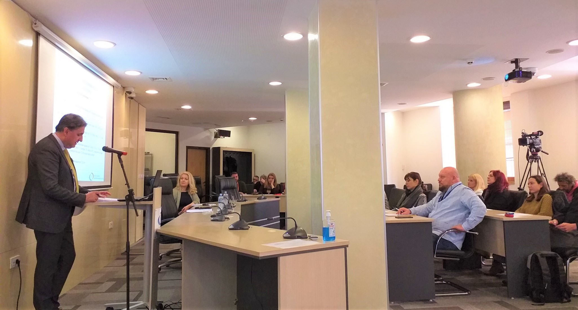

Presented at the meeting were the findings of the Analysis of Gender Issues and the Manner of Portraying and Representing Women and Men in the Broadcasters’ Entertainment Programmes in 2022, which the Institute for Social Sciences and Humanities from Skopje had prepared for the Agency’s needs. The Analysis covers 412 analyzed and processed thematic units or items aired in the period from 15 May to 16 June 2022, on the following nine state-level television channels: MRT1, MRT2, Alsat – M TV, Alfa TV, Kanal 5 TV, Sitel TV, Telma TV, 24 TV and Kompani 21 – M TV.

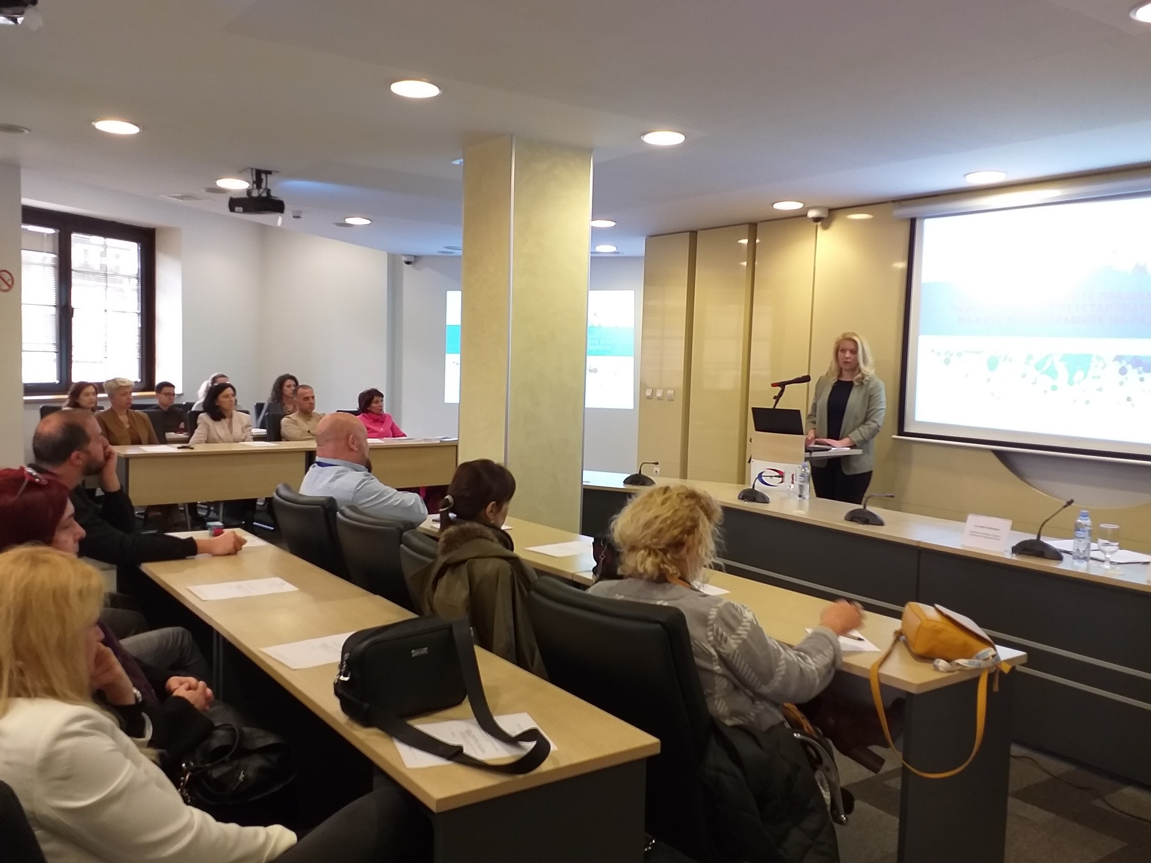

In terms of the analysis of gender discourse, one could note a considerable diversity - from patriarchal and stereotyped discourses, through gender blindness and neutrality, to affirmative discourses in favour of gender equality. Although the general conclusion regarding such a large sample as this is that most of the content was gender-neutral, one could still note both extremes – content with strikingly traditional aspects and content with strikingly progressive and advanced attitudes regarding gender equality. The integral Analysis is available on the Agency’s website, [www.avmu.mk](http://www.avmu.mk).

**March 2023 No.3**

**Supervisions over Broadcasters and Operators of Public Electronic Communication Networks**

**Broadcasters**

Regular programme and administrative supervisions with regard to complying with the rules for audiovisual commercial communications, the protection of juvenile audiences, the use of value-added telephone services and telephone voting, broadcasting games of chance, provision of quizzes or other forms of prize-winning participation, the use of language in the programmes, broadcasting of at least 12 hours of TV programme daily, broadcasting of at least 30% of originally created programme, publication of Impressums, information that should be made available to the users and publication of the broadcaster’s identification sign, were carried out over Klan Makedonija TV, Shenja TV, Kompani 21-M TV and Sonce TV. The supervisions showed that Klan Makedonija TV and Kompani 21-M TV had failed to broadcast at least 30% of the originally created programme on their channels, Sonce TV had failed to provide translation from English into Macedonian for two shows, Kompani 21-M TV had failed to broadcast Impressum in its programme, while Klan Makedonija TV had ignored the ban on product placement in certain types of programme.

As regards the obligations related to the publication of Impressums, information that should be made available to the users, and identification signs of the broadcasters; the rules for broadcasting audiovisual commercial communications; the protection of minors; the use of value-added telephone services and telephone voting, broadcasting games of chance and provision of quizzes or other forms of prize-winning participation, regular programme and administrative supervision was carried out over 24 Vesti TV and Nasha TV. The supervision found that Nasha TV had aired a feature film without any warning signal before its start and without marking the category of the programme during its entire duration.

After the deadline for legal compliance with the imposed public warning measures expired, control supervisions were carried out over MRT2, Spektra TV, Kanal Festa TV and Marija Blagovest Radio, with the aim to establish whether they had removed the violations. The supervisions showed that the three broadcasters had racen appropriate action upon the imposed measures.

**Operators of Public Electronic Communication Networks**

As for the obligation of the operators of PECNs to provide, obligatorily and free of charge, the programme services of the public broadcaster as part of their own programme packages, as well as the obligations to register their programme services with the Agency and provide subtitles for the programmes they retransmit, respectively, regular programme supervision was carried out over Altra Sat 2000, IP Sistems, Skrembel, Biv Piramida, Infel KTV and Kabel Net. The supervision found no violations.

An ad hoc programme supervision was carried out over the operator Makedonski Telekom in relation to its retransmission of the "Pickbox" programme service. No violations were found by the supervision. After the expiry of the deadlines for legal compliance with the imposed public warning measure, control programme supervision was carried out over the Signal-Net operator from Kumanovo, which showed that the latter had fully complied with the previously imposed measure.

**Public Warning Measures Imposed**

At its 9th session held on 8 March 2023, the Agency Council adopted a decision to impose a public warning measure against Kaltrina TV broadcaster, based on the findings of a control programme supervision which had established that Kaltrina TV had continued not to broadcast at least 30% of programme originally created as Macedonian audio and audiovisual works.

At its 10th session held on 13 March 2023, the Agency Council issued a public warning measure against the KABEL-NET operator of public electronic communication networks from Strumica, due to retransmitting a programme service that had not been covered by the programme service registration certificate issued by the Agency.

At its 12th session held on 28 March, the Agency Council adopted a Decision to annulling and declaring null and void the Decision to impose a public warning and seek to discontinue the retransmission of the programme service against Kabel-NET from Strumica, which had been adopted based on findings of a regular programme supervision.

