**Supervisions over Broadcasters, Operators of Public Electronic Communication Networks and Print Media Publishers**

**Broadcasters**

The Agency conducted regular programme supervision over the national radio channels of Jon, Metropolis, Antenna 5 and Channel 77, concerning their observance of several legal obligations relating to the use of language in their programmes, the broadcasting of at least 18 hours of radio programme daily and broadcasting of the voluntarily reported percentage of Macedonian music, compliance with the rules on broadcasting audiovisual commercial communications, protection of juvenile audiences, use of value-added telephone services with and telephone voting, broadcasting games of chance and providing quizzes or other forms of prize-winning participation.

**Report on Media Ownership in 2023**

On 29 June, the Agency for Audio and Audiovisual Media Services produced the [report on media ownership in 2023](https://avmu.mk/wp-content/uploads/2023/06/%D0%A1%D0%BE%D0%BF%D1%81%D1%82%D0%B2%D0%B5%D0%BD%D0%BE%D1%81%D1%82%D0%B0-%D0%BD%D0%B0-%D0%BC%D0%B5%D0%B4%D0%B8%D1%83%D0%BC%D0%B8%D1%82%D0%B5-%D0%B2%D0%BE-2023-%D0%B3%D0%BE%D0%B4%D0%B8%D0%BD%D0%B0-1.pdf), which had been prepared with the aim of achieving a higher level of transparency of media ownership. The Report contains data on the owners of the television and radio stations and the print media publishers, based on the current financial statements issued by the Central Registry of the Republic of North Macedonia in March 2023, as well as the announcements in a daily newspaper stating the data on the ownership structure of the print media publishers.

In addition, the report also contains information regarding the changes in the broadcasters’ ownership structure in the previous year, as well as data on the broadcasters’ integration of capital.

On June 23rd, the Agency for Audio and Audiovisual Media Services held its second Public Meeting in 2023, at which Agency Director Zoran Trajchevski presented an overview of the activities implemented in accordance with the Annual Work Programme for the past three months. Those present had the opportunity to hear about the activities as part of the supervisions conducted over the broadcasters, operators of public electronic communication networks, providers of on-demand AVMS and print media publishers, the imposed public warning measures, the conducted research, as well as the Agency’s activities in the sphere of international cooperation.

Presented at the Meeting were also the findings of the Analysis of the Market of Audio and Audiovisual Media Services in 2022, which included the economic operations of the public broadcasting service and the commercial television and radio

**Agency Holds its Second Public Meeting in 2023**

**[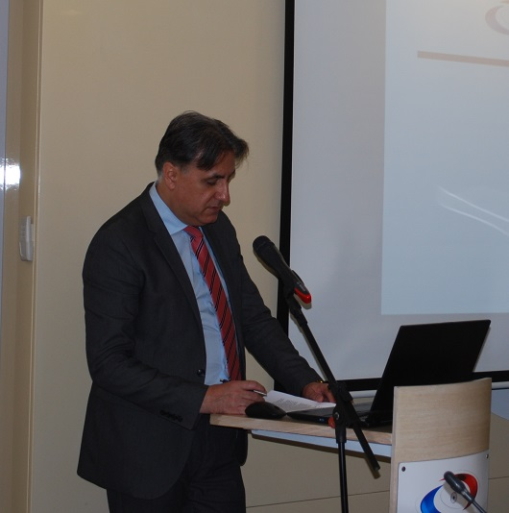](https://avmu.mk/wp-content/uploads/2023/06/2javen-sostanok-2.jpg)**

stations in 2022, as well as data from the measurements of the television and radio audiences, respectively. The Analysis showed that the total revenues in the industry in 2022 had amounted to 2,514.63 million Denars, while the total expenditures had amounted to 2,578.53 million Denars. Compared to 2021, the public broadcaster and the commercial radio stations marked an increase in their revenues, while the commercial television stations had earned less funds. The entire Analysis is available at this [link](https://avmu.mk/wp-content/uploads/2023/06/%D0%90%D0%BD%D0%B0%D0%BB%D0%B8%D0%B7%D0%B0%D1%82%D0%B0-%D0%BD%D0%B0-%D0%BF%D0%B0%D0%B7%D0%B0%D1%80%D0%BE%D1%82-%D0%B7%D0%B0-2022-%D0%B3%D0%BE%D0%B4%D0%B8%D0%BD%D0%B0.pdf). As regards the implementation of the activities specified in the Regulatory Strategy for the Development of the Audio and Audiovisual Industry for the period 2019-2023, it was concluded that virtually all projected activities had been carried out. The Agency had produced a large number of studies, analyses and other relevant documents, and held a large number of workshops, debates and trainings related to various aspects of the work of the media.

The Meeting also involved a public consultation on the Rulebook on the Minimum Technical, Spatial, Financial and Staffing Requirements for Obtaining a Radio or Television Broadcasting License, following the Decision of the Constitutional Court that partially repeals Paragraph 6 of Article 9 of this Rulebook. A large number of the attendees took part in the consultation.

**Press Release**

On 29 June, the Agency condemned the verbal threats addressed against all journalists and media workers, including journalist Ognen Janevski, uttered during two contact shows on 24 TV. In its Press Release, it pointed out that any form of attack against journalists is absolutely unacceptable and represents a direct attack on democracy and the freedom of speech in any society. The media are the guardians of the public interest and creators of public awareness, which is why the safety of media workers must not be jeopardized at any time.

The Agency appealed, as many times before, to respect the dignity of media workers and to provide conditions for media’s completion of their tasks in a professional manner.

**June 2023 No.6**

The supervision established that, contrary to the LAAVMS, Metropolis Radio had broadcasted sponsored daily news shows in its programme broadcast on June 6, and had exceeded the advertising limit of 12 minutes per clock hour in several clock hours.

Тhe same radio stations were subjected to regular administrative supervision regarding their obligations to publish Impressums and information that should be made available to their users, respectively, and their obligations to publish the broadcaster's identification sign. The supervision found that, in its programme broadcasted on 2 June, more precisely the show titled "Praznicno so Angela" (Holiday Mood with Angela), Kanal 77 Radio had failed to provide the information it is obliged to air at an appropriate spot for each content of its programming service, and had failed to provide the information it should make available to its users, while Radio Metropolis had failed to air an Impressum in its the programme broadcast on June 6, both in the announcements and in the end credits of the radio news pieces titled: "Metropolis Business News", "One Minute of Positive News", "Sports News" and "News from Radio Free Europe".

Control programme supervision was carried out over Klan Macedonia TV to determine whether the broadcaster had acted upon the decision to impose a public warning measure, issued due to its failure to broadcast the minimum of 30% of the programme originally created as Macedonian audiovisual works. The supervision showed that the broadcaster had acted upon the imposed measure in full.

One ad hoc administrative supervision was carried out as well, over the operations of all 107 broadcasters, in order to check if any of the broaddcasters had changed their ownership structure without first notifying the Agency and before obtaining the Agency’s endorsement. The supervision concluded that all 107 broadcasters had acted in accordance with the relevant legal obligation.

**Operators of Public Electronic Communication Networks**

As regards the obligation of the operators of PECNs to provide the programme services of the public service broadcaster as part of the programme packages that they retransmit, as well as their obligations to register their programme services with the Agency and provide subtitling of the programs they retransmit, regular programme supervision was carried out over the following operators: A1 Makedonija, Makedonski Telekom, Spajder and Total TV. The supervision established that the Total TV operator had not been retransmitting the programme services of "MRT 2", "MRT 3", "MRT 4" and "MRT 5".

**Print Media Publishers**

The Agency conducted regular administrative supervision over 19 print media publishers, in order to make sure that they had published data on the name and address of the headquarters and the editorship of their print media outlets, data on the responsible person, editors, printing house, date of print or reprint and their circulation, in line with the Media Law. The supervision showed that all print media outlets had met this legal obligation.

**Operators of Public Electronic Communication Networks**

Based on the findings of conducted supervisions, at its 19th session held on 15 June, the Agency Council adopted three public warning measures against Alsat-M TV, Telma TV and PRO-FM Radio, respectively. A public warning was issued against Alsat-M TV for broadcasting surreptitious audiovisual commercial communications. Telma TV received a public warning because of its particular promotional recommendation of certain catering services and products and not marking the programme containing product placement accordingly, while PRO-FM Radio was issued a public warning due to its failure to submit a written report on its implementation of the requirements established in its radio broadcasting license.

At its 20th session held on 26 June, the Agency Council issued public warning measures against the Total TV operator of public electronic communications network due to violation of Article 141 and Article 143, Paragraph 3, of the LAAVMS, i.e. for broadcasting a programme service that had not been covered in the programme service registration certificate issued by the Agency for Audio and Audiovisual Media Services, and failure to provide the programme services of the public service broadcaster, i.e. "MRT 2", "MRT 3", "MRT 4" and "MRT 5".

