On 31 March 2022, representatives of the Agency for Audio and Audiovisual Media Services held a working meeting with Benoît Loutrel, Member of the College of the French Audiovisual and Digital Communication Regulatory Authority (ARCOM).

The purpose of the visit was to share experiences and viewpoints in the area of several segments, including the implementation of the revised Directive on Audiovisual Media Services, the monitoring of media content during electoral processes, the ban on retransmitting channels that appear to be founded by the Russian Federation or private individuals, natural or legal persons originating from the Russian Federation. The participants in the meeting also discussed the regulation of the social networks.

**AAAVMS and ARCOM Hold Bilateral Meeting**

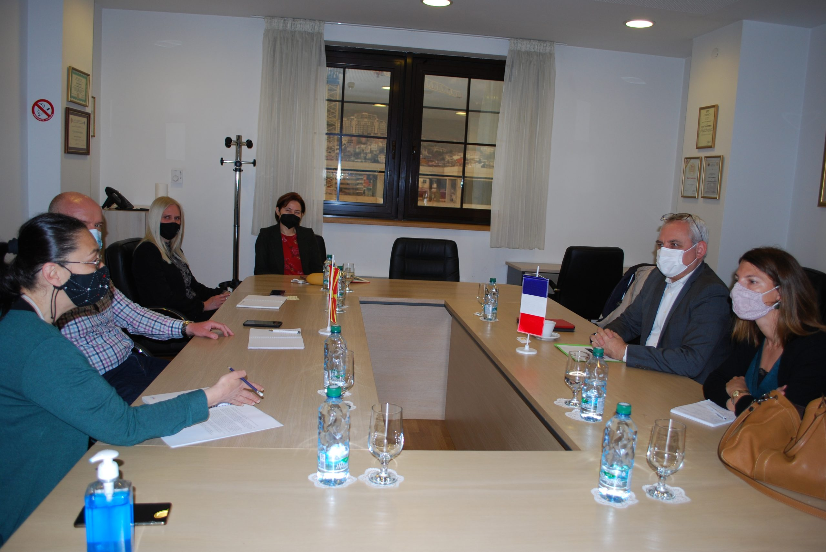

At the end of the meeting, it was concluded that bilateral relations were of exceptional importance and that this practice should continue in the future.

The analysis, which the RESIS Institute had prepared for the Agency’s needs, showed that the coverage of sports and sports events and the broadcasting of sports competitions occupied a significant place in the overall programme scheme of the Public Broadcasting Service. The public broadcaster strives to pursue a well-thought-through and consistent editorial policy regarding sports, i.e. it provides a genre variety and obviously a great diversity in the sports it covers and to which it dedicates considerable airtime. Prevailing in the programmes of the three analyzed channels – MRT 1, MRT 2 and MRT 3 – are male team sports competitions. There is a prevailing presence of men among the reporters as opposed to the marginal participation of female reporters, as well as predominance of male sports workers, i.e. sports experts.

On 28 March 2022, the Agency for Audio and Audiovisual Media Services held its first public meeting for this year, at which Agency Director Zoran Trajchevski presented an overview of the activities the Agency had carried out in the past three months, in line with its Annual Work Programme. Those attending had an opportunity to hear about the activities relating to the supervisions conducted over the broadcasters, operators of public electronic communication networks, print media publishers, the imposed public warning measures, the conducted surveys, and activities in the field of international cooperation.

**March 2022 No.3**

**Gender in the Sports TV Programmes Holds the Spotlight at AAAVMS’s First Public Meeting in 2022**

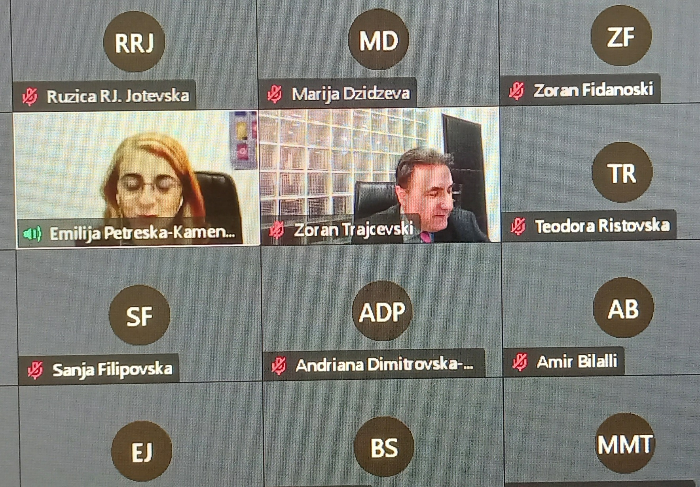

Also presented at the meeting were the findings of the Analysis titled “Gender in the Media in 2021: Gender Issues and the Manner of Depicting Women and Men in the Sports Programmes of the National Terrestrial Television Channels,” which is the first ever to provide both a quantitative and a qualitative insight into the extent to which and the way in which national television channels reported on the female athletes and women’s sports, as opposed to male athletes and men’s sports.

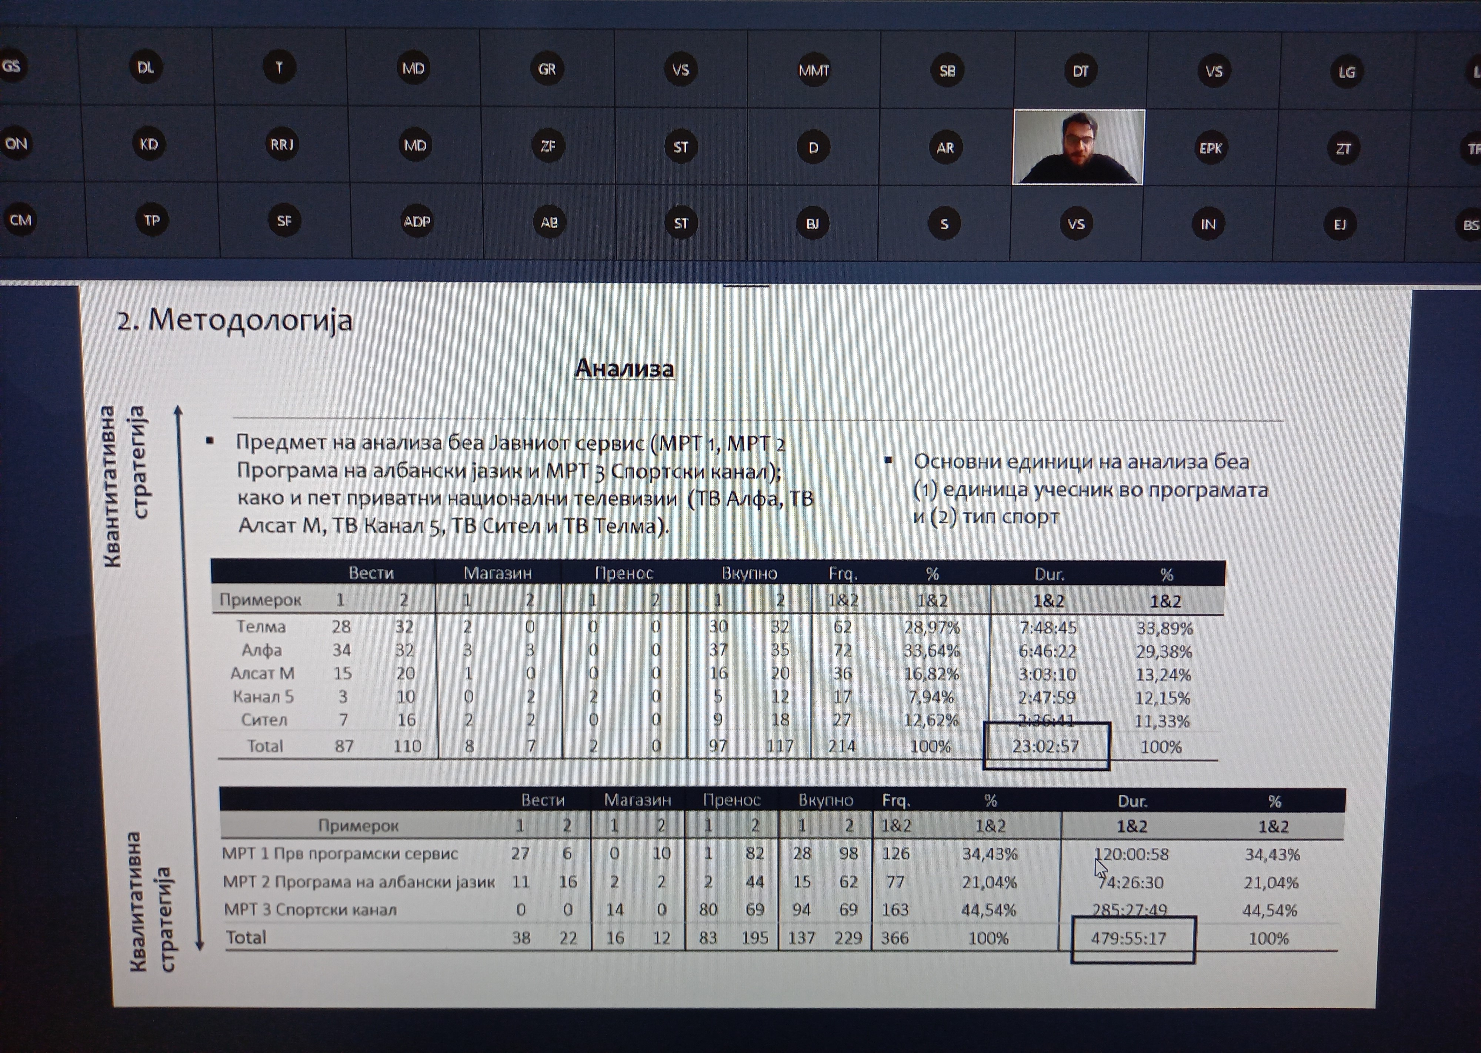

The private television channels Alfa TV, Sitel TV, Kanal 5 TV, Telma TV and Alsat-M TV had dedicated significantly less time to sports than the Public Broadcasting Service. This was totally expected, given the fact that, due to the already purchased broadcasting rights, the private television stations did not air broadcasts of the Summer Olympic Games. Nevertheless, there were visible differences among the five private television stations in terms of the way they covered the sports events and the attention they paid to sports. Male sports domination was noted in their regular sports news programmes, considering both individual and team sports. Female sports experts were almost completely absent from the regular programmes of the private television channels, while the TV newsrooms sought the views and analyses of the sports events mostly from male sports workers.

.

**Supervisions over Broadcasters, Operators of PECNs and Print Media**

**Broadcasters**

Regular programme supervision was conducted regarding a number of legal obligations, such as compliance with the rules on airing audiovisual commercial communications, protection of the juvenile audience, use of value-added telephone services and telephone voting, broadcasting games of chance and provision of quizzes or other forms of prize-winning participation, advertising, sponsorship, use of language in the programme, the requirement to broadcast 12 hours of programme and to fulfill the quota for originally created programmes, publishing Impressums, information that should be made available to the users and identification of the broadcaster. Regular administrative supervision was carried out over Nasha TV and 24 Vesti TV. The supervision established that, on 4 March 2022, 24 Vesti TV had aired an entertaining and documentary programme, “1001 Meals,” which had not been marked as a programme containing product placement, while certain products had been promoted through excessive visual and verbal recommendation.

After having received reports from the Food and Veterinary Agency concerning broadcast of illegal audiovisual commercial communications about food supplements, a number of ad hoc programme supervisions were conducted over Kanal 5 TV and Sitel TV. The supervisions found that, contrary to the LAAVMS, on 21, 22 and 23 February 2022, Kanal 5 TV and Sitel TV had aired teleshopping spots for the products of “Bronfo Protekt - 500 ml” and “Diabetol Forte – 30 capsules”, of the "Natura Therapy” food operator from Skopje, which presented falsely the nature and characteristics of these products, i.e. were untrue and dishonest, and were as such misleading the public and were against the consumers’ interests. On these same dates, Kanal 5 TV had been airing teleshopping spots for the "Bronho Protect" dietary supplement, in which a regular news presenter of this same television channel appeared in picture and tone, while Sitel TV had aired covert audiovisual commercial communications for the products "Bronho Protect" and "Prostatol Complex" in certain segments of its morning, news and entertainment show titled “Ja sakam Makedonija," (I Love Macedonia) as well as teleshopping spots for the "Bronho protect" dietary supplement, in which a regular news presenter of Kanal 5 TV had appeared in picture and in tone. Additionally, Kanal 5 TV was found to have broadcasted covert audiovisual commercial communications about the products "Bronho Protekt" and "Diabetol Forte" in certain segments of its morning current affairs programme "Zdravo, Makedonijo" (Hello, Macedonia), on 22 and 23 February 2022.

Based on some initiatives submitted in writing by a civil society organization regarding the special prohibition against inciting or spreading discrimination, intolerance or hatred on the prohibited discriminatory grounds, an ad hoc programme supervision was carried out over Kanal 5 TV and Alfa TV. The supervision showed, however, that the programmes of Kanal 5 TV (its show titled "Samo vistina" (Only the Truth)), broadcast on 21 February, and the programme of Alfa TV (its show titled "Sto ne e jasno?” (What’s not clear?)) broadcast on 23 February, respectively, had not violated the special prohibition under Article 48 of the LAAVMS. Both the two media outlets and the submitter of the initiatives were duly informed about the findings.

Further to a request for explanation, information and evidence concerning certain allegations presented in a complaint submitted by a natural person to the Ombudsman’s regional office in Kichevo, the Agency conducted an ad hoc programme supervision over Telma TV’s show titled "KOD" (CODE), regarding its abidance by the principles of performing one’s business activity. The supervision showed that, in its episode of "KOD" titled "A year in prison for running over a policeman, Pale’s act – a murder or self-defense", broadcast on 6 February, Telma TV had made an editorial decision to reveal the full name and surname, date of birth and place of residence of the accused in the first part which referred to the court case in which the petitioner was a participant, although the court proceedings for this case were in the phase of an appeal before the Gostivar Court of Appeals and no final and valid decision had been reached yet. By having revealed the identity of the petitioner (first and last name, date of birth and place of residence), Telma TV had acted contrary to the principle of "respecting the presumption of innocence" under Article 61, Paragraph 1, Indent 5, of the LAAVMS.

**Print Media Publishers**

The Agency carried out regular administrative supervision over 20 print media publishers with the aim of verifying if they had published data on their ownership structure in at least one daily newspaper, once a year, no later than 31 March 31 2022, and whether they had submitted excerpts of their respective announcements within 15 days from the date of announcing, to the competent regulatory body. The supervision showed that all print media publishers had acted in accordance with the Law on Media.

**Operators of Public Electronic Communication Networks**

As regards the obligations related to the registration of programme services with the Agency and subtitling of the programmes retransmitted by the operators, regular programme supervision was carried out over the operators Robi, KDS Kabel Net, Skrembl, Transped Trejd, Altra Sat 2000, Inel Internacional, Kabel and Kabel L Net. No violations were found during the supervision.

As for the obligation that requires the operators of PECN to include, free of charge, the programme services of the Public Broadcasting Service as part of the programme package that they retransmit, regular programme supervision was carried out over Global Sat, Infel-KTV, Kabel-Net, Pet Net, Altra Sat 2000, Inel Internacional, Kabel, Kabel L Net, Robi, Transped Trejd and KDS-Kabel Net operators. The supervision showed that, on 10 March 2022, the Altra Sat 2000 operator, which, according to the notification from the Agency, may carry out activities in the territory of the municipality of Ohrid, had retransmitted the programme services of "RTR Planeta", "Russia 24", "Al Jazeera" and "DM Sat" for its users, although these had not been covered by the programme service registration certificate issued by the Agency.

**Public Warning Measures Imposed**

At its 11th session held on 18 March 2022, the Agency Council adopted a decision to issue a public warning against Altra-Sat 2000 operator from Ohrid, based on supervision findings according to which it had disregarded the obligation to register the programme services it had been retransmitting, and request termination of the retransmission of the disputed TV channels. At the same session, a decision was adopted to issue a public warning measure against Due TV from Gostivar, due to failure to publish the data that the television station is obligated to broadcast at an appropriate place for each content of the programme service.

At the 9th session held on 10 March 2022, the Agency Council adopted four decisions on imposing public warning measures against Due TV from Gostivar, Gurra TV from Kichevo and G-TV Televizija from Gostivar. G-TV Televizija, Due TV and Gurra TV were issued public warnings because they had not aired the minimum of 30% of programme originally created as Macedonian audio or audiovisual works as part of their programming services between 7:00 a.m. and 7:00 p.m. In addition, a public warning measure was issued against Due TV for disregarding the obligation related to use of language in its programme.

At its 8th session held on 3 March 2022, the Agency Council adoted, based on the findings of a control administrative supervision, a decision to impose a public warning measure against Gurra TV from Kichevo, due to failure to provide the information that should be made available to the users.

**AGENCY FOR AUDIO AND AUDIOVISUAL MEDIA SERVICES OF THE**

**REPUBLIC OF NORTH MACEDONIA**

**ul. Makedonija br. 38, 1000 Skopje**

**tel (02) 3103400, fax: (02) 3103401**

**е-mail:** [**contact@avmu.mk**](mailto:contact@avmu.mk) **, website:** [**www.avmu.mk**](http://www.avmu.mk)



