On 20 February 2024, representatives of the Agency for Audio and Audiovisual Media Services and the Independent Media Commission of the Republic of Kosovo (NKM) held a bilateral meeting at the Agency’s premises.

The participants in the meeting discussed a number of topics, focusing on the practical experiences and activities related to the alignment of domestic media-related regulation with the EU acquis and the implementation of the obligations arising from the revised Audiovisual Media Services Directive. Special attention was dedicated to the experiences concerning the manner of conducting the monitoring of media content during electoral processes.

**AVMU Condemns SDSM Party Leader’s Statement**

On 21 February 2024, the Agency for Audio and Audiovisual Media Services issued a oress release most strongly condemning the statement of the president of the political party of SDSM, Dimitar Kovachevski, in which he had accused the media of “having sold themselves and even now still selling themselves” and placing themselves at the service of one political party.

The press release underlined that politicians should be aware of the responsibility they have and instead of using inappropriate communication, they should show the highest level of respect for the journalistic profession and the media as one of the key pillars of democracy. Labeling the media, especially during sensitive periods such as pre-electoral ones, negatively affects the freedom of expression and violates the dignity of media workers. The Agency reminded that it was necessary to respect the standards and called on the politicians to refrain from using language that discredits media.

**Broadcasters Should Abide by the Electoral Code**

On 15 February 2024, the Agency informed the broadcasters that the announcement of Presidential and Parliamentary Elections, scheduled for 24 April and 8 May 2024 had brought into force the provisions of the Electoral Code, also marking the start of the monitoring of media coverage on the Agency’s part. Until the beginning of the electoral campaign, the monitoring will be focused on nine state-level television programme services, while all other programme services shall be monitored based upon complaints.

The broadcasters that will be airing paid political advertising (PPA), should observe the three-day deadline for registering with the State Election Commission (SEC), and the five-day deadline for setting the PPA price lists and submitting them to the competent institutions: the SEC, the State Audit Office, the State’s Anti-Corruption Commission and AVMU. Reporting on the regular activities of the state bodies, municipal authorities and the City of Skopje, the state institutions and organizations, as well as other legal entities holding public powers, must not perform the role of pre-election media representation of any political entity whatsoever. The rules for publishing the results of the public opinion polls related to the participants in the electoral process should be observed, as should the bans on broadcasting PPA before the start of the election campaign, broadcasting advertisements financed from the Budget, and the ban on simultaneous engagement of editors, journalists, programme hosts and presenters in the broadcasters’ programmes and in the pre-election activities of the participants in the election campaign.

The Public Broadcasting Service and the national broadcasters that have decided to cover the electoral process are obliged to do so in a format and in a language accessible and available to persons with disabilities. When reporting on the electoral process, broadcasters are obliged to abide by the professional principles of journalistic activity, the principle of objective and impartial presentation of the events in particular, ensuring equal treatment of the diverse viewpoints and opinions, so as to enable the audience to freely form their own opinion about certain events and issues. At the same time, all broadcasters are obliged to respect the specific prohibitions laid down in Article 48 of the Law on AAVMS.

As it has done before, the Agency has again placed a banner on its website containing all the materials related to the electoral process: laws and bylaws, a complaint form, etc. Apart from the Macedonian language, this banner also contains Albanian- and English-language versions.

**AVMU and IMC Hold Bilateral Meeting**

**[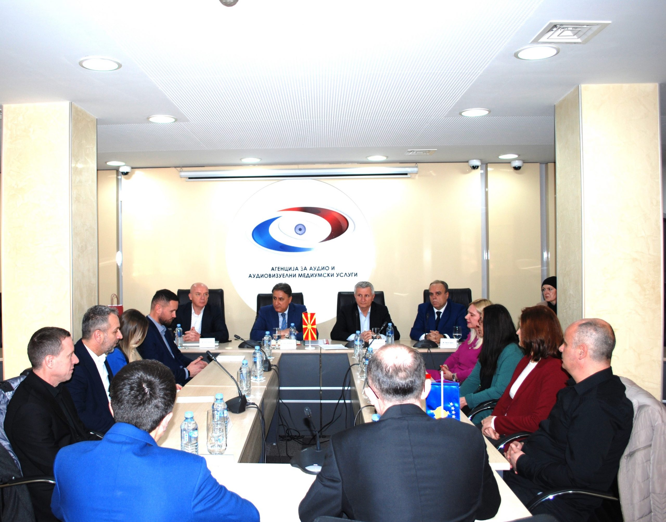](https://avmu.mk/wp-content/uploads/2024/02/Slika-1-scaled.jpg)**

At the end of the meeting, the representatives of the two regulatory bodies concluded that mutual cooperation should continue in the future, through exchanging information in the field of media regulation on issues that are of common interest to both parties.

**February 2024 No.2**

**Citizens May React to the Conduct in the Online Sphere during the Elections**

The announcement of the Parliamentary and Presidential Elections marked the start of the active period for the Coordinating Body for Monitoring Compliance with the Code of Conduct in the Online Sphere during Electoral Processes and Referenda. The Coordinating Body shall act upon complaints against any violations of the Code on the part of the political parties or their candidates, the independent candidates, broadcasters’ internet editions, online media, the fact checkers, influencers and other entities that may influence the public in favour of one’s electoral or referendum campaign.

All citizens and legal entities may send their complaints to the following e-mail address: [koordinativnotelozaizbori@avmu.mk](mailto:koordinativnotelozaizbori@avmu.mk). The complaints may refer to the spread of disinformation (inaccurate, incomplete, false or malicious information), hate speech, discrimination on any grounds, non-compliance with the rules and standards of personal data protection, as well as other forms of unethical conduct on the Internet. The Coordinating Body is composed of representatives of the Association of Journalists of Macedonia, the Macedonian Institute for Media, the Council for Media Ethics of Macedonia, the Institute of Communication Studies, the "Metamorphosis" Foundation and the Agency for Audio and Audiovisual Media Services. Sashe Dimovski of the Association of Journalists of Macedonia was elected Coordinator of the Body, while Olivera Vojnovska of the Metamorphosis Foundation – as its Deputy Coordinator.

**Supervisions over Broadcasters, Operators of Public Electronic Communication Networks and Print Media Publishers**

**Broadcasters**

The Agency conducted regular programmе and administrative supervision into the broadcaster’s compliance with the rules for airing audiovisual commercial communications; protection of juvenile audiences; provision of quizzes and other forms of prize-winning participation; use of value-added telephone services and telephone voting, broadcasting of games of chance; the use of language in their programmes; broadcasting of at least 12 hours of programme on television and at least 18 hours of programme on the radio daily; broadcasting of a specified percentage of programmes originally created as Macedonian audio or audiovisual works daily; publishing of Impressums, information that should be made available to the users, and the broadcasters’ identification symbols, over the TV and radio channels of the public service broadcaster – MRT 1, MRT 2, MRT 3, MRT 4, MRT 5 and MRA 1, MRA 2, MRA 3. The supervision found that, on 2 February 2024, MRT 2 had failed to air the required minimum of 40% of programme originally created as Macedonian audiovisual works.

An ad hoc administrative supervision was carried out over Kompani 21-M TV, Radio PRO-FM and Radio Metropolis to verify if these had met the obligation to provide the staffing requirements under the LAAVMS and the Rulebook on Minimum Technical, Spatial, Financial and Staffing Requirements for Obtaining a Radio or Television Broadcasting License. The supervision found that the broadcasters had met this legal obligation.

Control programme and administrative supervision was carried out as well over Telma TV, Radio Metropolis and Radio Balkan FM in order to establish if the latter had acted upon the previously imposed public warning measures. The supervision showed that these broadcasters had complied in full with the previously imposed measures.

**Operators of Public Electronic Communication Networks**

The Agency conducted regular programme supervision over the following operators: Viva Net, Ultra-Sat 2000, Infel-KTV, Telekabel, Pet Net, Telenet Com, Scramble, Multimedia Network L, Combo 2003 and IP System, concerning their to provide, free of charge, as part of the programme packages that they retransmit, the programme services of the Public Broadcasting Service, as well as the obligations to register their programming services with the Agency and provide subtitling of the programmes they retransmit. The supervision showed that the operators Multimedia Network, Infel KTV and Telenet had been retransmitting programme services that were not covered by the programme service registration certificates issued by the Agency.

**Print Media Publishers**

Regular administrative supervision was conducted over 19 print media publishers in order to establish if they had published data such as the name and address of their head office and the editorial office of the print media outlet, details about the responsible person, the editors, the printing house, date of print or reprint and circulation data, in accordance with the relevant obligation laid down in the Media Law. The supervision showed that the print media publishers had fulfilled the relevant legal obligations.

Control administrative supervision was conducted over KOLOR MEDIA PLUS, publisher of the "The Economist" magazine, to determine whether the Decision to impose a public warning measure, due to failure to publish the address of the print media publisher’s headquarters, the address of the printing house, the date of print or reprint and the circulation, had been acted upon. The supervision established that the print media publisher had partly acted upon the Decision on imposing a measure, i.e. had failed to publish some of the data for which it had been reprimanded in its December 2023 issue no. 6, as follows: address of the print media publisher’s headquarters (which had not been published in the issue no. 5 either), and had additionally failed to publish the address of the editorial office of the print media publisher.

**Imposed Public Warning Measures**

Based on the findings of the regular programme supervisions conducted, at its 6th Session held on 19 February 2024, the Agency Council adopted three Decisions on imposing public warning measures against the operators of Multimedia Network L from Gostivar, Telenet Kom from Tetovo and Infel-KTV from Ohrid.

The measures were imposed for retransmitting programme services that are not covered by the programme service registration certificates issued by the Agency.

