**Public Debate Opened on the Draft Rulebook on Registering the Providers of Video-Sharing Platform Services**

At its 45th Session held on 12 December 2024, the Agency Council adopted the [Draft Rulebook on Registering the Providers of Video Sharing Platform Services](https://avmu.mk/wp-content/uploads/2024/12/%D0%9D%D0%B0%D1%86%D1%80%D1%82-%D0%BF%D1%80%D0%B0%D0%B2%D0%B8%D0%BB%D0%BD%D0%B8%D0%BA-%D0%B7%D0%B0-%D1%80%D0%B5%D0%B3%D0%B8%D1%81%D1%82%D1%80%D0%B8%D1%80%D0%B0%D1%9A%D0%B5-%D0%BD%D0%B0-%D0%B4%D0%B0%D0%B2%D0%B0%D1%82%D0%B5%D0%BB%D0%B8%D1%82%D0%B5-%D0%BD%D0%B0-%D1%83%D1%81%D0%BB%D1%83%D0%B3%D0%B8-%D0%BF%D0%BE-%D0%BF%D0%BB%D0%B0%D1%82%D1%84%D0%BE%D1%80%D0%BC%D0%B0-%D0%B7%D0%B0-%D1%81%D0%BF%D0%BE%D0%B4%D0%B5%D0%BB%D1%83%D0%B2%D0%B0%D1%9A%D0%B5-%D0%B2%D0%B8%D0%B4%D0%B5%D0%B0.pdf). This bylaw regulates the format and the content of the application form and the Register of Video-Sharing Platform Service Providers, which will be maintained by the Agency.

The Agency invited all interested parties to participate in the public debate by submitting their opinions and proposals in writing, electronically, to the following e-mail address: [contact@avmu.mk](mailto:contact@avmu.mk). The public debate will last until 13 January 2025, conclusive.

A workshop on “Enhancing Media Reporting on Gender-Based Violence” was held on 5 December 2024, organized by the Council of Europe’s Programme Office in Skopje and the Agency for Audio and Audiovisual Media Services. The workshop was intended for media workers from the local radio and television stations and was attended by other professionals in the field as well.

**Workshop Held on Enhancing Media Reporting on Gender-Based Violence**

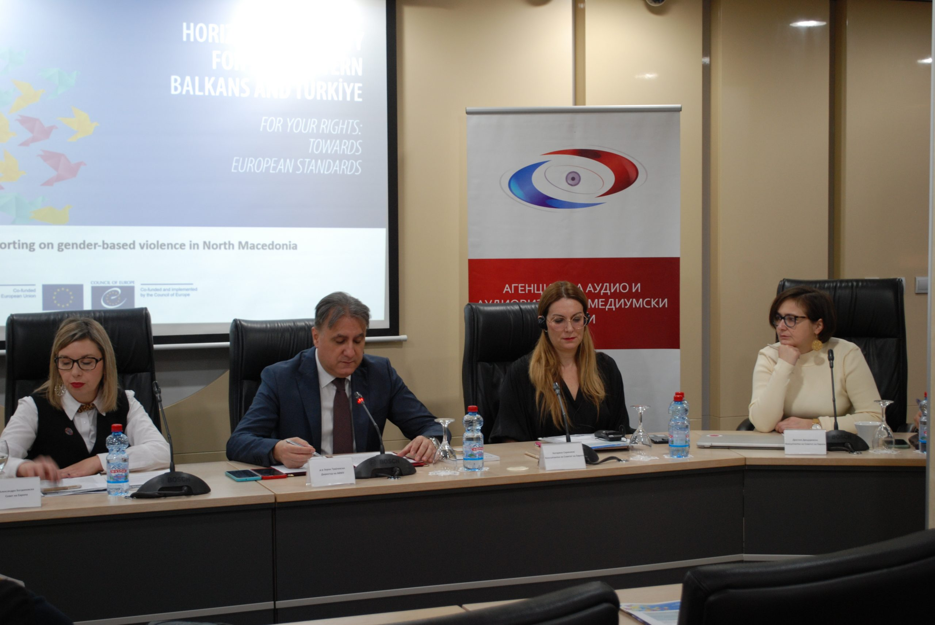

“Gender stereotypes are a complex social phenomenon that hinder gender equality, reinforce harmful discourses in the media and in society as a whole, and are also a cause for gender-based violence. Media outlets and media professionals play a particularly important role and responsibility in raising awareness of the gender issues and in promoting gender equality,” AVMU Director Zoran Trajchevski, PhD, emphasized at the beginning of the event.

Aleksandra Bogdanovska of the Council of Europe highlighted the importance of the project for “Protection of the Freedom of Expression and Freedom of the Media in North Macedonia (PRO-FREX)” under which this workshop was carried out, and which enables the beneficiary institutions and civil society organizations in the country to advance in fulfilling their reform agendas in the area of ​​freedom of expression and freedom of the media, in accordance with the European standards. Ana Nushkova-Avramovska, legal advisor at the National Network to End Violence against Women and Domestic Violence, spoke about the relevant national legislation and the system for protecting victims of gender-based violence, while media expert Marina Tuneva, PhD, presented to the attendees the Handbook for Gender-Sensitive Reporting in the Media, which aims to assist media in their efforts to report professionally in a gender-sensitive manner, and thus to draw attention to the problem of gender-based violence.

Dragana Drndarevska, member of the Commission for Preventing and Protection against Discrimination, spoke about the intersectoral approach to addressing gender-based violence, then about the importance of journalistic reporting and the manner of framing topics related to domestic and gender-based violence, gender equality and the LGBTI community, as well as about the need to take into account the intersectionality of discrimination, i.e. the situations in which a person is being discriminated against on multiple grounds. The Agency’s Guide for monitoring the implementation of the reporting standards in cases of gender-based violence in the media was presented by its author, Prof. Dr. Katharine Sarikakis of the University of Vienna. The document is designed to provide clear standards and criteria aimed at assessing given content when reporting on gender-based violence, which can also serve as a roadmap for the media to resolve dilemmas in their reporting. While moderating the event, Emilija Petreska-Kamenjarova, M.A., of the AVMU reminded that media play an important role in shaping society’s viewpoints and values ​​and offer enormous potential as instruments for social change..

**AVMS Holds its Fourth Public Meeting in 2024**

**[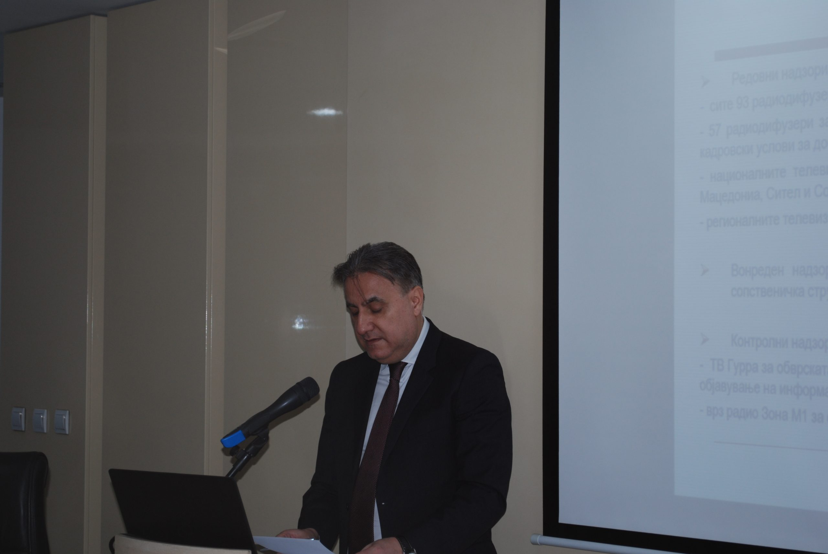](https://avmu.mk/wp-content/uploads/2024/12/1-scaled.jpg)**

Also mentioned at the event were the activities related to international and EU cooperation, the initiated procedures for revoking the licenses of certain broadcasters, the decisions to announce public calls for granting radio broadcasting licenses, etc. The presentation of the activities carried out according to the Annual Work Programme for the period October-December 2024, is available at this [**link**.](https://avmu.mk/wp-content/uploads/2024/12/%D0%9F%D1%80%D0%B5%D0%B7%D0%B5%D0%BD%D1%82%D0%B0%D1%86%D0%B8%D1%98%D0%B0-%D0%A7%D0%B5%D1%82%D0%B2%D1%80%D1%82%D0%B8-%D1%98%D0%B0%D0%B2%D0%B5%D0%BD-%D1%81%D0%BE%D1%81%D1%82%D0%B0%D0%BD%D0%BE%D0%BA-%D0%B7%D0%B0-2024.ppt)

On 25 December 2024, the Agency for Audio and Audiovisual Media Services held its last public meeting for 2024. At the meeting, Director Zoran Trajchevski presented a review of the activities carried out in accordance with the Annual Work Programme in the past three months. Those attending had an opportunity to hear about the activities related to the conducted programme and administrative supervisions over broadcasters, operators of public electronic communication networks and print media publishers, as well as the public warning measures imposed on those entities that had violated the Law on Media or the Law on Audio and Audiovisual Media Services.

**December 2024 No.12**

**Supervisions over Broadcasters**

The Agency carried out regular administrative and programme supervision over “Marija Blagovest” Radio from Strumica, Student FM 92.9 University Radio from Skopje, UKLO FM University Radio from Bitola and UGD FM University Radio from Shtip, concerning several legal obligations, such as use of language in the programming, broadcasting of at least 4 hours of radio programming daily, publishing Impressums, airing information that should be made available to the users, publishing the broadcaster’s identification sign, the rules for broadcasting audio commercial communications, obligations related to providing quizzes or other forms of prize winning participation, use of value-added telephone services and telephone voting and broadcasting games of chance. The Agency established that the Student FM 92.9 Radio and the UGD FM Radio from Shtip could not be supervised because they had not broadcasted any type of programming with journalistic and editorial involvement. Regular administrative supervision regarding fulfillment of the minimum staffing requirements laid down in the Rulebook on the Minimum Technical, Spatial, Financial and Staffing Requirements for obtaining a Radio or Television Broadcasting License was carried out over Kanal Vis TV from Strumica. The supervision showed that this broadcaster had not met the minimum staffing requirements, i.e. the responsible editor did not have a regular employment status and was not engaged as a full-time employee by the broadcaster.

Control supervisions were carried out as well, over several broadcasters. Kompani 21-M TV, Zone M-1 Radio, Sitel TV and Sonce TV underwent control programme supervision regarding their obligations related to the use of language in their programmes, broadcasting of at least 30% of music in the Macedonian language in the period from 06:00 to 00:00 :00 hrs out of the total amount of music broadcasted during the analyzed day and night, and the protection of minors from programmes that could harm their physical, mental or moral development. The supervision established that these broadcasters had acted in accordance with the LAAVMS’ obligations.

Control programme supervision was carried out over KTV TV, EDO TV and Shenja TV, concerning the obligations to broadcast programming in the Macedonian language and the Cyrillic script and, in the cases where the programme was intended for a community that did not constitute the majority, in the language and script of that community, as well as the obligation to broadcast 30% of programme originally created as Macedonian audio or audiovisual works daily. The supervision showed that these broadcasters had acted in accordance with the obligations arising from the LAAVMS.

Control programme supervision concerning the obligation to protect minors from programmes that could harm their physical, mental or moral development was carried out over Shenja TV, and Klan Macedonia TV. The supervision found that Kompani 21-M TV had broadcasted a feature programme that contained an incorrect warning signalization for a second category programme (8+), while Shenja TV had only partially acted upon a decision imposing a public warning measure against it. Control administrative supervision was carried out over Kanal Vis TV from Strumica, in order to verify if it met the minimum staffing requirements laid down in the Rulebook on the Minimum Technical, Spatial, Financial and Staffing Requirements for obtaining a Radio or Television Broadcasting License. The supervision established that this broadcaster did not meet the minimum staffing requirements of this Rulebook, which was why his TV broadcasting license was revoked.

**Public Warning Measures Imposed**

At its 44th Session held on 5 December, the Agency Council imposed three public warning measures due to non-compliance with the LAAVMS provisions. A public warning measure was issued against Edo TV for not broadcasting at least 30% of programme originally created as Macedonian audiovisual works, to KTV TV due to non-compliance with the language use rules in the programme, and against Star TV due to non-compliance with the rules for the protection of juvenile audiences.

At its 46th Session held on 25 December, the Agency Council issued several public warning measures against five broadcasters due to non-compliance with the provisions of the Law on AAVMS and the Law on Media. Four public warning measures were imposed against TV News due to failure to broadcast at least 30% of the programme originally created as Macedonian audiovisual works, provide information that should be made available to its users, publish Impressum data in several programmes and due to mislabeling and insufficient minors’ protection signaling in several broadcasted programmes. Public warning measures were issued against Due TV due to failure to broadcast the legally required minimum of programme created as Macedonian audiovisual works, provide translation of foreign programmes into the Albanian language and due to inadequate signaling and airtime of fourth-category programmes. Protel TV received a public warning measure due to wrong classification and insufficient signaling for the protection of minors during the broadcast of a feature film, Spektra TV – due to inappropriate labeling and airtime of certain feature films, and Svet TV – due to incorrect warning signals before the broadcast of certain documentaries and feature films.

