# **Ambassador of France Christophe Le Rigoleur Pays Working Visit to AVMU**

**[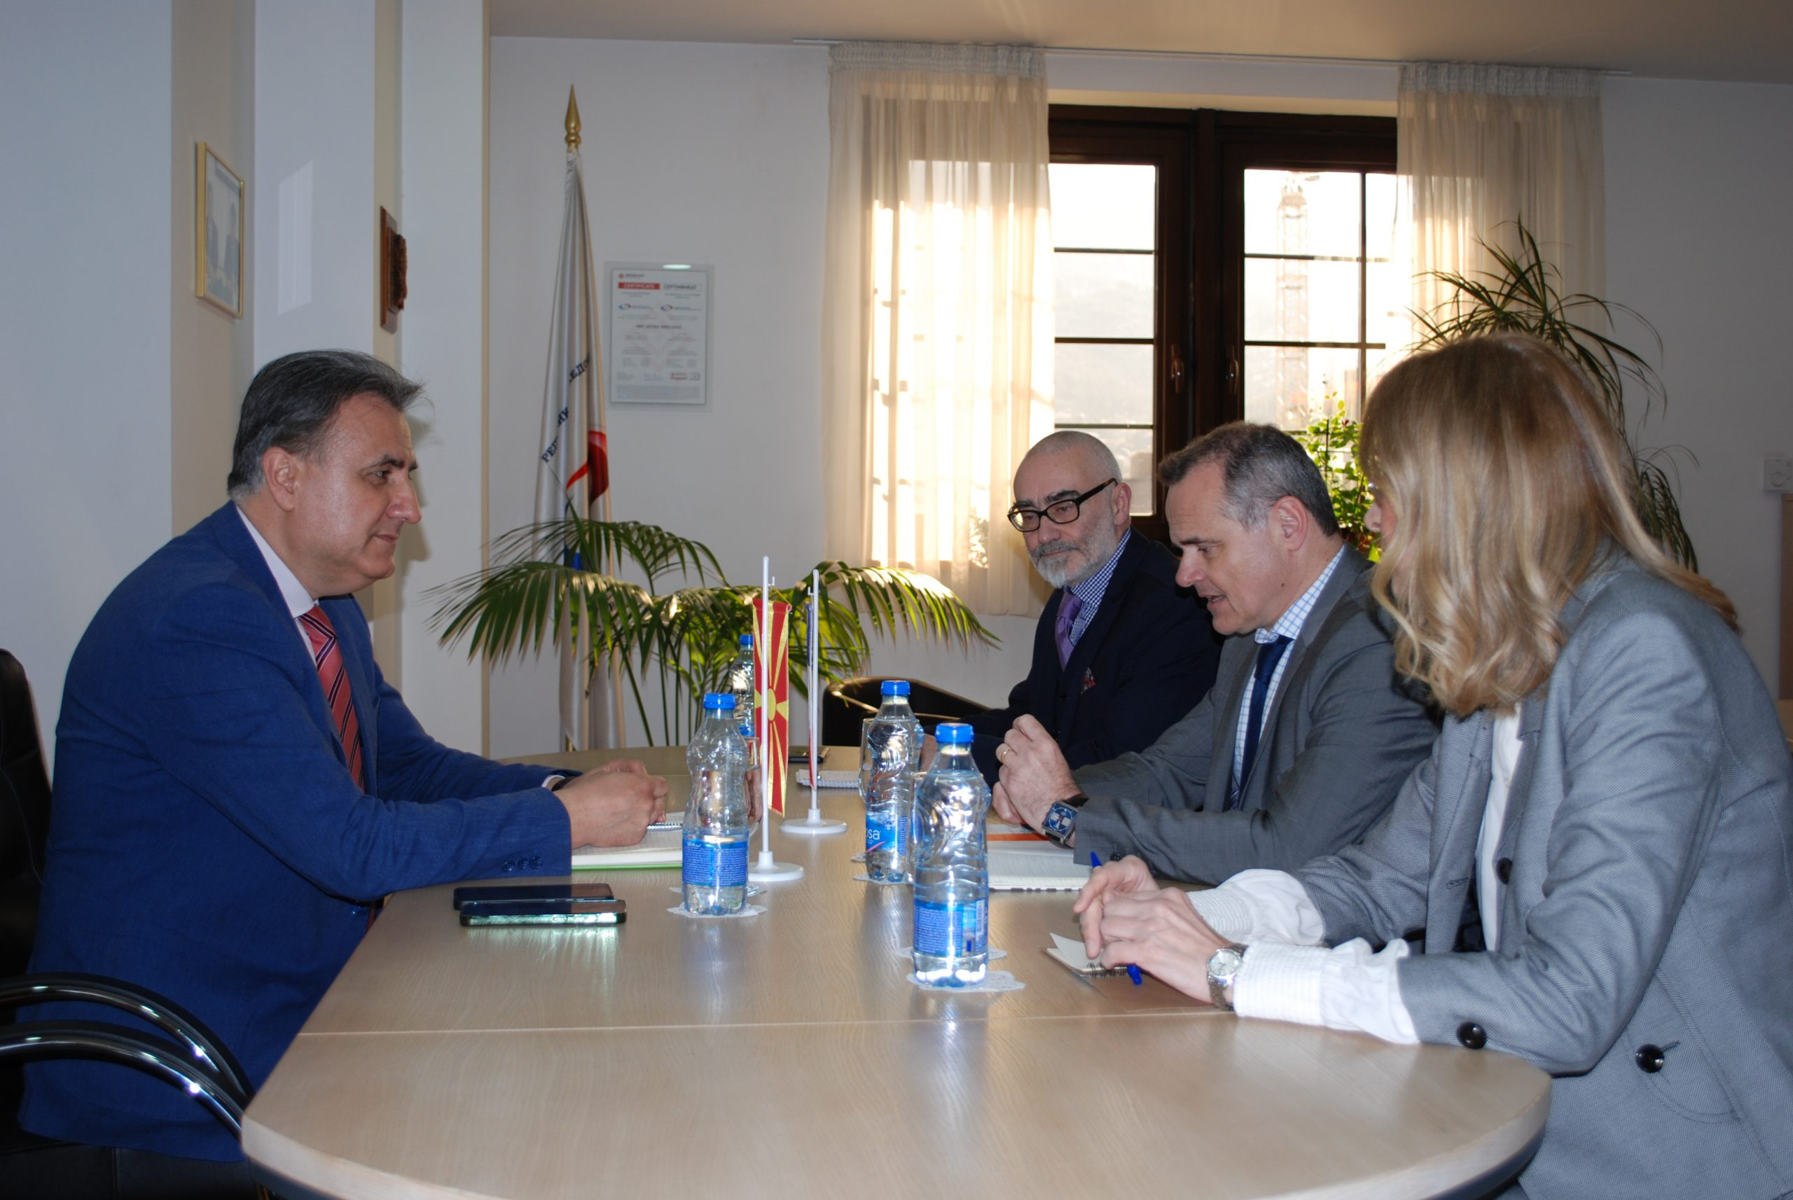](https://avmu.mk/wp-content/uploads/2025/03/AVMU--scaled.jpg)**

Discussed at the meeting were the regulator’s work and the challenges it faces, the implementation of the Macedonian legislation that has been aligned with the European Union’s Audiovisual Media Services Directive and the need for its further alignment with the EU acts and standards, as well as the Electoral Code in terms of the media and the monitoring of media coverage of elections.

At the end of the meeting, the parties expressed their commitment to extend and intensify mutual cooperation.

**AVMU Holds Its First Public Meeting in 2025**

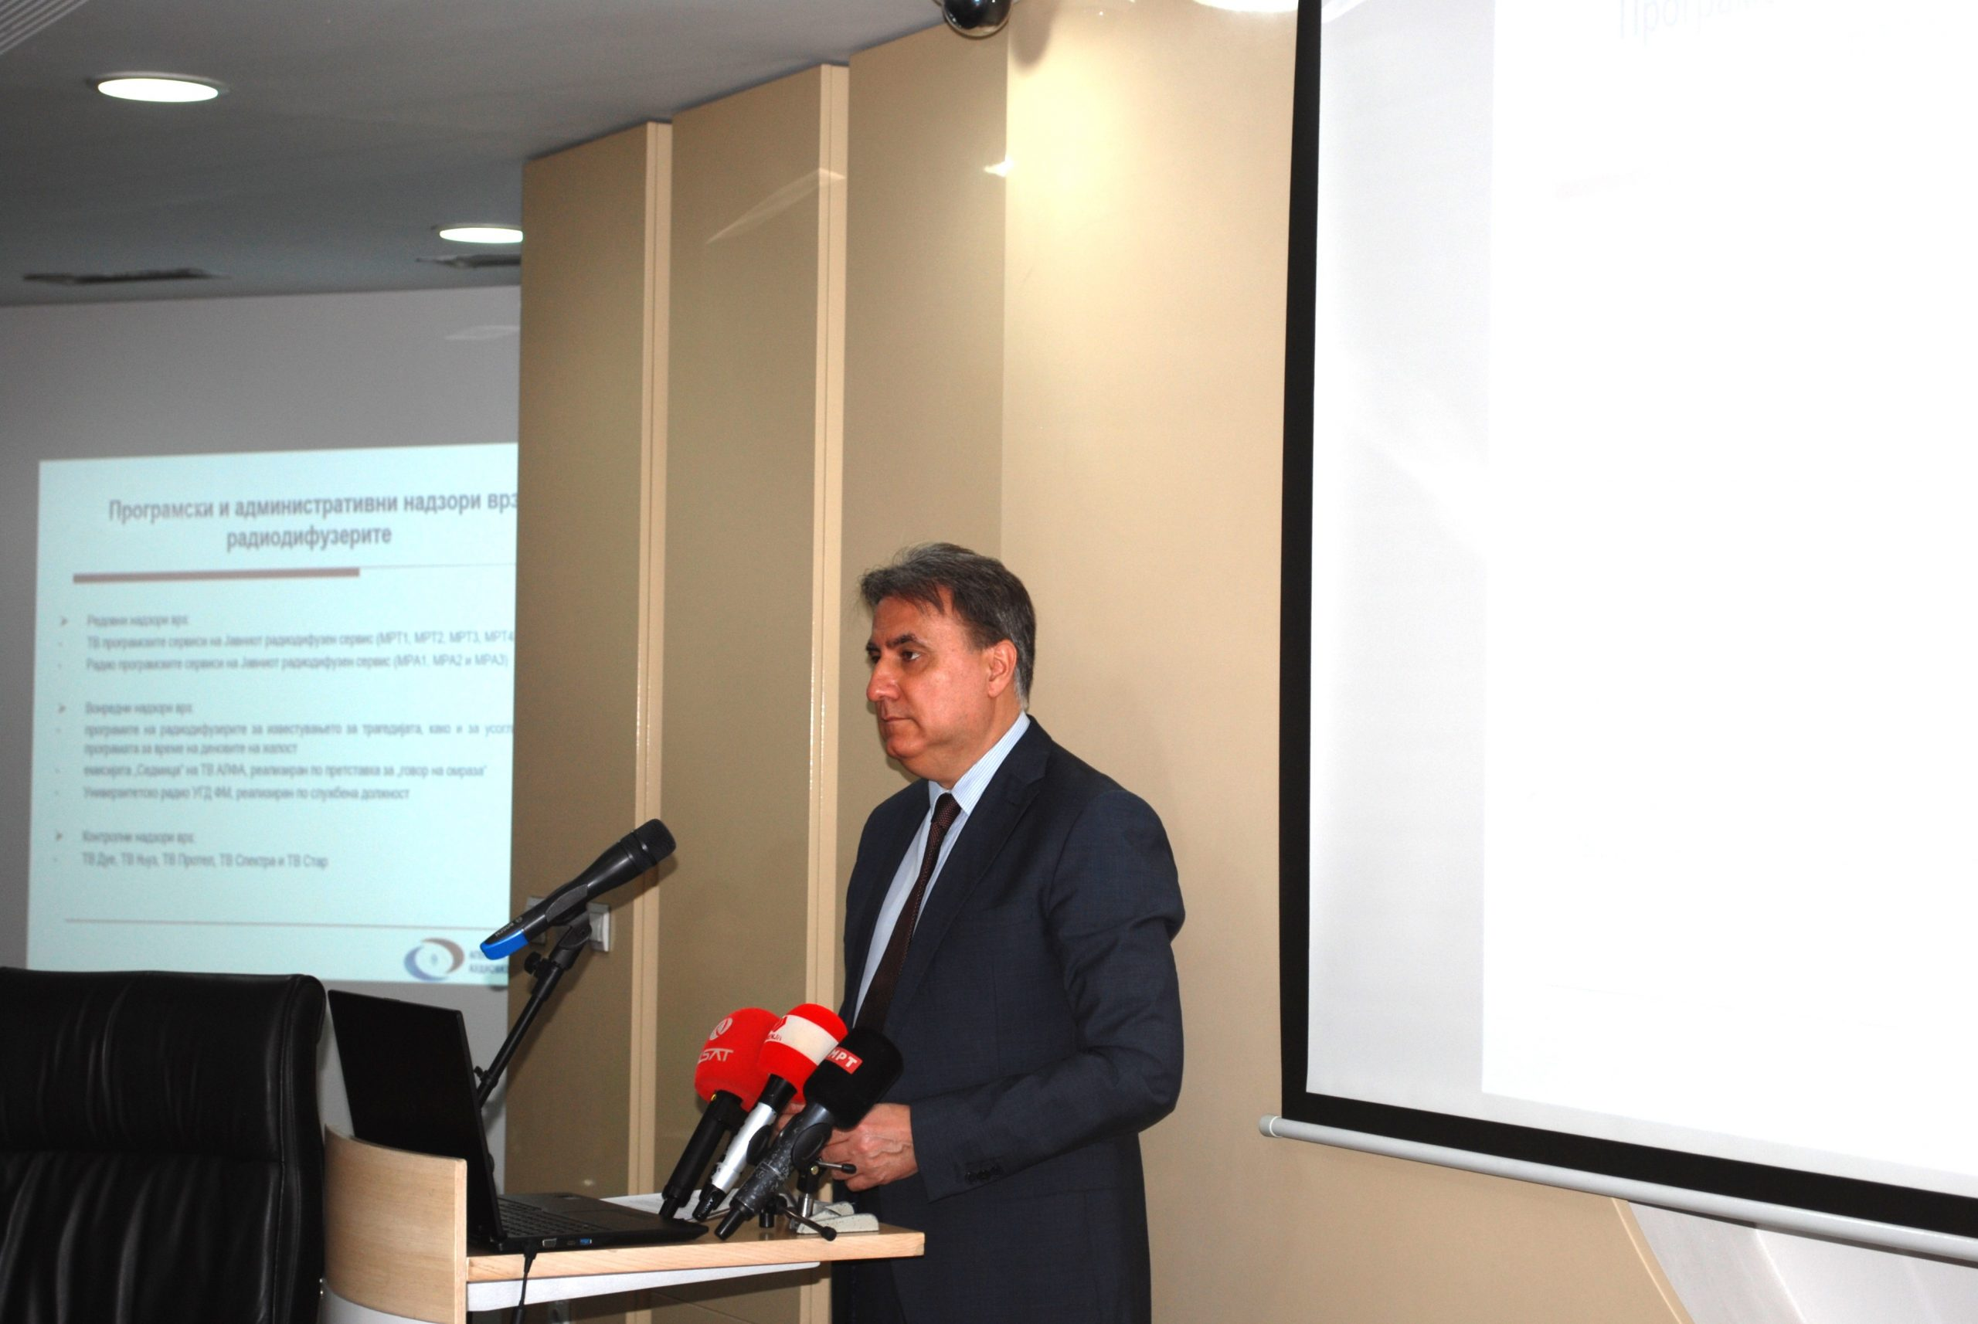

Also mentioned at this event were the activities related to the international and EU cooperation, the initiated procedures for revoking broadcasters’ licenses, the decisions revoking and granting broadcasting licenses, the donation of MKD 1,500,000 to the victims of the fire in Kochani, etc.

The presentation of the activities carried out in accordance with the Annual Work Programme for the period January-March 2025 is available at this [link](https://avmu.mk/wp-content/uploads/2025/03/%D0%9F%D1%80%D0%B5%D0%B7%D0%B5%D0%BD%D1%82%D0%B0%D1%86%D0%B8%D1%98%D0%B0-%D0%9F%D1%80%D0%B2-%D1%98%D0%B0%D0%B2%D0%B5%D0%BD-%D1%81%D0%BE%D1%81%D1%82%D0%B0%D0%BD%D0%BE%D0%BA-%D0%B7%D0%B0-2025.ppt)

**Press Releases**

Агенцијата за аудио и аудиовизуелни медиумски услуги на 16 март преку соопштение за јавност изрази длабоко жалење во врска со трагедијата On 16 March 2025, the Agency for Audio and Audiovisual Media Services expressed its deepest condolences for the tragedy that took place in a Kochani disco club. The Agency called on the media to be particularly careful with their reporting so as to show respect for the dignity of the victims and not cause additional pain to their families. The Press Release underlined that the media should ensure balance between the public’s right to be informed and the personal pain and grief, and should avoid airing explicit scenes/photographs/footages of the incident, i.e. should strictly abide by the professional and ethical standards. When publishing sensitive content, the same should be labelled using appropriate visual and/or acoustic warnings.

After the Government of the RNM declared a seven-day period of mourning on the entire territory of the country, the Agency advised the media that they would air/publish content that, by its media function, is appropriate for days of mourning. The music that they were to broadcast should belong to the musical genres appropriate for days of mourning, while the broadcasting of entertainment shows, funny shows or comedy programmes should be postponed until after the mourning period. The broadcast of advertisements, i.e. all forms of commercial communications, were also to be postponed until the end of the days of mourning. During the days of mourning, broadcasters were exempt from the obligation to broadcast certain percentage of domestic music.

On 19 March, the Agency informed that, further to the tragic fire disaster in Kochani, it had adopted a decision at the 12th Session of the agency Council, to grant financial assistance, i.e. donation, in the total amount of MKD 1,500,000.00. The donation was transferred via the Red Cross Organization of the Republic of North Macedonia to a dedicated account – the Solidarity Fund.

Director of the Agency for Audio and Audiovisual Media Services Dr. Zoran Trajchevski had a working meeting with H.E. Mr. Christophe Le Rigoleur, Ambassador of the French Republic and his delegation on 21 March 2025, at the Agency premises. At the very start of the meeting, Ambassador Le Rigoleur expressed his deep condolences for the victims of the tragic fire in Kochani and conveyed the messages of sympathy from the French people in these difficult moments for the Macedonian citizens.

The Agency for Audio and Audiovisual Media Services held its first public meeting for this year on the 26th of March, starting with Director Zoran Trajchevski’s overview of the activities carried out in accordance with the Annual Work Programme for the first quarter of 2025. Those present had an opportunity to hear about the activities related to the conducted programme and administrative supervisions over broadcasters, operators of public electronic communication networks and print media publishers, as well as the public warning measures imposed on those entities that had violated the Law on Media or the Law on Audio and Audiovisual Media Services.

**March 2025 No.3**

On 20 March, the Agency called on the media once again to adhere to the highest professional and ethical standards in reporting on the funerals of the victims of the tragic fire in Kochani. The Press Release underlined that, when conveying information, including via the social networks, it was mandatory to respect the personal pain and grief of the families, relatives and close persons of the deceased, and to allow them to say goodbye to their deceased loved ones with dignity. The media outlets were not to publish photos or footages of the graves or close family members and were to respect these private moments so as not to further increase the pain of the bereaved.

On 21 March, a Press Release was issued most strongly condemning the hate speech and the calls for violence against media and journalists. The Press Release indicated that the calls to attacks on media and media workers posed direct threats to journalists’ safety and constituted attacks on the freedom of expression as well. The Agency reminded the media outlets once again to pay utmost attention to the content of the shows, movies and series when creating their respective programmes, in particular to what meaning they could have in the context of these sensitive moments. The information and content published should be appropriate for days of mourning and should at the same time observe the highest professional and ethical journalistic standards.

**Overview of programmes accessible for persons with sensory impairments in 2025**

On 13 March 2025, the Agency published an [Overview of the Programmes that Media Service Providers Shall Make Accessible in 2025 to Persons with Sensory Impairments, In Accordance with Their Respective Action Plans](https://avmu.mk/wp-content/uploads/2025/03/%D0%9F%D1%80%D0%B5%D0%B3%D0%BB%D0%B5%D0%B4-%D0%BD%D0%B0-%D0%B4%D0%BE%D1%81%D1%82%D0%B0%D0%B2%D0%B5%D0%BD%D0%B8-%D0%B3%D0%BE%D0%B4%D0%B8%D1%88%D0%BD%D0%B8-%D0%B0%D0%BA%D1%86%D0%B8%D1%81%D0%BA%D0%B8-%D0%BF%D0%BB%D0%B0%D0%BD%D0%BE%D0%B2%D0%B8-%D0%B7%D0%B0-%D0%BF%D1%80%D0%B8%D1%81%D1%82%D0%B0%D0%BF%D0%BD%D0%BE%D1%81%D1%82-%D0%B7%D0%B0-2025-%D0%B3%D0%BE%D0%B4%D0%B8%D0%BD%D0%B0-02-%D0%B2%D0%B5%D1%80.docx). According to the Law on Audio and Audiovisual Media Services, media service providers are obliged to take continuous and progressive steps to ensure the accessibility of their services to persons with disabilities. In order to operationalize this obligation, the Agency had prepared a Rulebook on Media Services Accessibility, which the Agency Council adopted on 13 June 2024, and on the basis of which the media services concerned submitted annual action plans for 2025.

For all issues related to media services accessibility, the Agency has established an e-mail address, [dostapnost@avmu.mk](mailto:dostapnost@avmu.mk). This contact point serves to obtain information, submit complaints, submit action plans and reports, as well as to exchange relevant information.

The Overview of the programmes that media service providers, will make accessible to persons with sensory impairments in the course of 2025 in accordance with their respective action plans, can be downloaded at the following [link](https://avmu.mk/wp-content/uploads/2025/03/%D0%9F%D1%80%D0%B5%D0%B3%D0%BB%D0%B5%D0%B4-%D0%BD%D0%B0-%D0%B4%D0%BE%D1%81%D1%82%D0%B0%D0%B2%D0%B5%D0%BD%D0%B8-%D0%B3%D0%BE%D0%B4%D0%B8%D1%88%D0%BD%D0%B8-%D0%B0%D0%BA%D1%86%D0%B8%D1%81%D0%BA%D0%B8-%D0%BF%D0%BB%D0%B0%D0%BD%D0%BE%D0%B2%D0%B8-%D0%B7%D0%B0-%D0%BF%D1%80%D0%B8%D1%81%D1%82%D0%B0%D0%BF%D0%BD%D0%BE%D1%81%D1%82-%D0%B7%D0%B0-2025-%D0%B3%D0%BE%D0%B4%D0%B8%D0%BD%D0%B0-02-%D0%B2%D0%B5%D1%80-4.pdf)

**Supervisions over broadcasters and operators of public electronic communication networks**

Regular programme supervisions over the compliance with several legal obligations were carried out on Nasha TV, 21-M TV, 24 Vesti TV, Klan Macedonia TV, Shenja TV and Sonce TV. The supervisions covered the obligations for the use of language in the programmes; for broadcasting at least 12 hours of television programming daily and broadcasting at least 30% of originally created Macedonian audio or audiovisual works daily; the rules for broadcasting audiovisual commercial communications; minors’ protection from programmes that could harm their physical, mental or moral development; protection of minors’ personal data; provision of quizzes or other forms of prize-winning participation; use of value-added telephone services and telephone voting, and for broadcasting games of chance. The supervisions found several violations on the part of certain broadcasters against various provisions of the LAAVMS. The Nasha TV programme broadcasted on 4 March contained pop-ups/split-screen advertisements in the premieres and reruns of the shows "Project Health", "Building to Last" and "Cooked Above the Clouds", which did not abide by the prescribed interval of at least 15 minutes in between.

Three violations were detected in the TV 21-M programme aired on 4 March, in the premiere edition of the show "Thirre 21-shin (Call 21)”: pop-ups/split-screen advertisements were broadcast without abiding by the prescribed period of at least 15-minute interval in between, and covert audiovisual commercial communication promoting "Optika Capri" was broadcast without adhering to the obligations applicable to prize-winning participation programmes. The specialized information show titled "Health Factor with Biljana Debarlieva" aired by the 24 Vesti TV on 4 March, did not abide by the product placement requirements in the audiovisual programmes, nor the rules for labelling programmes containing product placement, while the Klan Macedonia TV programme broadcasted on 4 March aired episodes of the drama series titled “Nënë (Mother)", "Merjem" and "Tradhetia (Infidelity)", which are labelled as Category 3 programmes(12+), at inappropriate time slots of the programming service.

Klan Macedonia TV and Shenja TV had failed to broadcast the 30% minimum of programme originally created as Macedonian audiovisual works, nor did they broadcast at least half of the legal minimum for originally created programmes as Macedonian audiovisual works in the period from 7:00 hrs to 19:00 hrs. Only Sonce TV was not found to have violated the legal provisions.

Regular administrative supervision was also conducted over the same television stations regarding the obligations to publish an Impressum, information that should be made available to the users, and the obligation to publish the identification sign of the broadcaster. During the supervision, violations were found with 21-M TV, Klan Macedonia TV and Shenja TV. 21-M TV had not published Impressum data in its shows titled “#21 Reportazhe” and “Për ditë të mjër”; Klan Macedonia TV had not published Impressum data in the educational programmes with religious content on the occasion of Ramadan "Merr Frymë" ("Breathe") and "N'konak te Hoxha" ("In the Hoxha's Residence"), and the current affairs-information programme "Klan debat", nor had it published the information that should be made available to the users. Shenja TV had not published Impressum data in the documentary programme "Al Jazeera hulumton (Al Jazeera – Investigations)".

Control programme supervision was also carried out over Spektra TV, to establish if the broadcaster had acted upon the public warning measures issued due to its non-compliance with the obligation to broadcast programmes in the Macedonian language and the Cyrillic script and its failure to broadcast at least 30% of programme originally created as Macedonian audio or audiovisual works daily. The supervision found that the television station at issue had not acted in tune with one of the public warning measures, i.e. its programme broadcasted on 20 February had not broadcasted at least 30% of programme originally created as Macedonian audiovisual works.

As part of its duty, the Agency also conducted an ad hoc programme supervision over the work of the University Radio UGD FM in order to determine whether this broadcaster had been implementing the programming concept as specified in its broadcasting license. The ad hoc supervision established that, in the programme aired in the period from 10 to 16 February, the broadcaster had not realized the required minimum of 80% of the programming concept for which it had been issued a broadcasting license,.

**Operators of public electronic communication networks**

The Agency carried out regular programme supervisions over the operators of Viva Net, Kabel-L-Net, Makedonski Telekom, Neotel, Telenet Kom and Infel-KTV regarding their obligation to provide, obligatorily and free of charge, as part of their respective programme packages, the programme services of the Public Broadcasting Service, as well as the obligations to register their programme services with the Agency and provide subtitles for the programmes they retransmit. The supervisions found no violations.

