The Members of the Council of the Agency for Audio and Audiovisual Media Services, appointed by the Assembly of the Republic of North Macedonia on 24 June 2025, held a Constitutive Session on 3 July 2025. At the Session, in accordance with the Law on Audio and Audiovisual Media Services and the Agency’s Rules of Procedure, they elected the Council’s President and Vice President. Mr. Sasho Stefanovski was elected President, while Ms. Zirjeta Hajro Jajaga is the new Vice President.

Apart from Sasho Stefanovski and Zirieta Hajro Jajaga, the new Council of the Agency for Audio and Audiovisual Media Services also includes Afrona Vrzivoli, Viktor Pavlovski, Gordana Majnova, Petar Djurovski and Cvetanka Minovska.

.

**Public Hearing Opened on the Draft-Guidelines Amending and Supplementing the Guidelines for Verifying the Reports on Broadcast Paid Political Advertising**

At its 5th Session held on 21 July 2025, the Agency Council adopted the [Draft-Guidelines Amending and Supplementing the Guidelines for Verifying the Reports on Broadcast Paid Political Advertising](https://avmu.mk/wp-content/uploads/2025/07/%D0%9D%D0%B0%D1%86%D1%80%D1%82-%D0%A3%D0%BF%D0%B0%D1%82%D1%81%D1%82%D0%B2%D0%BE-%D0%B7%D0%B0-%D0%B8%D0%B7%D0%BC%D0%B5%D0%BD%D0%B0-%D0%B8-%D0%B4%D0%BE%D0%BF%D0%BE%D0%BB%D0%BD%D1%83%D0%B2%D0%B0%D1%9A%D0%B5-%D0%BD%D0%B0-%D1%83%D0%BF%D0%B0%D1%82%D1%81%D1%82%D0%B2%D0%BE%D1%82%D0%BE-%D0%B7%D0%B0-%D0%BF%D0%BE%D1%82%D0%B2%D1%80%D0%B4%D1%83%D0%B2%D0%B0%D1%9A%D0%B5-%D0%BD%D0%B0-%D0%B8%D0%B7%D0%B2%D0%B5%D1%88%D1%82%D0%B0%D0%B8%D1%82%D0%B5-%D0%B7%D0%B0-%D0%B5%D0%BC%D0%B8%D1%82%D1%83%D0%B2%D0%B0%D0%BD%D0%BE-%D0%9F%D0%9F%D0%A0.pdf).

The Agency invited all interested parties to take part in the public hearing by submitting their opinions and proposals regarding the Draft-Guidelines in writing, electronically, to the following email address: [contact@avmu.mk](mailto:contact@avmu.mk). The public hearing will remain open for 45 days, ending on 5 September 2025.

**Public Hearing Opened on the Draft Rules of Procedure of the Agency for Audio and Audiovisual Media Services**

At its 5th Session held on 21 July 2025, the Council of the Agency adopted the [Draft Rules of Procedure of the Agency for Audio and Audiovisual Media Services.](https://avmu.mk/wp-content/uploads/2025/07/%D0%9D%D0%B0%D1%86%D1%80%D1%82-%D0%94%D0%B5%D0%BB%D0%BE%D0%B2%D0%BD%D0%B8%D0%BA-%D0%B7%D0%B0-%D1%80%D0%B0%D0%B1%D0%BE%D1%82%D0%B0-%D0%BD%D0%B0-%D0%90%D0%92%D0%9C%D0%A3_compressed-2.pdf)

The Agency invited all interested parties to take part in the public hearing by submitting their comments and suggestions regarding the Draft Rules of Procedure in writing, electronically, to the following e-mail address: [contact@avmu.mk](mailto:contact@avmu.mk). The public hearing shall be open for 30 days, ending on 20 August 2025.

**Public Hearing Opened on the Draft Guidelines Amending and Supplementing the Guidelines on Establishing the Deadline for Acting upon the Agency’s Decisions to Take Measures**

On 7 July 2025, the Agency for Audio and Audiovisual Media Services opened a public hearing on the [Draft Guidelines Amending and Supplementing the Guidelines for Establishing the Deadline for Acting upon the Agency’s Decisions to Take Measures](https://avmu.mk/wp-content/uploads/2025/07/%D0%9D%D0%B0%D1%86%D1%80%D1%82-%D0%A3%D0%BF%D0%B0%D1%82%D1%81%D1%82%D0%B2%D0%BE-%D0%B7%D0%B0-%D0%B8%D0%B7%D0%BC%D0%B5%D0%BD%D1%83%D0%B2%D0%B0%D1%9A%D0%B5-%D0%B8-%D0%B4%D0%BE%D0%BF%D0%BE%D0%BB%D0%BD%D1%83%D0%B2%D0%B0%D1%9A%D0%B5-%D0%BD%D0%B0-%D0%A3%D0%BF%D1%82%D0%B0%D1%81%D1%82%D0%B2%D0%BE%D1%82%D0%BE.pdf).

The amending and supplementing of the Guidelines stems from the amendments to the 2023 Law on Audio and Audiovisual Media Services and the amendments to the Law on Media of 2025. The purpose of these changes is to establish deadlines for the new entities (online media outlets/Internet portals and video sharing platform service providers) for acting upon the public warning measures. Deadlines have also been added for the new provisions of the LAAVMS for ensuring accessibility to content for persons with disabilities and for the protection of minors’ personal data. Also proposed is to harmonize the duration of the deadlines for all entities.

The Agency invited the online media outlets/Internet portals, video sharing platform service providers, operators of public electronic communication networks, all broadcasters and interested parties, to take part in the public hearing by sending their opinions and proposals, in writing, electronically, to the following email address: [contact@avmu.mk](mailto:contact@avmu.mk). The public hearing shall last 60 days, until 4 September 2025 inclusive.

**Press Release**

The Agency for Audio and Audiovisual Media Services issued a Press Release on 9 July 2025, in which most strongly condemned the physical attack on the Alsat-M television journalist crew, which had been documenting the fire at the Vizbegovo landfill. In the Press Release it pointed out that journalists’ safety was an essential prerequisite for professional and independent reporting, which in turn was the foundation of the citizens’ right to be informed in an accurate, timely and objective fashion.

It is essential that journalists have the opportunity to freely and safely perform their professional duties in the interest of the public. Therefore, violence against media workers, in any form, is absolutely unacceptable and must be clearly sanctioned.

**New AVMU Council Constituted**

**[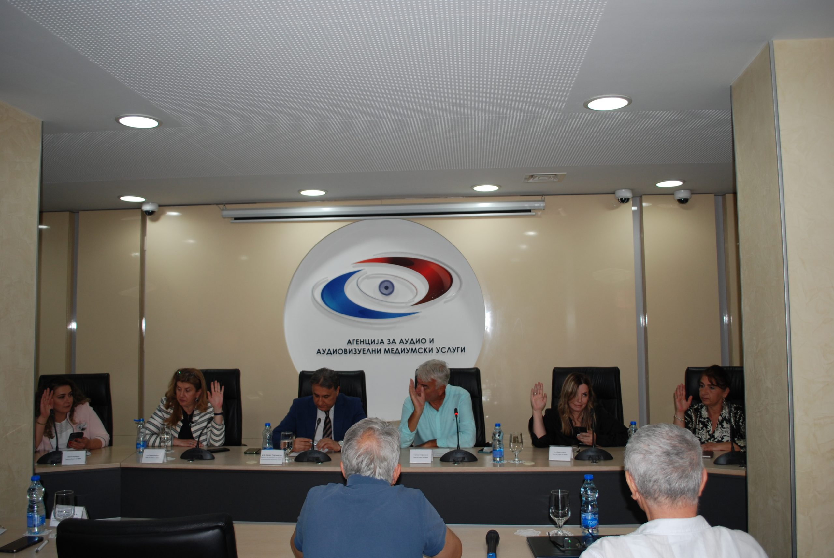](https://avmu.mk/wp-content/uploads/2025/07/FOTO-1.--scaled.jpg)**

**July 2025 No. 7**

**Supervisions over Broadcasters and Operators of Public Electronic Communication Networks**

**Broadcasters**

The Agency carried out regular programme and administrative supervision over the radio stations of Metropolis, Ion, Antenna 5 and Kanal 77 concerning several legal obligations, such as compliance with the rules when broadcasting audiovisual commercial communications, providing quizzes or other forms of prize-winning participation, using value-added telephone services and telephone voting, broadcasting games of chance, compliance with the obligations for the use of language in their programmes, for broadcasting at least 18 hours of radio programming daily, airing an Impressum, information that should be made available to their users and the obligation to publish the identification sign of the broadcaster. The supervision found no violations of the Law on Media or the LAAVMS.

**Operators of Public Electronic Communication Networks**

The Agency carried out regular programme supervision over the operators Datakom JV, Skupi Kable, A1 Macedonia, Makedonski Telekom and Nafi and Beko, concerning their obligation to provide obligatorily and free of charge, as part of the programming packages they retransmit, the programming services of the Public Broadcasting Service, as well as the obligations to register their programming services with the Agency and provide subtitling for the programmes they retransmit. The supervision found no violation of the provisions of the LAAVMS.

Control programme supervision was also carried out over the operator of Total TV in order to determine whether it had acted upon the Decision to Impose a Public Warning Measure and to discontinue the retransmission of the programming services within the deadline specified therein, i.e. whether the programming services it retrasmits are registered with the Agency in accordance with Article 141 of the LAAVMS. The control supervision over TOTAL TV showed that the operator had acted fully in accordance with the requirements of the Decision.

**Public Warning Measures Imposed**

At its 2nd Session held on 7 July, the Agency Council adopted three decisions on imposing a public warning measure, based on supervision findings. A public warning was imposed on the operator Altra-Sat 2000 from Ohrid, due to retransmitting programming services that are not covered by the registration certificate issued by the Agency. Due to non-compliance with the legal obligation to protect minors, i.e. the application of warning signs for second-category programmes, public warning measures were imposed against M TV and Studio Terra TV.

At its 5th Session held on 21 July, the Agency Council imposed public warning measures on TV Kanal Festa and TV Plus, based on supervision findings. Public warning measures were issued against both television stations because, on 3 June 2025, they had not broadcasted at least 30% of the programme originally created as Macedonian audiovisual works, nor had they aired at least half of the legal minimum in the period from 7:00 hrs to 19:00 hrs.

At its 6th Session held on July 29, the Agency Council issued public warning measures against TV Uskana Media and TV Kanal Festa, due to non-compliance with certain provisions of the Law on Audio and Audiovisual Media Services. Public warning measure was imposed on TV Festa due to failure to provide information that should be made available to the users, and on TV Uskana Media due to failure to broadcast at least 30% of the programme originally created as Macedonian audiovisual works, as well as due to broadcasting an advertisement in English without providing a translation into the languages in which the media broadcasts programmes in accordance with its license.

