**Guidelines for Broadcasters for 2025 Local Elections Adopted**

Following the conclusion of a public consultation process on 26 September 2025, the Agency for Audio and Audiovisual Media Services adopted the *Guidelines for Broadcasters for the 2025 Local Elections.*

The Guidelines outline the rules concerning the limits on paid political advertising (PPA), the identification of the advertising sponsors, the allocation of airtime in news segments by the Public Broadcasting Service, the free political presentation on the Parliamentary Channel, and the requirement to make election-related content accessible to persons with disabilities.

During the election campaign for the Local Elections, in the first round of voting, broadcasters may air a total of nine minutes and thirty seconds of additional advertising time per clock hour of broadcast programming, exclusively intended for PPA. The Guidelines precisely define the allocation of these minutes among the participants in the electoral process. In the second round of voting, the total airtime for PPA will depend on the PPA time used by the list submitters whose mayoral candidates will continue the election campaign into the second round. The allocation of airtime among the list submitters will remain the same as in the first round of the election campaign.

During the first round of the election campaign for the Local Elections, the Parliamentary Channel will provide a total of three hours daily for free political presentation of the campaigns of political parties represented in the Assembly of the Republic of North Macedonia, as well as a total of one hour daily for free political presentation of the campaigns of list submitters not represented in the Assembly. In the second round, this airtime will be used for the free presentation of mayoral candidates continuing the campaign into the second round.

The Public Broadcasting Service and the national-level television stations that will broadcast paid political advertising must ensure that content related to the election process is accessible to persons with disabilities.

The *Guidelines for Broadcasters for the 2025 Local Elections* are available on the [link.](https://avmu.mk/wp-content/uploads/2025/09/%D0%A3%D0%BF%D0%B0%D1%82%D1%81%D1%82%D0%B2%D0%BE-%D0%B7%D0%B0-%D1%80%D0%B0%D0%B4%D0%B8%D0%BE%D0%B4%D0%B8%D1%84%D1%83%D0%B7%D0%B5%D1%80%D0%B8%D1%82%D0%B5-%D0%B7%D0%B0-%D0%9B%D0%BE%D0%BA%D0%B0%D0%BB%D0%BD%D0%B8%D1%82%D0%B5-%D0%B8%D0%B7%D0%B1%D0%BE%D1%80%D0%B8-%D0%B2%D0%BE-2025.pdf)

**Market Analysis of Audio and Audiovisual Media Services in 2024 in the Spotlight of AVMU’s Third Public Meeting**

[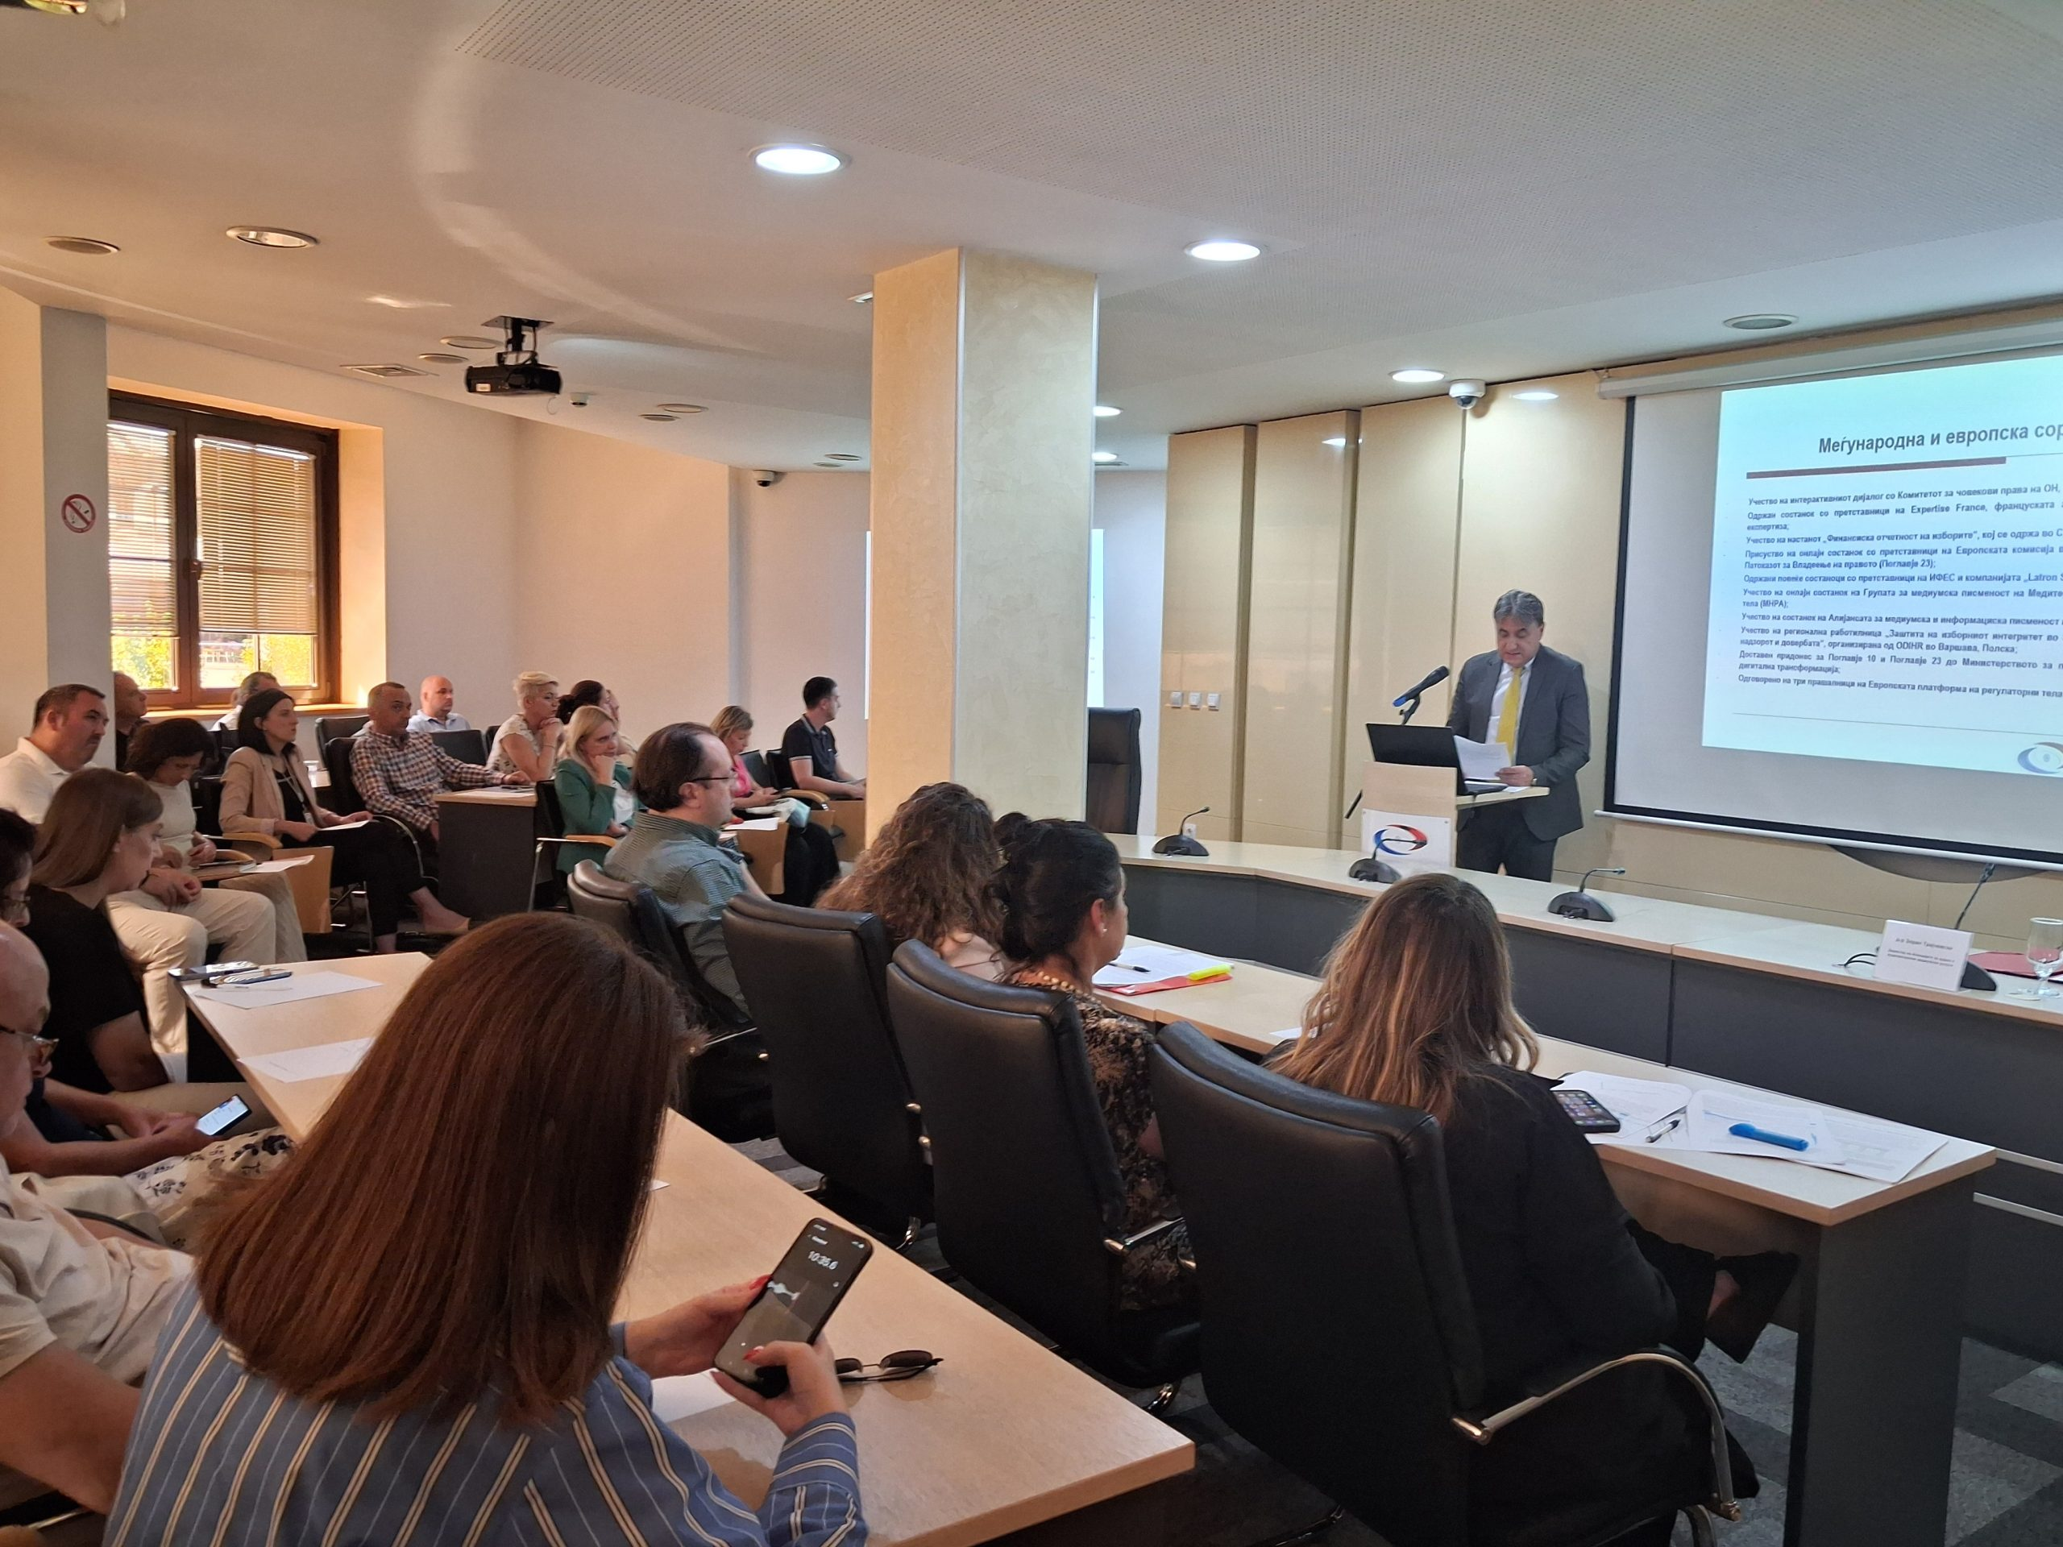](https://avmu.mk/wp-content/uploads/2025/09/1-%D1%81%D0%BB%D0%B8%D0%BA%D0%B0-scaled.jpg)

During the meeting, the findings of the Market Analysis of Audio and Audiovisual Media Services for 2024 were also presented. The Analysis includes data on the economic performance of broadcasters, specifically covering total revenues, total expenditures, financial operating results, and the average number of employees.

Total industry revenues in 2024 amounted to MKD 3,219.21 million, while total expenditures reached MKD 2,994.12 million. The revenues of the Public Broadcasting Service (MRT) were significantly higher than in previous years, amounting to MKD 1,365.55 million, with expenses totaling MKD 1,266.52 million. MRT operated with a profit of MKD 87.81 million, marking the best financial result achieved in the past six years.

The combined revenues of all commercial television stations amounted to MKD 1,607.39 million, while their total expenses stood at MKD 1,503.13 million. In the radio market, total revenues reached MKD 246.27 million, with total expenses amounting to MKD 224.47 million.

The average number of employees with regular employment contracts in the 36 commercial television stations was 887, while the radio stations employed 186 persons on average. The full analysis is available on the website of the Agency, [www.avmu.mk](http://www.avmu.mk) .

Просечниот број вработени лица во редовен работен однос во 36-те комерцијални телевизии изнесувал 887 лица, додека кај радиостаниците изнесувал 186 лица. Целата анализа е достапна на [линкот.](https://avmu.mk/wp-content/uploads/2025/09/%D0%90%D0%BD%D0%B0%D0%BB%D0%B8%D0%B7%D0%B0-%D0%BD%D0%B0-%D0%BF%D0%B0%D0%B7%D0%B0%D1%80%D0%BE%D1%82-%D0%BD%D0%B0-%D0%B0%D1%83%D0%B4%D0%B8%D0%BE-%D0%B8-%D0%B0%D1%83%D0%B4%D0%B8%D0%BE%D0%B2%D0%B8%D0%B7%D1%83%D0%B5%D0%BB%D0%BD%D0%B8-%D0%BC%D0%B5%D0%B4%D0%B8%D1%83%D0%BC%D1%81%D0%BA%D0%B8-%D1%83%D1%81%D0%BB%D1%83%D0%B3%D0%B8-%D0%B7%D0%B0-2024-%D0%B3%D0%BE%D0%B4%D0%B8%D0%BD%D0%B0-1.pdf)

On 24 September 2025, the Agency for Audio and Audiovisual Media Services held its Third Public Meeting for this year, where Director Zoran Trajchevski presented an overview of the activities carried out over the past three months in accordance with the Agency’s Annual Work Programme..

The attendees were informed about the activities related to monitoring the broadcasters’ coverage of the 2025 Local Elections, the supervisions conducted over broadcasters, operators of public electronic communications networks and print media publishers, the public warning measures issued, the radio broadcasting licenses granted, as well as the Agency’s activities in the sphere of international cooperation.

**September 2025 No. 9**

**Guidelines Amending and Supplementing the Guidelines for Verifying the Reports on Broadcast Paid Political Advertising Adopted**

At its 11th Session in 2025, The Agency Council adopted [Guidelines Amending and Supplementing the Guidelines for Verifying the Reports on Broadcast Paid Political Advertising](https://avmu.mk/wp-content/uploads/2025/09/%D0%A3%D0%BF%D0%B0%D1%82%D1%81%D1%82%D0%B2%D0%BE-%D0%B7%D0%B0-%D0%B8%D0%B7%D0%BC%D0%B5%D0%BD%D0%B0-%D0%BD%D0%B0-%D0%A3%D0%BF%D0%B0%D1%82%D1%81%D1%82%D0%B2%D0%BE-%D0%B7%D0%B0-%D0%BF%D0%BE%D1%82%D0%B2%D1%80%D0%B4%D1%83%D0%B2%D0%B0%D1%9A%D0%B5-%D0%BD%D0%B0-%D0%B8%D0%B7%D0%B2%D0%B5%D1%88%D1%82%D0%B0%D0%B8%D1%82%D0%B5-%D0%B7%D0%B0-%D0%B5%D0%BC%D0%B8%D1%82%D1%83%D0%B2%D0%B0%D0%BD%D0%BE-%D0%9F%D0%9F%D0%A0.pdf). The adoption of the document was preceded by a public hearing that had lasted 45 days.

Out of the four key changes, two are related to previous amendments to the Electoral Code, and two are the result of the Agency's experience in implementing the obligations arising from the Electoral Code during the past election cycles.

**Guidelines Amending and Supplementing the Guidelines for Determining the Deadline for Acting upon the Agency’s Decisions to Take Measures Adopted**

Following a previously held public hearing, at its 11th Session held on 24 September 2025, the Agency Council adopted the [Guidelines Amending and Supplementing the Guidelines for Determining the Deadline for Acting Upon the Agency’s Decisions to Take Measures](https://avmu.mk/wp-content/uploads/2025/09/%D0%A3%D0%BF%D0%B0%D1%82%D1%81%D1%82%D0%B2%D0%BE-%D0%B7%D0%B0-%D0%B8%D0%B7%D0%BC%D0%B5%D0%BD%D0%B0-%D0%B8-%D0%B4%D0%BE%D0%BF%D0%BE%D0%BB%D0%BD%D1%83%D0%B2%D0%B0%D1%9A%D0%B5-%D0%BD%D0%B0-%D0%A3%D0%BF%D0%B0%D1%82%D1%81%D1%82%D0%B2%D0%BE-%D0%B7%D0%B0-%D0%BE%D0%BF%D1%80%D0%B5%D0%B4%D0%B5%D0%BB%D1%83%D0%B2%D0%B0%D1%9A%D0%B5-%D0%BD%D0%B0-%D1%80%D0%BE%D0%BA%D0%BE%D1%82-%D0%B7%D0%B0-%D0%BF%D0%BE%D1%81%D1%82%D0%B0%D0%BF%D1%83%D0%B2%D0%B0%D1%9A%D0%B5-%D0%BF%D0%BE-%D1%80%D0%B5%D1%88%D0%B5%D0%BD%D0%B8%D1%98%D0%B0%D1%82%D0%B0-%D0%BD%D0%B0-%D0%90%D0%B3%D0%B5%D0%BD%D1%86%D0%B8%D1%98%D0%B0%D1%82%D0%B0-%D0%B7%D0%B0-%D0%BF%D1%80%D0%B5%D0%B7%D0%B5%D0%BC%D0%B0%D1%9A%D0%B5-%D0%BC%D0%B5%D1%80%D0%BA%D0%B0.pdf).

The amendments and supplements to the Guidelines are aimed at aligning with the amendments to the Law on Audio and Audiovisual Media Services (LAAAVMS) of 2023 and the Law on Media of 2025, in order to establish deadlines for acting upon the public warning measures against the new entities under the Agency’s competence – namely, online media, internet portals, and providers of video-sharing platform services. Deadlines have also been introduced for compliance with the new provisions on ensuring accessibility of content for persons with disabilities and on the protection of personal data.

**Supervisions over Broadcasters and Operators of Public Electronic Communication Networks**

**Broadcasters**

After the period for legal alignment with the public warning measures expired, the Agency conducted control supervisions over Kanal Festa TV for compliance with the obligations for minors’ protection, publication of an Impressum and information that should be made available to the users. The inspections showed that Kanal Festa TV had acted in full upon the three decisions for imposing a public warning measure.

Following a complaint filed by an individual, the Agency conducted an ad hoc administrative supervision over Kobra TV from Radovish concerning the fulfillment of staffing requirements set forth in the LAAVMS and the Rulebook on Minimum Technical, Spatial, Financial and Staffing Requirements for Obtaining a Radio or Television Broadcasting License. The supervision concluded that, on the day of submission of the employees’ documents, the television station Kobra DOO Radovish met the minimum staffing requirements established in the Rulebook on Minimum Technical, Spatial, Financial and Staffing Requirements for Obtaining a Radio or Television Broadcasting License.

**Operators of Public Electronic Communication Networks**

The Agency carried out regular programme supervision over the operators Kabel-Net, IP Systems, Multimedia-Net, Transped Trade, Cablecall, Drim Sat, Scramble and Altra Sat concerning their obligation to provide, mandatorily and free of charge, the programming services of the Public Broadcasting Service as part of the programme package they retransmit, as well as the obligations to register their programme services with the Agency and ensure subtitling of the programmes they retransmit. The supervisions found no violations of the provisions of the LAAVMS.

**Providers of On-Demand Audiovisual Media Services**

As regards the obligations relating to the transmission of cinematographic works and the protection of minors, regular programme supervisions were conducted over the following providers of on-demand AVM services: Svod Master, Makedonski Telekom and Mtel. The supervisions detected no violations.

