LOCAL ELECTIONS 2025
Reports on electoral media coverage and paid political advertising aired during the first round of the 2025 Local Elections

The monitoring of election media coverage during the first round of the 2025 Local Elections included 11 national broadcasters: MRT 1, MRT 2, the MRT Parliamentary Channel, Alsat-M TV, Alfa TV, Kanal 5 TV, Sitel TV, Telma TV, 24 Vesti TV, Klan 21-M TV, and Shenja TV. The analysis focused on the different forms of election-related media representation. For other broadcasters, action was taken based on submitted complaints. During the election campaign for the first round of the Local Elections, no violations of the Electoral Code were identified among the broadcasters. Violations were noted only during the election silence period, and only by four broadcasters. Regarding balance in daily news programmes, all analyzed media generally reported neutrally on the election participants. Ten television broadcasters aired interviews with participants in the campaign. Alsat-M TV and Sitel TV aired their interviews within their daily news programmes; in addition to the 10 election-related interviews aired in its news bulletins, Sitel TV broadcast 13 more interviews in other programmes. The highest number of interviews were aired by Alsat-M TV (30), Alfa TV (29), MRT 1 (28), Sitel TV (23), Telma TV (15), Shenja TV (13), and 24 Vesti TV (12). Except for Sitel TV, all other analyzed broadcasters aired debates. The highest number of debates was recorded on 24 Vesti TV (24) and Telma TV (24), followed by MRT 1 (17), Kanal 5 TV (13), and MRT 2 (11).

The public service broadcaster and the national television stations that aired paid political advertising fulfilled their legal obligation to provide information in formats accessible to persons with sensory disabilities — one news edition per day and one current affairs programme per week. MRT 1, MRT 2, and the Parliamentary Channel met the obligations of the Electoral Code and offered candidates the opportunity for free political presentation. The report on election media coverage during the first round of the 2025 Local Elections is available at the following link.

In the period from 17 to 24 November, the Media Literacy Network held the Media Literacy Days 2025 for the seventh time. The Network members and their supporters organized more than twenty events at various locations across the country, with some activities also taking place online. In this way, our country joined UNESCO’s Global Media and Information Literacy Week.
Media Literacy Days 2025
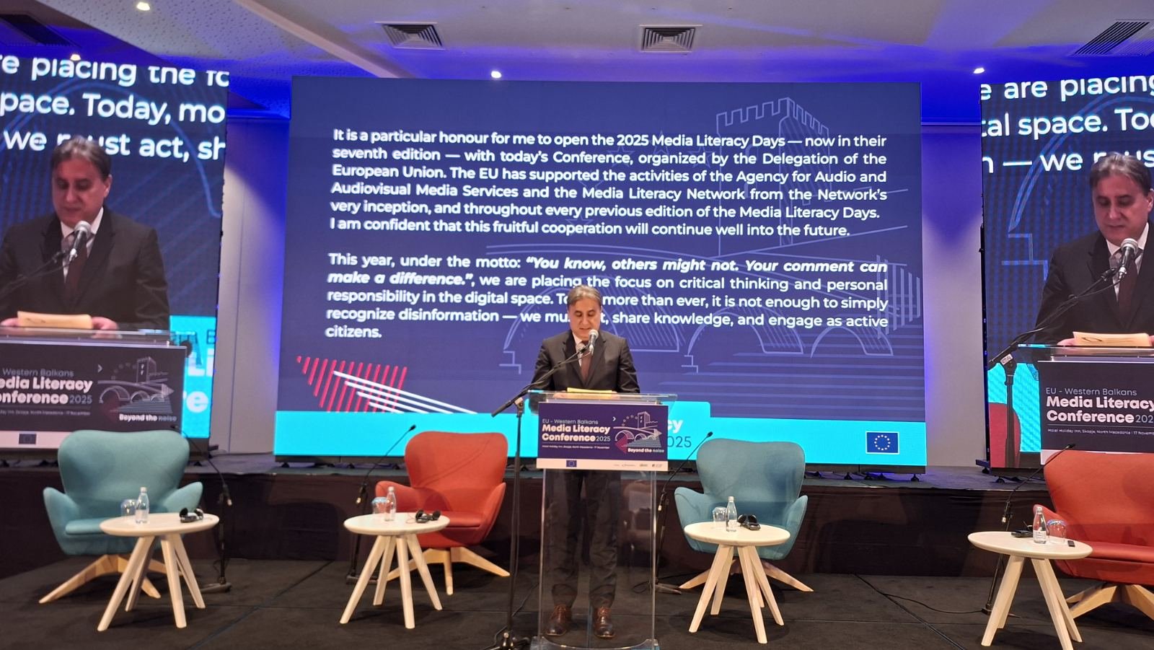
At the 2025 EU–Western Balkans Media Literacy Conference, organized by the Delegation of the European Union, AVMU Director Zoran Trajchevski noted that “this year, under the motto: ‘You know, others don’t. Your comment can help’, the Media Literacy Days focus on critical thinking and on personal responsibility in the digital space. Because today, more than ever, it’s not enough just to recognize disinformation — we need to react, to share knowledge, to be active citizens.”
The Conference was the key regional event of the European External Action Service in the field of media literacy, and this year’s gathering in Skopje marked the beginning of Media Literacy Days. The EU Ambassador to the country, H.E. Mr. Michalis Rokas, stressed that in a dynamic media environment — one in which social media, artificial intelligence, and foreign information manipulation and interference are reshaping the way citizens access and interpret information — it is essential to strengthen the collective response to disinformation and the influence of malicious actors.
“Media literacy is one of the strongest tools we have to protect our societies. When people can identify false content, question the material they encounter online, and seek out reliable information, they become active guardians of democracy. This, among other things, is one of the reasons behind the ‘European Democracy Shield,’ an EU initiative that strengthens our shared readiness to confront manipulative information and build collective resilience,” Ambassador Rokas emphasized.
For the purposes of the 2025 Media Literacy Days, video and audio spots were produced in Macedonian, Albanian, and English.
More information about the events held in person or online, as well as the media content presented during the Media Literacy Days, can be found on the websites of mediumskapismenost.mk and avmu.mk, and on the Facebook, Instagram, and YouTube channels of the Media Literacy Network.

November 2025 No.11
The report on paid political advertising aired by broadcasters during the first round of the Local Elections campaign was prepared in accordance with the Agency’s obligations under the Electoral Code and submitted to the State Election Commission. Of the 75 broadcasters (33 television and 42 radio stations) registered in the State Election Commission’s Register of Broadcasters Airing Paid Political Advertising (PPA) for the 2025 Local Elections, a total of 68 concluded contracts with election campaign participants in the first round — 33 television stations and 35 radio stations. Across all 33 television stations, a total of 377 hours, 20 minutes and 10 seconds of paid political advertising was aired, while all 35 radio stations broadcast 185 hours, 17 minutes and 43 seconds. In total, radio and television broadcasters aired 562 hours, 37 minutes and 53 seconds of PPA.

Among the nine national television stations that concluded contracts for PPA, the largest advertising volumes were recorded on Kanal 5 (41 hours, 7 minutes and 53 seconds), Alsat-M (34 hours, 54 minutes and 29 seconds), and Klan 21-M (27 hours, 3 minutes and 57 seconds). All four national radio stations concluded contracts, with the largest volumes aired by Antenna 5 (14 hours, 8 minutes and 27 seconds) and Kanal 77 (9 hours, 49 minutes and 40 seconds). The highest volume of PPA time purchased on broadcasters came from the coalition Your Macedonia led by VMRO–DPMNE (189 hours, 39 minutes and 20 seconds), followed by the National Alliance for Integration – NAI led by DUI (119 hours, 5 minutes and 50 seconds), the 2025 Local Elections Coalition led by SDSM (109 hours, 25 minutes and 5 seconds), and the Vlen Coalition (76 hours, 42 minutes and 2 seconds).

The report on paid political advertising aired by broadcasters during the first round of the 2025 Local Elections campaign is available at this link.

Reports on electoral media coverage and paid political advertising aired during the second round of the 2025 Local Elections

The sample for monitoring election media coverage during the second round of the Local Elections campaign once again included the three programming services of the Public Service Broadcaster — MRT 1, MRT 2, and the Parliamentary Channel — as well as eight commercial national television stations: Sitel, Alfa, Kanal 5, Telma, Alsat-M, Klan 21-M, Shenja, and 24 Vesti. For all other broadcasters, action was taken based on submitted complaints. During both the campaign period and the election silence period in the second round of the Local Elections, no violations of the Electoral Code were found among the broadcasters.

In their coverage of the election campaign, the media generally adhered to professional standards of fairness, balance, and impartiality, respecting the principle of equal treatment of the remaining mayoral candidates. Regarding balance in daily news programmes, all analyzed media provided generally neutral reporting on the participants in the election campaign.

The Public Service Broadcaster and the national television stations that aired paid political advertising fulfilled their legal obligation to provide information in formats accessible to persons with sensory disabilities — through one daily news edition and one weekly current affairs programme.

The report on election media coverage by broadcasters during the second round of the 2025 Local Elections campaign is available at this link.

The report on paid political advertising aired by broadcasters during the second round of the Local Elections campaign was prepared in accordance with the Agency’s obligations under the Electoral Code and submitted to the State Election Commission. A total of 41 broadcasters — 22 television and 19 radio stations — concluded contracts with election campaign participants. Across all 22 televisions, 52 hours, 56 minutes and 15 seconds of paid political advertising were aired, while the 19 radio stations together aired 47 hours, 34 minutes and 31 seconds.

In total, broadcasters aired 100 hours, 30 minutes and 46 seconds of paid political advertising during the second round. Among the nine national television stations that concluded PPA contracts for the second round, the largest advertising volumes were aired by Kanal 5 (4 hours, 53 minutes and 36 seconds), Alsat-M (4 hours, 43 minutes and 19 seconds), and Alfa (4 hours, 42 minutes and 17 seconds). Of the four national radio stations, three concluded PPA contracts; the largest volumes were aired by Antenna 5 (5 hours, 29 minutes and 47 seconds) and Kanal 77 (2 hours, 51 minutes and 26 seconds). Radio Metropolis aired 53 minutes and 5 seconds, while Jon Radio did not air PPA in the second round.

The report on paid political advertising aired by broadcasters during the second round of the 2025 Local Elections campaign is available at the link.

Supervisions over broadcasters and operators of public electronic communication networks
Broadcasters
Regular administrative supervisions to verify compliance with Article 62, paragraph 6 of the Law on Audio and Audiovisual Media Services (LAAVMS) and Articles 9 and 21 of the Rulebook on the Minimum Technical, Spatial, Financial and Staffing Requirements for Obtaining a Radio or Television Broadcasting License were carried out over the following radio stations: Modea, Red FM, Play, Rosa AB, Sveti Nikole, City, Hit, Jazz, Goldy, Madison, Meff, Angels FM, Impuls, Marija Blagovest, Time, Bleta, Kanal 77, Urban, and the television stations Kanal 5, Kocani-LD, 24 Vesti, M-NET HD, Spektra, G-TV, Due, Tera, Era, Koha and Shenja. The supervisions found that the above broadcasters met the minimum staffing requirements prescribed in the Rulebook.
Regular programme supervision was conducted to verify compliance with the obligations related to language use in programming; broadcasting the voluntarily declared share of music in Macedonian and in the languages of ethnic communities; providing at least 12 hours of daily radio programming; adherence to rules for broadcasting audiovisual commercial communications; offering quizzes or other forms of prize-winning participation in the programme; the use of value-added telephone services and phone voting; and the broadcasting of games of chance. These programme supervisions were carried out over Jazz FM, RFM, Sky Radio, FM 90.3 Sports Radio and Urban FM. The supervisions established that, on 11 November 2025, between 06:00 hrs and 00:00 hrs, Jazz FM broadcast 2.77% domestic music instead of the required 10% of the total music aired during the monitored 24-hour period.
The Agency also conducted regular administrative oversight over all 93 broadcasters transmitting radio or television programmes. The subject of this supervision was the obligation for broadcasters to publish information on their ownership structure, editor-in-chief or editors, and sources of funding for the previous year on their own respective programmes at least three times annually during peak viewing or listening hours, and to submit a recording of the announcement to the Agency within 15 days of broadcast. According to the Rulebook on the Manner of Publishing Operational Data, broadcasters are required to make the third annual publication no later than 31 October. The oversight established that all 93 broadcasters had complied with the obligation set out in Article 15, paragraph 4 of the Law on Media.

Operators of PECNs

Regarding the obligation for operators to include, free of charge, the programme services of the public broadcasting service in the packages they retransmit, as well as the obligations for registering their programme services with the Agency and subtitling the programmes they retransmit, the Agency for Audio and Audiovisual Media Services carried out regular programme supervisions over the cable operators of Vinsat Kabel, Inel International, Kabel-L-Net, Signal-Net, Viva Net, Spider, Mtel and Neotel. The supervisions found that on 31 October 2025, the operator Neotel retransmitted the programme services of “Kompani 21-M” and “Da Vinci,” which are not covered by the programme-service registration certificate issued by the Agency—an action contrary to Article 141, paragraph 13 of the Law on Audio and Audiovisual Media Services.

A follow-up programme supervision was conducted over Viva Net to determine whether the operator had complied, within the specified deadline, with the Decision imposing the public warning measure – specifically, the obligation to deliver to the Agency a signal identical to the one available to its subscribers, in accordance with Article 144, paragraph 3 of the Law. A follow-up supervision was also carried out over Globalsat in Skopje to verify whether the programme services retransmitted by the operator had been registered with the Agency in accordance with Article 141 of the Law.
The supervisions concluded that the operators fully complied with the Decisions issued by the Agency.

Public warning measures imposed

At its 16th Session held on 3 November 2025, the Council of the Agency adopted a decision to impose a public warning measure on the operator of the “Viva Net” cable network from Berovo. The measure was issued for breaching the legal obligation to continuously deliver a signal identical to the content available to its subscribers to the designated signal-collection points located in each regional area, for further distribution to the Agency’s programme-monitoring system—an obligation set out in Article 144, paragraph 3 of the Law on Audio and Audiovisual Media Services (LAAVMS). The operator was ordered to bring its operations into compliance with the Law within 30 days.
Based on the findings of a regular programme inspection, the Council of the Agency, at its 17th Session held on 5 November 2025, adopted a Decision to issue a public warning measure and order the discontinuation of the retransmission of certain programme services by the operator Neotel from Skopje. The measure was imposed because the operator had been retransmitting the programme services of “Kompani 21-M” and “Da Vinci,” which are not included in the programme-service registration certificate issued by the Agency.



