Public Opinion Survey on Media Takes Centre Stage at AVMU Public Meeting

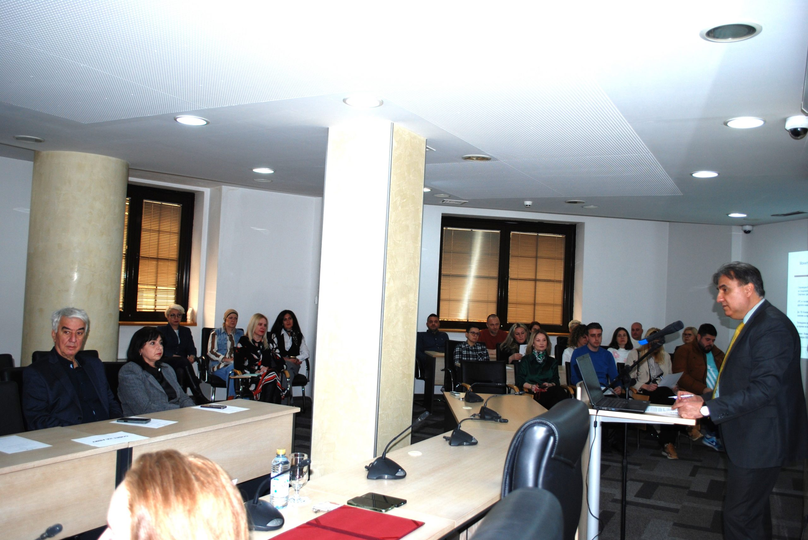

The meeting also featured a presentation of the findings from the Survey of Public’s Opinion and Perceptions of the Media, conducted between 27 December 2025, and 25 January 2026, aimed at gaining insight into citizens’ perceptions, habits, and attitudes toward media and media content.
The key findings of the research show that television and social media are the primary sources of information, with nearly identical levels of daily use, while online portals represent a stable third pillar. Radio and print media, by contrast, have a marginal role in informing the public. Viewing habits indicate a high level of saturation with news, series, and debate programmes on television, alongside a clear lack of educational, cultural, documentary, children’s, and high-quality domestic fiction content. Radio continues to successfully maintain its role as a “companion medium,” with high listenership in the morning hours and a predominantly music-oriented function. The data also point to low levels of trust in news from social media, as well as a significant share of citizens who do not trust any media outlet. The full survey is available on the AVMU’s website at this link.

Press Releases

On 26 March, in response to the reaction of the Governor of the National Bank, Trajko Slaveski, to a question posed by a TV Kanal 5 journalist during a public media event, the Agency for Audio and Audiovisual Media Services emphasizes that communication with the media must always respect professional standards.
Journalists’ asking questions is a fundamental part of the democratic process and must not be treated as an attack. Likewise, journalists should never be discredited for carrying out their professional duties.
Public officials have a responsibility to demonstrate a high level of political culture, accountability, and professionalism, thereby contributing to strengthening citizens’ and media confidence in institutions. This is particularly important given their role in ensuring transparency and public accountability.
The Agency calls on all public officials to show appropriate respect toward media professionals and to make every effort to ensure conditions that allow journalists to carry out their work in a dignified, free, and unobstructed manner.

On 25 March 2026, following the inappropriate conduct of journalist Nevrij Ademi toward the Minister of Education and Science, Vesna Janevska, the Agency for Audio and Audiovisual Media Services underscores that media professionals, while performing their duties, must consistently uphold the highest standards of journalistic ethics and practice.
Communication between journalists and public officials should be conducted in a proper and dignified manner, grounded in mutual respect and with a strong sense of professionalism and responsibility.
The Agency reiterates that critical reporting and posing questions are fundamental to journalism. However, the questions must be formulated and delivered in accordance with ethical standards, without causing offense, undermining credibility, or generating unnecessary tension.

The Agency for Audio and Audiovisual Media Services held its first public meeting of the year on 30 March 2026, where Director Zoran Trajchevski presented an overview of the activities carried out in the first quarter of 2026 in line with the Agency’s Annual Work Programme.
Attendees had the opportunity to hear more about the 2026 repeat local elections, the programme and administrative supervision conducted over broadcasters, operators of public electronic communications networks, print media publishers and online media outlets (internet portals). Information was also shared regarding radio and television broadcasting licenses, completed analyses, as well as activities related to international cooperation and the European integration process.

March 2026 No.3
Media Market Analysis in Macedonia

The Agency for Audio and Audiovisual Media Services conducted an Analysis of the Media Market in Macedonia, with the aim of providing comprehensive insights into the scope and features of the overall media market. The analysis covers four media sectors: print media, online media (internet portals), television, and radio.
The findings indicate that the media industry operates under conditions of limited economic potential and pronounced fragmentation. A small market size, low advertising budgets, and the large number of media outlets challenge financial sustainability and restrict investments in quality content. Addressing these challenges requires systemic measures aimed at strengthening economic stability and ensuring the sustainable development of the media sector. The Media Market Analysis is available on the Agency’s website at the following link.

Supervisions over Broadcasters and Operators of Public Electronic Communication Networks

Broadcasters
The Agency for Audio and Audiovisual Media Services conducted regular programming and administrative supervisions of the broadcasters Nasha TV, TV Company 21-M, TV Shenja, and TV 24 Vesti to verify compliance with multiple legal obligations.
The programming supervisions covered obligations related to language use in programmes, broadcasting of at least 12 hours of television content daily, airing of at least 30% original content produced as Macedonian audio or audiovisual works daily, rules regarding quizzes or other forms of prize-based participation, use of premium-rate telephone services and phone voting, and the broadcasting of games of chance. Additionally, the supervisions assessed compliance with regulations on the protection of minors and the airing of audiovisual commercial communications.
Administrative inspections focused on obligations such as publishing an Impressum, identifying the broadcaster, and providing accessible information to users.
During the supervisions, it was found that TV Kompani 21-M had not complied with the rules for the protection of minors, the regulations on audiovisual commercial communications, or the obligation to publish an Impressum.
An ad hoc administrative supervision was also carried out on Nasha TV to determine whether the license holder meets the conditions set out in the Rulebook on Minimum Technical, Spatial, Financial, and Staffing Requirements for Obtaining a Radio or Television Broadcasting License. The inspection revealed that the broadcaster did not meet the minimum staffing requirements specified in this Rulebook.

Operators of Public Electronic Communication Networks

Regular programme supervisions were also conducted over the operators Makedonski Telekom, Nafi and Beko, Skupi Cable, Drim Sat IPTV, and Datakom JB, regarding their obligations to provide mandatory and free retransmission of the public broadcaster’s programming services, registration of programming services with the Agency, and subtitling of the programmes they retransmit.

The supervisions showed that all operators complied with the obligations under the Law on Audio and Audiovisual Media Services (LAAVMS).



