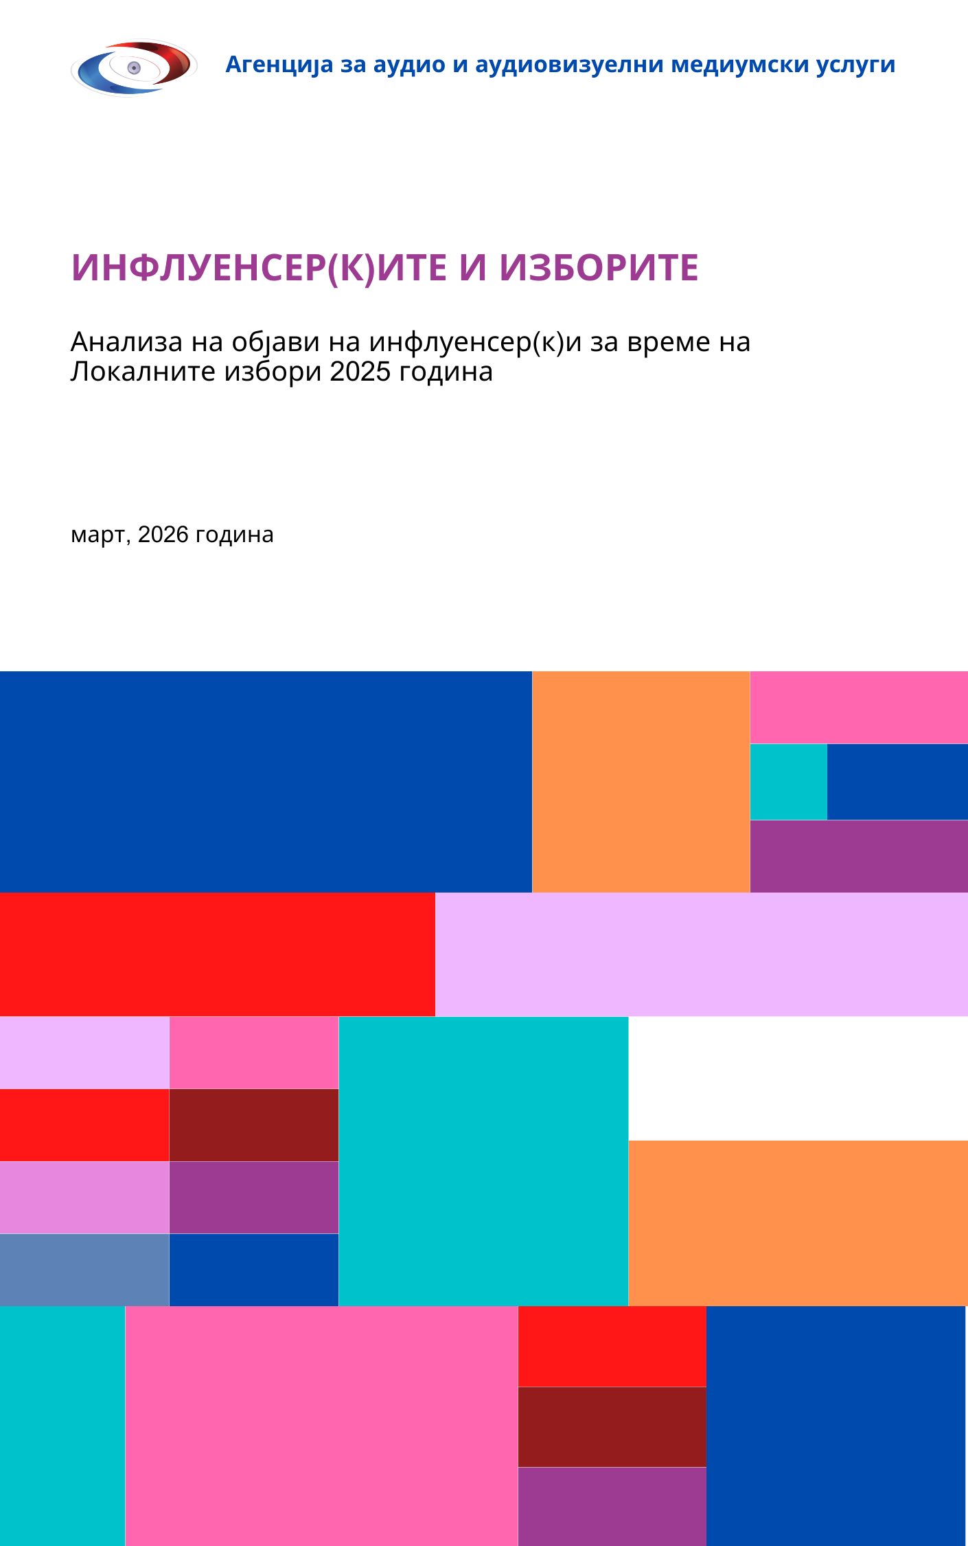
Agency for Audio and Audiovisual Media Services
May, 2026
INFLUENCERS AND ELECTIONS
Analysis of influencers’ posts during 2025 Local Elections
Introduction
In recent years, digital platforms have become one of the key spaces for shaping the public opinion at any time, including during the electoral period. Apart from traditional media, influencers, who maintain social media accounts/channels with large number of followers, now play a significant role in public outreach, as their content has the potential to reach and mobilize a wide audience.
Given the growing importance of social media as space for information, debate and promotion of different viewpoints, the Agency for Audio and Audiovisual Media Services (AVMU) decided to conduct an analysis of the content published by influencers during the first round of the campaign for the 2025 Local Elections, specifically in the period from 29 September to 19 October 2025.
This report provides a comprehensive overview of the content published by influencers from the sample during this period, with a focus on the campaign, the pre-election silence, and the election day. The data obtained serve as a useful basis for monitoring communication practices in the online environment, both during elections and beyond. They enable to identify trends in how digital platforms are used, especially during elections, as well as to assess the potential role of influencers within the broader media and social context.
The role of influencers is not always formally political; however, during electoral cycles, some of them become channels through which positions, messages, support, criticism or information related to the electoral process are conveyed. Therefore, their influence on perceptions, public sentiment, and possibly, the electoral behavior, cannot be overlooked.
In this context, monitoring the activity of influencers aims to provide a clearer picture of their role in the digital communication during the electoral process. Given that a large portion of their audience are active social media users, the content they publish may significantly impact the ways in which political messages, candidate(s) and elections are perceived.
Moreover, influencers often combine different types of content – from private and entertaining topics to promotional and informative posts. In such a communication environment, political messages may appear as part of a broader context of everyday posts, which further enhances their visibility and potential influence on followers. For this reason, this analysis is not restricted only to political content, but also includes other topics that the influencers published in order to compare their usual activity and content related to the electoral process.
Furthermore, during the electoral period, the issue of content transparency is especially relevant, as well as how political messages are communicated and whether they appear at times when public communication is legally restricted, such as during the election silence. Given that social media enable the rapid dissemination of information and direct interaction with the audience, such contents may in a short period of time reach a large number of citizens and influence their level of information and views.

Methodological notes

This report is informative and analytical in nature and is based on systematic collection and processing of data on posts published by selected Facebook, Instagram and TikTok accounts/channels. It aims to provide a clear and comprehensive overview of influencers’ activity and contribute to a better understanding of their role in the contemporary digital communication related to electoral processes and to assist the efforts to improve electoral legislation.
For the purpose of this analysis, specialized software was used for data scraping and systematization. All posts were individually reviewed by a team of analysts at the AVMU, who coded them in order to ensure that all registered posts are categorized and then cross-analyzed across several indicators, such as: language, platform, format, thematic focus, posting intensity, the subjects addressed in the contents and the tone/framing of the reporting on those subjects, as well as the presence of commercial communications, including the paid political advertising (PPA), etc.
The analysis covered a total of 53 accounts, of which 50 were active in the period from 29 September to 19 October 2025. The accounts/channels were selected in accordance with the criteria of the Agency’s Rulebook on Natural Persons Providing On-Demand Audiovisual Media Services. Specifically, those were influencers with Facebook, Instagram and TikTok accounts/channels with over 10.000 followers (in fact, most have over 30.000 followers), and engage in economic activity, regularly publish contents with entertaining, informative or educational function, and independently make editorial decisions which videos to create or source and publish on their accounts/channels.
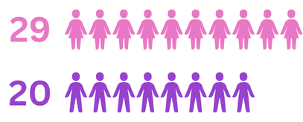
Of these, 37 influencers communicate with their audience in Macedonian language, and 13 in Albanian language. More than half of the accounts/channels belong to female influencers – 29, and 20 to male influencers. For the account/channel Tasty Food and Nature, it was not possible to determine the gender based on the name and content, although a female voice appeared in the posts.

During the analyzed period, a total of 810 posts were registered, with content in Albanian being dominant – 502 posts, compared to 308 posts in Macedonian. Most of the posts were published on Instagram (353), followed by Facebook (319) and TikTok (138), indicating a dominance of Instagram as communication platform used by influencers during the electoral period.
The research was not limited only to political content, rather, it included an overview of the overall activity on the profiles in order to determine:
- The share of posts related to elections compared to other topics;
- Whether and how content was published during the electoral silence period, and whether there was violation of the rules on electoral silence established by the Electoral Code;
- Which accounts were most active and their thematic focus;
- Which type of content (video, short video/ reel, photo, text) dominated during the electoral period;
- How many and which political entities were covered and with what type of framing.

Ranked from the highest to the lowest number of posts by each influencer included in the monitoring sample, the frequency of posting across the accounts/channels was as follows:

Nevrij Ademi | 276 | Almedina Ismajli | 6
Liridona Vejseli | 121 | Semra Ajeti Bedzeti | 6
Arsim Idrizi | 62 | Kristijan Landov | 5
Luna Stefanovska | 34 | Sofija Janeva | 5
Kristijan Landov – Pretres.mk | 22 | Aleksandar Mihajlovski | 4
Vasko Eftov | 19 | Antonia Gigovska | 4
Davor Panchevski | 19 | Elena Najdoski | 4
Tasty Foordand Nature | 18 | Sandra Kirkov | 4
Kristijan Stankovski | 16 | Stefanija Krzeska-Patoska | 4
Nikolina Slavkovska | 15 | Kaltrina Krueziu | 3
Mia Kostova | 11 | Marija Iliev-Maris | 3
Egzona Jashari | 10 | Naser Ismaili | 3
Lila Filipovska | 10 | Sanja Ristik | 3
Tijana Skulikj | 10 | Aida Ziberi | 2
Aleksandra Vejseli-Shijakoska | 9 | Alaudin Mustafa | 2
Ana Stojanova | 9 | Aleksandra Trpeska | 2
Dragan Tapshanov | 9 | Big Mama | 2
Marjana Stanojkovska | 9 | Branko Ognjanovski | 2
Stefan Lazarov | 9 | Viktorija Petrovska | 2
Tomislav ST | 9 | Mandar | 2
Jelena Spendzarska | 8 | Modernizam i renesansa | 2
Viktorija Loba | 8 | Steffonator | 2
Igor Dzambazov | 7 | Flora Shabani | 2
Muhamedin Osmani | 7 | Marta | 1
Stefan Nikolovski | 7 | Tamara Todevska | 1

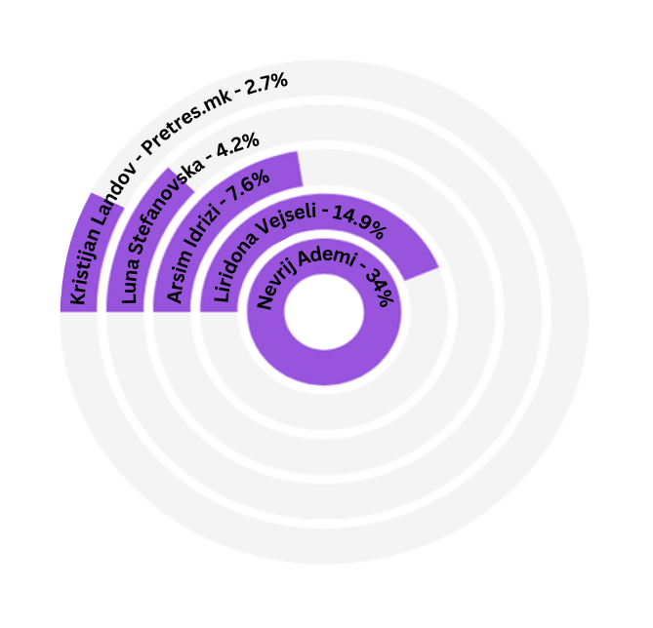
Most active in terms of posting were the accounts/channels of the following influencers:
The topics were divided in two general categories – “Elections/Politics“ and “Other Topics“, with detailed breakdown of subtopics under each category.
Within the category “Elections/Politics“, 22 subtopics were identified, which, according to the frequency of occurrence in the posts, are presented in the following table:
Elections/Politics
Political accusations | 71 | Sports events in political context | 7
Announcements and videos from campaign events/rallies | 37 | Call to vote and overall voter turnout | 5
Sarcastic comments | 35 | Comments and analysis of first-round voting results | 4
Interviews with candidates for mayor/s and councilors | 34 | Analysis of campaigns and predictions of election results | 4
Support and calls to vote for a certain entity | 31 | International relations/foreign policy | 4
Announcement of political shows | 20 | Interviews with politician/s | 3
Criticism of government policies | 15 | Debates with candidate/s | 3
Global politics | 14 | Interviews with expert/s and analysts/s | 3
Comments on societal and local issues | 14 | Parts of candidates’ programs | 2
Polls with citizens | 13 | Activities of the Government/state institutions at local and national level | 2
Posts about irregularities/incidents, and the course of voting | 9 |  | 2
Within the category “Other Topics” 30 subtopics were identified, which, according to the frequency of occurrence in the posts, were distributed in the following way:
Other topics
Posts about private life | 77 | Campaigns on social issues | 6
Food/restaurants/recipes/beverages | 62 | Cars/motorbikes/vehicles | 6
Fashion | 49 | Photography | 5
Crime reports | 28 | Discount announcements | 4
Travel | 27 | Pets | 4
Announcements of company promotions | 26 | Fitness | 3
Promotion and announcements of events/shows/podcasts | 22 | Art: theatre/films/concerts/books/music/series | 3
Sport | 21 | Supplements | 2
Humorous sketches | 20 | Entertainment | 2
Home/furniture/décor/interior design | 19 | Mental health | 2
Technology/tools/applications | 12 | Giveaways and prize games | 2
Social issues | 12 | Baby products | 1
Beauty and personal care | 10 | Music/concerts/performances | 1
Life advice | 7 | Health | 1
Shopping | 6 | Scripted and produced videos | 1

This structure allows for clear comparative analysis between political and commercial/entertaining content.
Additionally, the data analysis provides insight in the dynamics of online communication during the analyzed period.

Posts by influencers on the topic of “Elections/Politics“
The analysis of influencer’s posts for the 2025 Local Elections (2025 LE) was divided in two periods – first during the campaign for the first round of elections (29 September – 17 October 2025), and second during the first electoral silence period (18 and 19 October 2025).

Characteristics of posts during the electoral campaign for the first round of 2025 Local Elections (29 September – 17 October 2025)
During the 19-day electoral campaign for the first round of 2025 LE, a total of 306 posts were methodologically coded under the thematic category “Election/Politics”, and were further categorized into 18 subtopics, which appeared with the following frequency:
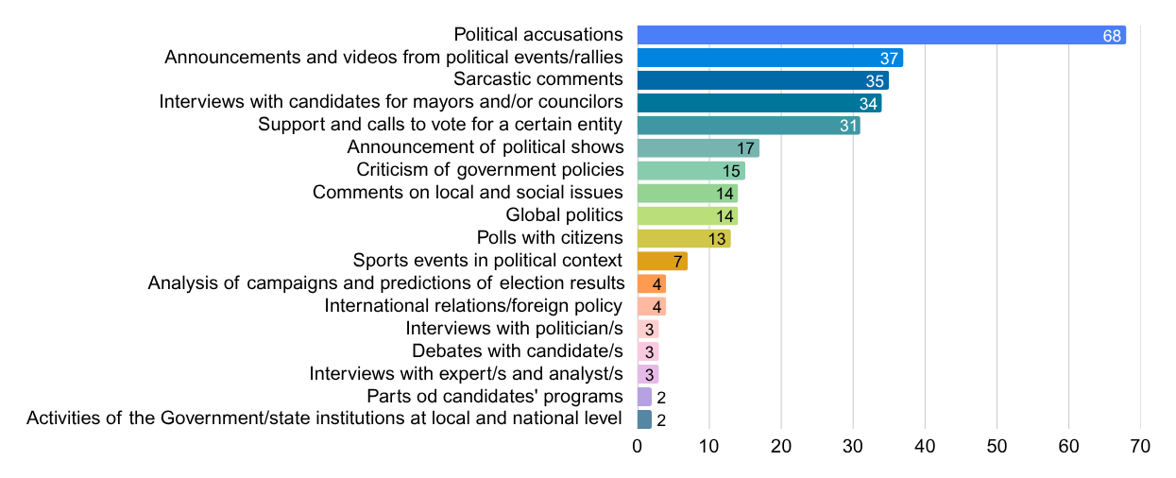

According to the platforms on which they were posted (Instagram, Facebook and TikTok), posts on electoral and political topics were predominantly published on Facebook (237), several times fewer on Instagram (53), and the least on TikTok (16). The distribution by subtopic was as follows:

Political accusations | Facebook | 55
Political accusations | Instagram | 11
Political accusations | TikTok | 2
Announcements and videos from political events/rallies | Facebook | 36
Announcements and videos from political events/rallies | Instagram | 1
Sarcastic comments | Facebook | 31
Sarcastic comments | Instagram | 4
Interviews with candidates for mayor/s and councilor/s | Facebook | 21
Interviews with candidates for mayor/s and councilor/s | Instagram | 7
Interviews with candidates for mayor/s and councilor/s | TikTok | 6
Support and call to vote for a particular subject | Facebook | 29
Support and call to vote for a particular subject | Instagram | 2
Announcements of political shows | Facebook | 12
Announcements of political shows | Instagram | 5
Criticism of government policies | Facebook | 8
Criticism of government policies | Instagram | 4
Criticism of government policies | TikTok | 3
Comments on social and local issues | Facebook | 11
Comments on social and local issues | Instagram | 2
Comments on social and local issues | TikTok | 1
Global politics | Facebook | 13
Global politics | Instagram | 1
Polls with citizens | Facebook | 10
Polls with citizens | Instagram | 2
Polls with citizens | TikTok | 1
Sports events in a political context | Facebook | 7
Analysis of campaigns and predictions of electoral results | Facebook | 4
International relations/foreign policy | Facebook | 4
Interviews with politicians | Facebook | 2
Interviews with politicians | Instagram | 1
Debates with candidates | Facebook | 3
Interviews with experts and analysts | Facebook | 2
Interviews with experts and analysts | TikTok | 1
Parts of candidates’ programs | Facebook | 2
Activities of the Government/state institutions at local and national level | Facebook | 1
 | TikTok | 1
Out of the total 50 influencers, whose accounts/channels were analyzed, only six published posts related to electoral and political topics: Nevrij Ademi (217), Liridona Vejseli (45), Kristijan Landov - Pretres.mk (21), Vasko Eftov (17), Muhamedin Osmani (4) and Kristijan Stankovski (2).
Nevrij Ademi on Facebook and Instagram
During the period of the electoral campaign for the first round of 2025 LE, the most active influencer was Nevrij Ademi, who devoted 217 out of a total 276 posts on his Facebook page and Instagram account to electoral and political topics. The majority of these posts were a combination of short video (reel) with text - 72; followed by photography with text - 60; text - 29; video and text - 28; short videos (reels) - 27 and one video (without text).
Of these, 204 were in Albanian language, 5 were marked with emoticons, 5 were bilingual (both in Albanian and Macedonian), and there was one post each in Macedonian only, English only, and bilingual (Albanian and English).
Looked at by type of posts, the majority of the posts – 57 - were political accusations; 37 were videos or announcements for/from political events or rallies; 32 sarcastic comments, a characteristic of his influencer style; 29 were calls for support and vote for a particular subject, of which, 16 posts (spots/photos) with paid political advertising (PPA): 7 for the independent candidate of Kichevo – Shkodran Alili; 4 for Bajram Redzepi, candidate for mayor from the National Alliance for Integration – NAI; 3 for Nazim Taipi, candidate for mayor of Tearce from NAI, 1 for Kujtesa Bajrami, candidate for councilor in Tetovo, also from NAI, and 1 for Emir Sulejmani, candidate for mayor of Zhelino from NAI. Posts with PPA were often not labelled.
Fourteen posts referred to individuals or events from Europe (protest in support of former leaders of the Kosovo Liberation Army, held under the motto “Freedom has a name. I am also KLA“, in Tirana, Albania; and comments on the elections in Kosovo). There were 11 polls with citizens expressing their views on political topics (such as the history of the Tetovo Monopoly, using sarcastic banners about its sale, etc.).
In 7 posts, sports event – a football match between the Albania and Serbia national teams – was presented in a political context, reinforcing the patriotic sentiments.
Six posts were interviews with two candidates (5 with Nazim Taipi, candidate for mayor of the municipality of Tearce from NAI, and one with Jovica Ilievski, candidate for mayor of the municipality of Brvenica from Your Macedonia coalition).
Four posts referred to international politics: a call from the leader of DUI Ali Ahmeti for participation in the protest in Tirana; a post by Ursula von der Leyen regarding a constitutional amendment; a shared video from Klan Kosova, in which a Kosovo historian says “Albin Kurti strengthens the fascist Mickoski – this is unforgivable!“, as well as one part of the debate from Klan Kosova with the comment “Rama united - Kurti divided: “Albanian parties in Macedonia and Sebia, from unity to division!“.
There were 4 comments on social/political issues (aimed against the mayor of Tetovo - Bilal Kasami, and related to granting the street lighting in Tetovo under concession and the sale of the Tetovo Monopoly). Three posts analyzed the campaigns (two by the analyst Naser Selmani, and one, in which Nevrij Ademi asked whether the NAI or VLEN/VREDI rallies had bigger attendance, ChatGPT replied – NAI). Three posts were about debates between the candidates Bilal Kasami и Bajram Redzepi, as well as Emir Sulejmani и Blerim Sejdiu (the first one on Kosovo television, and the second one on TV 21-M); 3 announcements of interviews with the president of DUI - Ali Ahmeti and two posts from the interview itself. Two posts contained extracts of the electoral programs of Bajram Redzepi and Shkodran Alili; 2 posts criticized the Minister of health - Azir Aliu, regarding his involvement in the elections while the healthcare system is in difficult situation, and one post was a clip from a show in which an analyst criticized the President of VMRO DPMNE, Hristijan Mickoski.
As can be inferred from the description of these posts, Nevrij Ademi was actively engaged in commenting on the campaign, focusing mainly on the municipalities in the northwestern part of the country and openly expressed support for the parties of the NAI coalition, and equally openly, took a position against VLEN/VREDI coalition. In this context, there were two posts (sarcastic comments) directed at the influencer Muhamedin Osmani, whom he regarded as supporter of VLEN/VREDI. This political positioning of Nevrij Ademi is reflected in the tone (positive, negative or neutral), i.e. framing and context in which he presented the subjects.
Specifically, the VLEN/VREDI coalition and its representatives were framed negatively 90 times, positively once and neutrally twice. NAI coalition (especially DUI) was framed positively 57 times, negatively 11 times and neutrally 8 times. Examples of negative framing targeting different subjects are given below, while positive framing generally may be summarized as support for NAI candidates, praise for Ali Ahmeti, and comparisons of NAI and VLEN/VREDI rallies attendance favoring NAI, etc. Additionally, the representatives of Your Macedonia coalition were 9 times mentioned with a negative tone, and the independent candidate Shkodran Alili was framed positively 10 times.
A total of 33 subjects appeared in Nevrij Ademi’s posts, 25 of which were Macedonian politicians of Albanian ethnicity, 1 of Macedonian ethnicity, 3 parties/coalitions, one institution (MOI), three analysts, foreign politician/s/foreign institutions, and citizens.
In more than one-third of the posts, i.e. 61 times, the subject was the President of the Movement BESA, Bilal Kasami, who at the time was the incumbent mayor and a candidate for new term as mayor of the municipality of Tetovo from VLEN/VREDI coalition. Of these, 59 posts presented him with a negative tone/framing (most often related to two topics frequently used to portray him negatively – sale of the Tetovo Monopoly and granting the street lighting of Tetovo under concession).
Ali Ahmeti, President of DUI, was the second most frequently mentioned politician in Nevrij Ademi’s posts – 21 times. Of these, 12 posts framed him positively/with positive tone, 8 times neutrally, and negatively only once (shared video from TetovaSot, online media outlet where Ademi works, in which the negative tone stemmed from the label “killer“, which Adnan Azizi, head of the VLEN/VREDI campaign headquarters, directed at Ali Ahmeti).
Bajram Redzepi, candidate for mayor of Tetovo from NAI, was a politician who appeared 19 times in the posts, and 16 times was positively framed.
Shkodran Alili, the independent candidate for mayor of the municipality of Kichevo was positively framed – with 11 positive posts and Nevrij Ademi openly supported his candidacy. This should be considered in correlation with the fact that Fatmir Dehari, NAI’s candidate for mayor of the municipality of Kichevo, was the only representative of NAI coalition who was negatively framed in five posts in which he appeared. Notably, at this time of the campaign, incriminating phone records of conversation of Dehari were published.
The President of VMRO DPMNE, Prime Minister Hristijan Mickoski, appeared as subject in Nevrij Ademi’s posts 9 times – always in negative context (negative comments from analysts, historian, citizens, from Ali Ahmeti etc.).
Nazim Taipi, candidate for mayor of the municipality of Tearce from NAI, was mentioned 9 times in the posts, 8 times of which he was positively framed, and once neutrally (in a short announcement of an interview with him).
The Head of VLEN/VREDI campaign headquarters - Adnan Azizi, appeared 8 times in the posts, always with negative tone (challenged to perform the eagle gesture by Arben Taravari; accusations for corruption; for obedience to Hristijan Mickoski).
Emir Sulejmani, NAI’s candidate for mayor of the municipality of Zhelino, appeared 8 times in Nevrij Ademi’s posts, but always in positive context, while his opponent, Blerim Sejdiu from VLEN/VREDI, appeared 7 times and always negatively framed (citizens saying he had not fulfilled the projects promised in previous mandates, attended the Friday prayers at the mosque only to get support, or “sold” the street lighting and similar).
The current independent MP Ilir Demiri appeared four times (three times in neutral and once in positive context).
Izet Medziti, mayoral candidate for municipality Chair from VLEN/VREDI coalition, and Bashkim Hasani, leader of candidate list for councilors from this coalition in the municipality of Gostivar, appeared three times in the posts with negative tone. In contrast, three positive posts were published for Flamur Gjoleka, candidate of NAI coalition for the municipality of Dolneni, and two for the mayoral candidate of the municipality of Chair from the same coalition, Bujar Osmani. The current MP from DUI, Ilire Dauti appeared twice, once in a positive frame and once in a neutral frame. Jovica Ilievski, candidate for mayor of the municipality of Brvenica from Your Macedonia coalition (neutral framing), Arben Taravari from NAI (neutral framing) and the Minister of health Azir Aliu from VLEN/VREDI (negative tone) appeared twice each in the posts. Seven other individuals were mentioned only once: Agron Arifi from the independent councilor list Better for Tetovo (neutral), Kujtesa Bajrami from NAI (positive), Mehmet Seferi from VLEN/VREDI (positive for Seferi, but negative for the coalition), Isen Shabani from NAI (positive), Blerant Ramadani from NAI (positive), Rami Mislimi, owner of the online medium TetovaSot (positive), Besar Durmishi from VLEN/VREDI (negative).
Three coalitions were also mentioned: NAI (five times in positive context), VLEN/VREDI (16 times with negative tone) and Your Macedonia (once, framed negatively).
One post included a photo from a Your Macedonia coalition rally, framed negatively.

Liridona Vejseli on Facebook, Instagram and TikTok
During the period of the first round of the electoral campaign, the influencer Liridona Vejseli published a total of 117 posts, 45 of which were coded on topics as “Election/Politics”, making her second ranked in terms of frequency in covering these topics. However, it should be taken into account that a specific feature of her work, in most cases, was that she created one original piece of content which she then published across the three platforms where she has accounts/channels, i.е. Facebook, Instagram and TikTok. A total of 43 posts were in Albanian, and two posts were bilingual - both in Albanian and Macedonian.
From the perspective of sub-topics: 13 of the posts were criticism of governmental policies (accusations directed at institutions by a mother fighting for her right to see her children; criticism directed at the health system and demanding accountability from the Minister of health Azir Aliu through a video of a patient being urgently referred to a clinic, but not being able to enter because the medical staff did not come to admit him; and the death of a 14-months old baby due to alleged incorrect medical treatment); 12 were interviews with mayoral candidates (Bajram Redzepi, Bilal Kasami, Izet Medziti, Nazim Taipi); 7 were political accusations (directed at Besnik Emshiu, Fatmir Dehari and MOI); 5 were comments about social and local issues (lack of drinking water in Bogovinje, problems with electricity supply in the villages of Lisec and Sinichane); 2 posts were about an interview conducted with an analyst; citizen poll published twice regarding the lack of parking space in the Skopje Old Bazaar; 2 posts about activities of state institutions (with Izet Medziti – current mayor of the municipality of Chair), one interview with a politician (Izet Medziti) and one call and support for voting in the form of PPA for Bilal Kasami.
In the posts by Liridona Vejseli, a total of 11 entities appeared, eight of whom were Macedonian politicians of Albanian ethnicity, one institution (MOI) and a large number of citizens.
In Ms. Vejseli’s posts, there was an equal number of posts regarding politicians from the VLEN/VREDI coalition both in positive and negative tone – 10 each, and 2 posts with neutral tone. For the NAI coalition, there were 12 posts with negative tone, 2 with positive tone, and 4 with neutral tone.
The most frequently mentioned politician (12 times) was Izet Medziti, mayoral candidate for the municipality of Chair from VLEN/VREDI coalition who was regularly positively framed, with the exception of two posts featuring a citizen poll regarding lack of parking space in the Skopje Old Bazaar, where citizens stated that he had promised an underground parking space, however, this had not been realized.
The Minister of Health Azir Aliu from VLEN/VREDI coalition was mentioned in the posts seven times (with negative tone, in the examples indicated above about criticism directed at the health system).
The opposing candidate for mayoral position in Chair from NAI, Bujar Osmani appeared as a subject 6 times – always framed negatively.
Besnik Emshiu, mayoral candidate for Bogovinje from NAI (negative tone); Bilal Kasami, candidate for mayor of Tetovo from VLEN/VREDI coalition (interview with neutral tone and PPA with positive tone) and Bajram Redzepi, mayoral candidate for Tetovo from NAI (neutral tone) appeared in three posts each.
In two posts each, the subjects were two politicians from NAI: Fatmir Dehari, mayoral candidate for Kichevo (negative tone) and Nazim Taipi, candidate for mayor of the municipality of Tearce (neutral tone).
The coalition NAI appeared in two posts with negative tone (accountability for the situation in the health sector), as well as the Ministry of Interior (due to involvement of the Sector for Internal Affairs Tetovo in a case where the son of an inspector was caught with cocaine).
In 13 posts, subjects were citizens, either through surveys, or by giving them space to tell their stories about their struggles with institutions.

Kristijan Landov – Pretres.mk on Instagram
Posts from the podcast “Pretres“ by the influencer Kristijan Landov were identified on the Instagram platform, that is originally published and aired on the YouTube channel of PRVATV.MK. During the first round of the campaign for the 2025 Local Elections, this profile featured 21 posts consisting of video and text (one was a combination of photography and text), in Macedonian language, and all focused on the topic of elections and politics.
These included five announcements and 16 excerpts from interviews with mayoral candidates: Mitko Janchev from Your Macedonia coalition led by VMRO-DPMNE for Kavadarci (6 posts); Kurto Dudush from Union of Roma for Shuto Orizari, part of NAI coalition (5); two posts were announcements for interviews with Janchev and Dudush; Amar Mecinovikj from “Levica” for Skopje (5); Maksim Dimitrievski from ZNAM for Kumanovo (4) and Kaja Shukova from the Coalition for the 2025 Local Elections led by SDSM for Skopje (1).
A defining characteristic of the tone used by Landov in these interviews is his critical approach, with politicians being asked sharp and “uncomfortable“ questions. In 19 of the posts, the framing was neutral, while there was negative tone in two of the posts with Maksim Dimitrievski (accusations that he had lied in previous elections by failing to fulfill promises, and that he had voted for the referendum on the name change, and is now criticizing the name change and acts as if he “came from Mars” even though he was member of SDSM at that time).
All posts were sponsored, which stems from the format of the podcast as a type of media content which is generally sponsored – such as through branding and equipping of studios, including illuminating logos of sponsors and the placement of various products. The Law on Audio and Audiovisual Media Services does not permit sponsorship and products placement in news and information content, such as the published interviews with mayoral candidate(s).

Vasko Eftov on Facebook
Vasko Eftov had 17 posts, in which, through his Facebook channel, announced the show “Vo centar“, which can be watched on his YouTube channel. The announcements were either photos/montages with a link to the YouTube location of the show (9) or short videos announcing the show (8). In eight short videos, he commented on social issues four times (about a whistleblower from MOI regarding the tragic fire in the Kochani nightclub “Puls“ and comments about DUI, Ali Ahmeti, Zoran Zaev and Hristijan Mickoski); three posts contained political accusations, that is: 2 posts were directed at the Minister of interior, Panche Toshkovski and one directed at the mayoral candidate for Kavadarci from Your Macedonia coalition, Mitko Janchev; and in one post, he analyzed the 2025 LE campaign, along with predictions on the electoral results, featuring subjects such as NAI, Your Macedonia coalition, Coalition for 2025 Local Elections (SDSM) and the political party Levica.
In 9 posts, his approach to topics and subjects was neutral, within the framework of journalistic questions and critique, in 6 posts a negative tone was observed, while in 2 posts the tone of reporting could not be methodologically determined. Among the posts with negative tone, one was directed at the mayoral candidate for Kavadarci, Mitko Janchev, and included negative framing – with indirect accusations that Janchev is on a “barley diet “(specifically, “Scottish barley”), combined with “baking powder“ and “orange pills“. In the second post with negative tone, Eftov shared comments that the politician Ali Ahmeti was “rattling weapons”. In four of his posts, Eftov directed accusations at the Minister Panche Toshkovski that he was “avoiding responsibility“ and “shaking things up“ in Kochani.

Muhamedin Osmani on Instagram
Muhamedin Osmani had a total of four posts in Albanian on the topic of “Elections/Politics”, 3 of which were a combination of a photo and text, and one a combination of video and text.
By format, 3 were sarcastic comments responding to Nevrij Ademi’s posts. In two of them, the photo showed the attendance of VLEN/VREDI coalition rally, and another one was a photo of him taking a statement from Izet Medziti, mayoral candidate from VLEN/VREDI for the municipality of Chair. The post with video was in fact Medziti’s statement.
As subjects in the post, four individuals and one coalition appeared. Izet Medziti appeared three times (twice framed positively and once framed neutrally); two posts were directed at his opponent from NAI coalition, Bujar Osmani (negative tone), Artan Grubi from NAI was mentioned once (negative tone), and one post had a positive tone towards VLEN/VREDI and negative towards Nevrij Ademi.
Although the number of posts was small, a tendency towards positive framing of VLEN/VREDI coalition was observed (3 positive and 1 neutral), while two posts had negative framing towards NAI, and one was negative towards Nevrij Ademi.

Kristijan Stankovski on Instagram
Another influencer who posted on “Elections/Politics” topics during the 2025 LE campaign is Kristijan Stankovski. He had two posts – a combination of photo and text, in Macedonian.
One was support for Orce Gorgievski, candidate for mayor of Skopje from Your Macedonia coalition, with a positive tone, and the other post included comments about social/local issues, referring to the poor hygiene in the Macedonian capital city during that period.

Influencers’ Posts on “Other Topics“

In addition to posts on political topics and related to the 2025 Local Elections, this analysis also covered posts addressing other topics, some of which included commercial communication (advertising, sponsorship, or product placement).
Out of a total of 810 posts from 50 active channels and accounts on the social media platforms Facebook, Instagram and TikTok, 410 fell into the category “Other topics“. These 410 posts originated from channels and accounts of 48 influencers. The largest number were on Instagram – 257, 105 posts on TikTok, while the fewest were on Facebook – 48. The posts most commonly consisted of video and text (147), followed by photo with text (122), only videos (106), short videos (reels) with text (29), while three posts included only text, two posts were short videos (reels), and one included only a photo.
The number of posts in Macedonian (159) and Albanian (155) were almost equally represented. Third ranked in frequency were the posts in English (50), followed by posts both in Macedonian and English (26), 15 posts were marked with emoticons, two posts were in Macedonian and Serbian language, one in Albanian and English, and one post had no text, description, or speech.
Half of these 410 posts did not contain commercial communication (205), while those that did were distributed as follows: posts with advertisements – 177, posts with sponsorship – 18 and posts with product placement - 10.
Posts under this category most commonly originated from the channels/accounts of: Liridona Vejseli (64), Arsim Idrizi (57), Luna Stefanovska (30), Nevrij Ademi (26), Davor Panchevski (19), as well as 14 posts each from Tasty Food and Nature, Kristijan Stankovski and Nikolina Slavkovska.

Posts without commecrial communication
Posts that did not contain commercial communication were mostly published on Instagram -118, followed by 49 posts on TikTok, and 38 on Facebook.
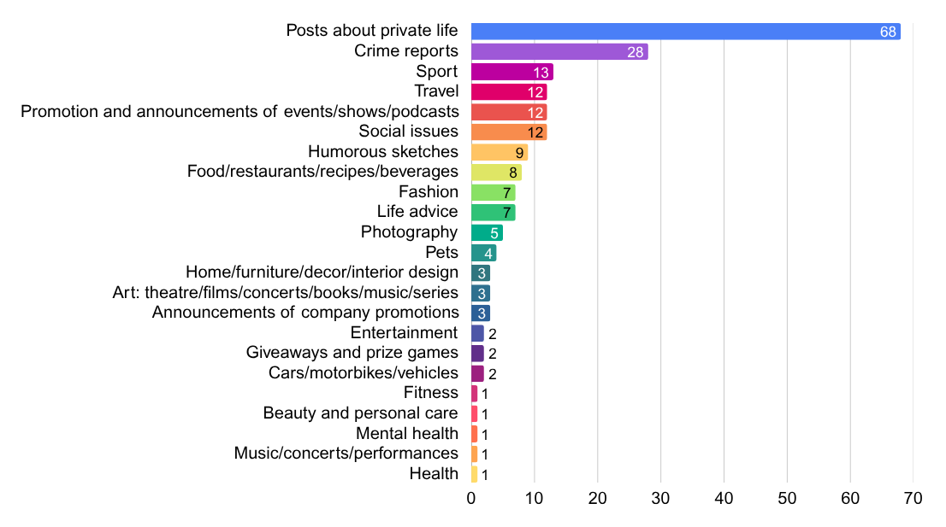
These 205 posts were further coded by sub-topic and fell into the following 23 subcategories:
The largest number of posts with subtopics in the “Other topics“ category were on Instagram, with the exception of posts related to “Crime reports“ which most often appeared on Facebook, as well as “Sports” posts which were most prevalent on TikTok. If presented by subtopics, the distribution of posts across platforms, was as follows:

Posts about private life | Instagram | 39 | Announcements for promotional events | Instagram | 3
Posts about private life | TikTok | 20 | Announcements for promotional events | Instagram | 3
Posts about private life | Facebook | 9 | Announcements for promotional events | Instagram | 3
Crime reports | Facebook | 21 | Giveaways and prize games | Instagram | 2
Crime reports | Instagram | 4 | Giveaways and prize games | Instagram | 2
Crime reports | TikTok | 3 | Giveaways and prize games | Instagram | 2
Sports | TikTok | 7 | Home/furniture/decor/interior design | Instagram | 2
Sports | Facebook | 4 | Home/furniture/decor/interior design | TikTok | 1
Sports | Instagram | 2 | Home/furniture/decor/interior design | TikTok | 1
Travel | Instagram | 10 | Art: theatre/films/concerts/books/music/series | Instagram | 2
Travel | TikTok | 2 | Art: theatre/films/concerts/books/music/series | TikTok | 1
Promotion and announcements of events/shows/podcasts | Instagram | 9 | Entertainment | Instagram | 1
Promotion and announcements of events/shows/podcasts | TikTok | 2 | Entertainment | TikTok | 1
Promotion and announcements of events/shows/podcasts | Facebook | 1 | Entertainment | TikTok | 1
Social issues | Instagram | 7 | Cars/motorbikes/vehicles | Instagram | 1
Social issues | Facebook | 3 | Cars/motorbikes/vehicles | TikTok | 1
Social issues | TikTok | 2 | Cars/motorbikes/vehicles | TikTok | 1
Food/restaurants/recipes/beverages | Instagram | 7 | Fitness | Instagram | 1
Food/restaurants/recipes/beverages | TikTok | 1 | Fitness | Instagram | 1
Fashion | Instagram | 5 | Beauty and personal care | TikTok | 1
Fashion | TikTok | 2 | Beauty and personal care | TikTok | 1
Life advice | TikTok | 5 | Mental health | Instagram | 1
Life advice | Instagram | 2 | Mental health | Instagram | 1
Humorous scetches | Instagram | 9 | Music/concerts/performances | Instagram | 1
Photography | Instagram | 5 | Health | Instagram | 1
Photography | Instagram | 5 | Pets | Instagram | 4
The largest number of posts originated from channels/accounts of: Liridona Vejseli (33), Nevrij Ademi (25), Luna Stefanovska (20), Arsim Idrizi (14) and Egzona Jashari (10). Other analyzed influencers had less than 10 posts during this period.

Posts containing advertisements
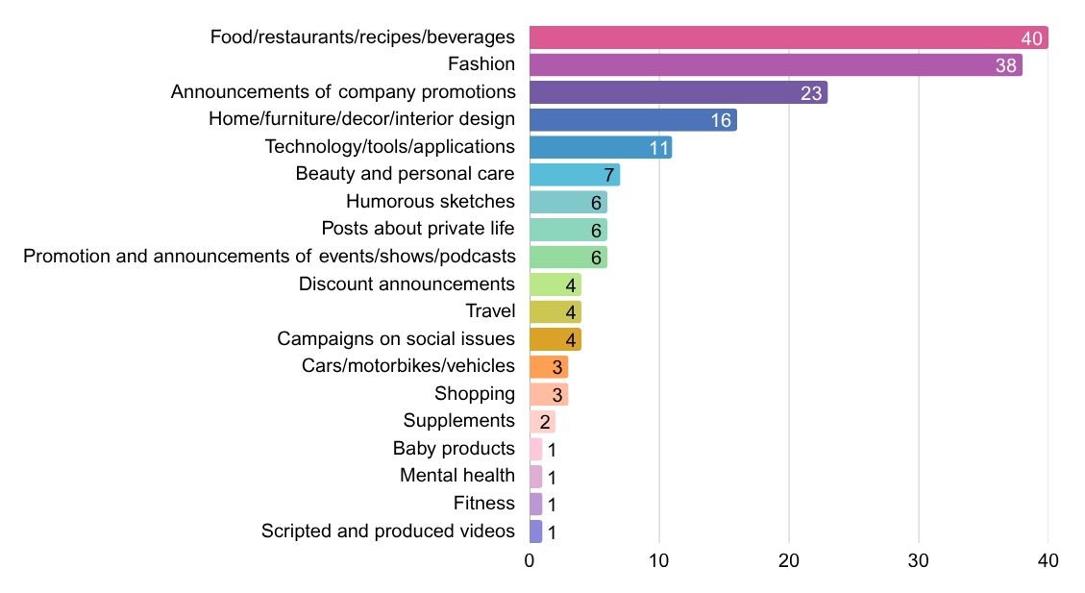
Posts containing advertisements - 177, fell within the following 19 subcategories:

Similar to the posts not containing commercial communication, posts containing advertisements were most prominent on Instagram – 115, followed by 52 on TikTok and 9 on Facebook. Their distribution across different platforms was as follows:
Food/restaurants/recipes/beverages | Instagram | 17 | Travel | Instagram | 2
Food/restaurants/recipes/beverages | TikTok | 20 | Travel | TikTok | 2
Food/restaurants/recipes/beverages | Facebook | 3 | Travel | TikTok | 2
Fashion | Instagram | 28 | Campaigns on social issues | Instagram | 2
Fashion | TikTok | 8 | Campaigns on social issues | TikTok | 1
Fashion | Facebook | 2 | Campaigns on social issues | Facebook | 1
Announcement of company promotions | Instagram | 14 | Cars/motorbikes/vehicles | Instagram | 2
Announcement of company promotions | TikTok | 7 | Cars/motorbikes/vehicles | TikTok | 1
Announcement of company promotions | Facebook | 2 | Cars/motorbikes/vehicles | TikTok | 1
Home/furniturе/décor/interior design | Instagram | 9 | Shopping | Instagram | 1
Home/furniturе/décor/interior design | TikTok | 6 | Shopping | TikTok | 2
Home/furniturе/décor/interior design | Facebook | 1 | Shopping | TikTok | 2
Technology/tools/applications | Instagram | 9 | Supplements | Instagram | 2
Technology/tools/applications | TikTok | 2 | Supplements | Instagram | 2
Beauty and personal care | Instagram | 5 | Baby products | Instagram | 1
Beauty and personal care | TikTok | 2 | Baby products | Instagram | 1
Humorous sketches | Instagram | 5 | Mental health | Instagram | 1
Humorous sketches | TikTok | 1 | Mental health | Instagram | 1
Posts about private life | Instagram | 6 | Fitness | TikTok | 1
Promotion and announcements of events/shows/podcasts | Instagram | 6 | Scripted and produced videos | Instagram | 1
Discount announcements | Instagram | 4 | Scripted and produced videos | Instagram | 1

This data provides a broader picture, showing that posts which included advertisements were most prominent on Instagram almost across all subtopics, with the exception of advertisements for “Food/restaurants/recipes/beverages” that were more prominent on TikTok. The Facebook platform, although a leader in the trends in recent years, is becoming the least used for advertising among influencers.
The largest number of advertisements originated from the channels/accounts of: Arsim Idrizi (37), Liridona Vejseli (31), Tasty Food and Nature (13) and Nikolina Slavkovska (11).

Posts contaning sponsorship
A total of 18 posts were sponsored, and according to subtopic, they fall within the following subcategories:
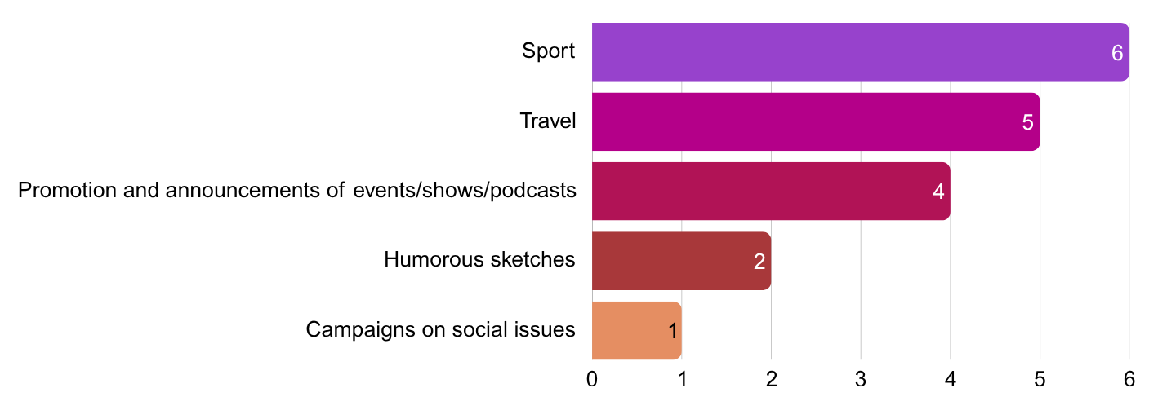

Interestingly enough, posts containing sponsorship were not present at all on the Facebook platform, while there were 15 on Instagram and 3 on TikTok:

Sport | Instagram | 3
Sport | TikTok | 3
Travel | Instagram | 5
Promotion and announcements of events/shows/ podcasts | Instagram | 4
Humorous sketches | Instagram | 2
Campaigns on social issues | Instagram | 1

These data once again show that among Macedonian influencers, the Facebook platform is no longer used for commercial content, such as sponsorship, while Instagram platform leads in this context.
Posts with sponsorship originated from the following channels/accounts, distrubuted as follows: Arsim Idrizi (6), Jelena Spendzarska and Stefan Nikolovski with 3 posts each, Kristijan Stankovski with 2 posts, while the channels/accounts of Aleksandar Mihajlovski, Lila Filipovska, Modernizam i renesansa and Sandra Kirkov had only 1 sponsored post each.
It is worth noting that in one of Kristijan Stankovski’s posts, there was both an advertisement for event/show/podcast and sponsorship from a private company. Furthermore, posts with sponsorships that were related to travel topics were registered as sponsorships if travel agencies were tagged in the posts, but were not explicitly mentioned or directly advertised.

Posts containing product placements
In 10 of the posts, all under the “Food/restaurants/recipes/beverages“ subcategory, there was product placement. Eight posts originated from the account of Davor Panchevski, and 1 post each from the accounts of Dragan Tapshanov and Tijana Skulikj. All 10 posts were published exclusively on Instagram.

Characteristics of posts during the election silence period in the first round of 2025 Local Elections (18 and 19 October 2025)

Electoral silence period – notion and meaning

The electoral silence is a legally prescribed period immediately before and on the day of voting, during which public promotion of candidates, political parties and electoral programs is prohibited, as well as any other activities that may influence voter’s decisions. According to the Electoral Code, electoral silence begins 24 hours before the day of voting and lasts untill the closing of polling stations.
The electoral silence is the silent period immediately before the voting process, during which citizens can reflect and decide about whom to vote for, and serves to prevent pressure or manuipulation of voters, in order to ensure fair and democratic elections.

Accordingly, the following are considered violations of electoral silence:
- Broadcasting any information, photographs, audio and audiovisual materials related to or involving participants in elections,
- Any forms of media reporting that are openly or covertly in support of someone’s campaign and that may influence voters’ decisions,
- Data that discloses the political identity of political subjects and/or individuals involved in incidents or irregularities on the day of voting,
- Statements by candidates in the electoral process, from political party representatives to officeholders in governmental bodies.
During the period of electoral silence for the first round of 2025 LE, i.e. 18 and 19 October 2025, out of a total of 50 accounts on Instagram, TikTok and Facebook platforms, 28 were active. A total of 58 posts were registered, 55 of which were available for analysis, while the 3 were unavailable. The largest number of these – 34, were published on the Instagram platform, 22 on Facebook, and 2 on TikTok. The most of these posts contained video and text (21), followed by text-only posts (14), posts with photo and text (13), posts with short video (reel) and text (5) and only-video posts (2), while 3 of the posts were unavailable.
Distribution of posts by language varied: 27 posts were in Albanian, 22 posts in Macedonian, 4 posts in English, one post combined Macedonian and English, while one post contained only an emoticon.
The majority of these posts originated from Nevrij Ademi’s account (17), while the remaining posts (41) originated from the other 27 accounts/channels.
During the electoral silence, the posts, according to their topic, were also classified within the two main categories: “Election/Politics” and “Other topics“.

Election/Politics
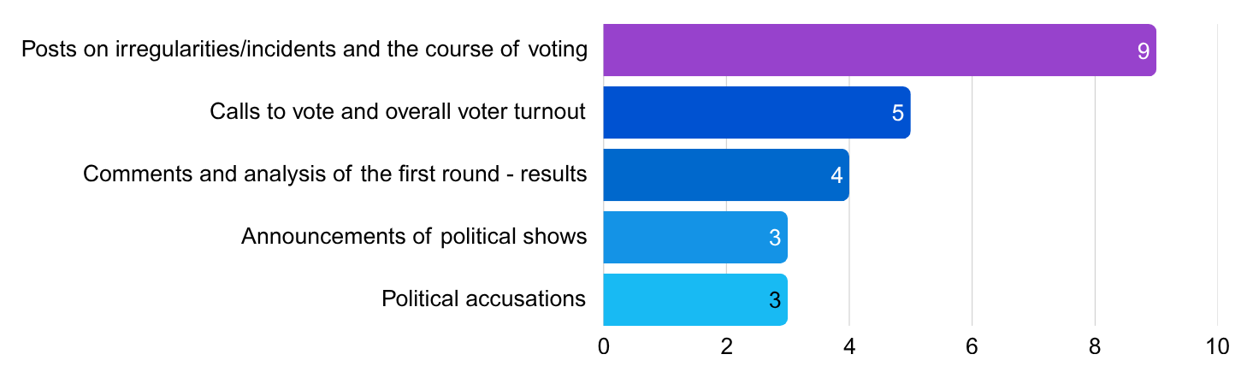
Within this category, 24 posts were included, which were coded into 5 subtopics and distributed as follows:

All posts were published on Facebook and Instagram accounts/profiles, as follows:

Posts on ireegularities/incidents and the course of voting | Facebook | 8
Posts on ireegularities/incidents and the course of voting | Instagram | 1
Calls to vote and overall voter turnout | Facebook | 5
Comments and analysis of the first round - results | Facebook | 3
Comments and analysis of the first round - results | Instagram | 1
Announcements of political shows | Facebook | 2
Announcements of political shows | Instagram | 1
Political accusations | Facebook | 3

The data on the distribution of political topics and topics related to the electoral process during the electoral silence show that they were most represented on Facebook (21 posts), unlike other topics (with and without commercial communication) which were more represented on Instagram and TikTok platforms.
Out of a total of 24 posts in this category, 10 had a neutral tone, 5 had a negative tone, and 3 had a positive tone. For the remaining 6 posts, neither the subject nor the tone could be detected.
Posts with neutral tone were directed at several subjects: citizens – 7 posts; NAI coalition – 1 post; foreign politicians/foreign institutions – 1 post; Bilal Kasami – 1 post and Bajram Redzepi – 1 post.
Posts with negative tone were directed at: Bilal Kasami – 2 posts; Blerim Sejdiu – 1 post; there was one post with negative stance towards politicians Artan Grubi, Ali Ahmeti and Bujar Osmani, and another post was referring to Fatmir Dehari and Liridona Vejseli.
The remaining three posts with a positive tone were directed at the candidates Izet Medziti, Muhamed Elmazi and Suat Shakiri.
The largest number of posts with political topics and related to elections originated from the account/channel of Nevrij Ademi – 16, which were all in Albanian. Fifteen of them were published on the Facebook platform, and only one on Instagram. Of these, 7 had a neutral tone, 3 posts had a negative tone, and 2 had a positive tone, while neither the subject nor the tone could be detected in the remaining 4 posts. Most of the posts with negative tone by Nevrij Ademi were directed at the candidate Bilal Kasami. Posts with positive tone were directed at the candidates Izet Medziti, Muhamed Elmazi and Suat Shakiri.
Four of the posts were published by Liridona Vejseli, two of which provided information on voting results, and one was a call to vote. These three posts had a neutral tone. The fourth post was a political accusation with a negative tone directed at Fatmir Dehari and at Ms.Vejseli. Namely, this post was a situation of double reposting. First, Fatmir Dehari posted content attacking Liridona Vejseli, and this post was then reposted by El Cheka who criticized Fatmir Dehari, and then Ms. Vejseli reposted El Cheka’s post.
Vasko Eftov had two posts in Macedonian - both announcng his upcoming show “Vo Centar“.
Muhamedin Osmani had one post (in Albanian) in which he congratutaled the vicotory of VLEN/VREDI coalition (Izet Medziti) in the municipality of Chair, while the post contained negative tone towards Ali Ahmeti, Bujar Osmani and Artan Grubi.
Kristijan Landov had one post in Macedonian language on Pretres.mk announcing a show that would report on the results of the first round of elections after the voting has ended.

Other topics
In the category „Other topics“, a total of 31 posts were registered during the electoral silence, which were then coded in13 subtopics. Unlike the posts on political topics and topics related to the electoral process, which were most frequent on the Facebook platform, during the electoral silence there were no posts in “Other topics” category on this platform. These were predominantly published on Instagram – 29, while the remaining two were published on TikTok:
Travel | Instagram | 6
Fashion | Instagram | 4
Food/restaurants/recipes/beverages | Instagram | 2
Food/restaurants/recipes/beverages | TikTok | 2
Humorous sketches | Instagram | 3
Shopping | Instagram | 3
Posts about private life | Instagram | 2
Sport | Instagram | 2
Beauty and personal care | Instagram | 2
Campaigns on social issues | Instagram | 1
Cars/motorbikes/vehicles | Instagram | 1
Technology/tools/applications | Instagram | 1
Promotion and announcements of events/shows/podcasts | Instagram | 1
Fitness | Instagram | 1
The majority of the posts in the „Other topics“ category originated from the account/channel of Arsim Idrizi (4 posts), and the remaining 27 posts originated from the other 22 accounts that were publishing on such topics during the electoral silence.
Twenty of these posts included commercial communication – 14 advertisements and 6 posts with sponsorship, while 11 posts contained no commercial communication. The table below shows the cross-analysed data from the categories “Other topics“ and “Commercial communication“.

Advertisements | Fashion | 3
Advertisements | Shopping | 3
Advertisements | Beauty and personal care | 2
Advertisements | Food/restaurants/recepies/beverages | 2
Advertisements | Campaigns on social issues | 1
Advertisements | Cars/motorbikes/vehicles | 1
Advertisements | Technology/tools/applications | 1
Advertisements | Fitness | 1
Posts with sponsorship | Travel | 3
Posts with sponsorship | Sports | 2
Posts with sponsorship | Promotion and announcements of events/shows/podcasts | 1
Posts without commercial communication | Humorous sketches | 3
Posts without commercial communication | Travel | 3
Posts without commercial communication | Posts about private life | 2
Posts without commercial communication | Food/restaurants/recepies/beverages | 2
Posts without commercial communication | Fashion | 1
The data on the distribution of posts in the „Other topics“ category on social platforms show that they were most represented on the Instagram platform, with advertisements being the most numerous, followed by posts without commercial communication, and lastly sponsored posts.
Advertisements | Instagram | 13
Advertisements | TikTok | 1
Posts with sponsorship | Instagram | 6
Posts without commercial communication | Instagram | 10
Posts without commercial communication | TikTok | 1
The posts that contained sponsorship originated from the accounts/channels of Lila Filipovska (2 posts), Arsim Idrizi (2 posts), Big Mama (1 post) and Stefan Nikolovski (1 post). Advertisements and posts without commercial communication were almost equally distributed across accounts/channels of influencers who were active during the electoral silence.

Violations of the electoral silence
On 18 and 19 October 2025, out of a total of 55 analyzed posts, six were registered as violations of the electoral silence, 5 of which were published on the channel of Nevrij Ademi, and one on the channel of Liridona Vejseli, both on the Facebook platform. Within this main topic, two subtopics were coded according to the content of the posts:
- Posts on irregularities/incidents and the course of voting and
- Political accusations
In the posts on irregularities/incidents and the course of voting during the electoral silence period, three cases of violations were observed:
- The first concerned the NAI coalition. The post had a neutral tone, but in the video a banner that read DUI was clearly visible, representing an indirect promotion during the electoral silence.
- The second case concerned Blerim Sejdiu, candidate from the VLEN/VREDI coalition for the municipality of Zhelino. In this post, the journalist/influencer presented him in negative context, accusing him of violating the electoral silence. However, by publicly mentioning his name and the alleged violation of the electoral silence, the post itself constituted a violation of electoral silence.
- The third post included a criticism of citizens for damaging the water-supply network in the village Leshnica, while emphasizing that neither Bilal Kasami nor Bajram Redzepi, candidates for mayors of municipality of Gostivar, were responsible for the specific situation. They were mentioned and depicted with a neutral tone, without direct condemnation or promotion.
In the posts related to the sub-topic of “Political accusations“, three other cases of electoral silence violations were also observed:
- Two posts by Nevrij Ademi with negative tone towards Bilal Kasami, candidate for mayor of municipality of Gostivar from VLEN/VREDI coalition, in which the influencer publicly accused him of misuse of public funds and scandals with contracts, which constituted an electoral silence violation.
- A repost on the channel of Liridona Vejseli with a photo and text from El Cheka, in which he criticized Fatmir Dehari for attacking Liridona Vejseli.

None of the posts during the electoral silence period contained paid political advertising.

Conclusions

Elections/Politics
- The analysis showed that, at least among the fifty influencers included in the sample for the analysis, only a few of them covered topics related to “Election/Politics” during the electoral process, that is, only six influencers.
- Although the number of posts is not insignificant – 306 out of a total of 810 posts, or about 38%, this data should be considered in correlation with the fact that one influencer, Nevrij Ademi, produced around 70% of all posts related to “Elections/Politics”.
- It is noticeable that influencers who addressed these topics, often openly took sides - for or against – some of the participants in the electoral campaign.
- During the first round of the electoral campaign, paid political advertising was published on 17 occasions, 16 of which by Nevrij Ademi (9 PPA for NAI coalition and 7 for the independent candidate, Shkodran Alili) and 1 by Liridona Vejseli (for VLEN/VREDI coalition). This research cannot identify whether the posts were paid for or the influencers independently decided to share the spots, however, it can be concluded that, although the individuals featured in the spots were named, the subjects that commissioned them (coalitions/independent candidates) were rarely marked and it was not indicated that these were paid political advertisements.
- The number of influencers who published posts on “Elections/Politics” during the electoral silence period decreased to five who published 24 posts, 16 of which were by Mr. Ademi.
- During the electoral silence period, one quarter of the posts (6) included contents that constituted a violation of the electoral silence rules specified in the Electoral Code, 5 of which were by Nevrij Ademi and one by Liridona Vejseli.
- In general, content on electoral and political topics during the first round of the electoral campaign for the 2025 Local Elections (from 29 September to 17 October), were predominantly published on Facebook (237), significantly less on Instagram (53), while least of the posts were published on TikTok (16).
- The five most frequent categories of posts during the first round of elections, according to subtopics, referred to: “Political accusations”; “Announcements and videos from political events/rallies”; “Sarcastic comments”; “Interviews with candidates for mayors and councilors”; and “Support and a call to vote for a certain subject”.
- During the electoral silence for the first round of elections, on 18 and 19 October 2025, out of a total of 50 accounts on Instagram, TikTok and Facebook platforms, only 28 were active. A total of 58 posts were registered, out of which, the largest number – 34, were published on the Instagram platform, 22 on Facebook, and only 2 posts on TikTok.
- In the category “Elections/Politics”, a total of 24 posts were coded in a total of 5 subtopics, and distributed as follows: “Posts on irregularities/incidents and the course of voting”; “Call to vote and overall voter turnout”; “Comments and analysis of the first-round results”; “Announcements for political shows”; and “Political accusations”.

Other topics
  - The data on posts categorized as “Other topics“ show that, among the fifty influencers included in the sample for analysis, 48 published contents within the category “Other topics“ in the period between 29 September and 17 October. 410 posts originated from their accounts/channels on Instagram, Facebook and TikTok platforms, which is 50% of the total number of posts during the analyzed period.
  - Of the total posts in this category, 238 or 58% originated from the accounts/channels of 8 influencers who were most active during the pre-election period: Liridona Vejseli (64), Arsim Idrizi (57), Luna Stefanovska (30), Nevrij Ademi (26), Davor Panchevski (19), including 14 posts each from Tasty Food and Nature, Kristijan Stankovski and Nikolina Slavkovska.
  - The five most active subtopics covered in these posts were: “Posts about private life” (75); “Food/restaurants/recipes/beverages” (58); “Fashion” (45); “Crime reports” (28) and “Announcements of company promotions” (26).
  - In 205 posts, no commercial communication was included, while 177 posts were in fact advertisements, 18 included sponsorship, and 10 included product placement. The majority of the posts that included commercial communication (advertisement, sponsorship, product placement) were not labelled as commercial content.
  - The five most common subtopics in posts without commercial communication were: “Posts about private life” (68); “Crime reports” (28); “Sports” (13); “Travel” (12) and “Promotion and announcements of events/shows/podcasts” (12). Out of a total of 205 posts without commercial communication, 118 or 57% were published on the Instagram platform, while 73 posts or 35% were in the form of photos and text. Out of a total of 43 accounts/channels that pubished posts without commercial communication, 33 posts or 16% originated from the influencer Liridona Vejseli.
  - The five most common subtopics in the 177 posts that included advertisements were: “Food/restaurants/recipes/beverages” (40); “Fashion” (38); “Announcements for company promotions” (23); “Home/furniture/decor/interior design” (16) and “Technology/tools/applications” (11). The largest number of advertisements were published on the Instagram platform – 115 or 65%, and 75 advertisements or 42% were in the format of videos with text. Advertisements originated from channels/accounts of 36 influencers, while 37 or 21% of them were published by the influencer Arsim Idrizi.
  - Subtopics in the 18 posts which included sponsorship were: “Sports” (6); “Travel” (5); “Promotion and announcements of events/shows/podcasts” (4); “Humorous sketches” (2) and “Campaigns on social issues” (1). Fifteen of them, or 83% were published on the Instagram platform, while the remaining 3 posts were published on TikTok. Eight of the posts with sponsorhip were in the form of video with text, 7 posts were photos and text, and 3 posts were just videos (without text). These posts originated from the accounts/channels of 8 influencers, the biggest number of which were published by Arsim Idrizi – 6 or 33%.
  - All 10 product placement posts fell under the subtopic “Food/restaurants/recipes/beverages“ and were published on the Instagram platform and included videos and text. Eight of them originated from the influencer Davor Panchevski, and one post each from the influencers Dragan Tapshanov and Tijana Skulikj.
- In the “Other topics“ category during the electoral slence, 31 posts were registered and coded into 13 subtopics. Unlike posts on political and electoral topics, which were most represented on the Facebook platform, during the electoral silence on this platform there were no posts in the “Other topics” category. They were predominantly published on Instagram – 29, and the remaining two were published on TikTok.

Recommendations
- Given the specific nature of audiovisual media services they provide - which allows rapid dissemination and direct communication - the influencers, especially those with a larger number of followers, have the potential of influencing the public opinion during electoral processes. In this context, any future changes to the electoral legislation, need to consider the possibility of appropriately including them, at least in terms of transparency and labeling of paid political advertsing, as well as compliance with rules on electoral silence.
- Influencers also have a certain level of influence on shaping the consumption habits of their audience. In this context, it would be useful if their followers were clearly and transparently informed about the possible presence of commercial communication (such as: advertising, sponsorship od product placement).
- It is advisable to devote greater attention to strengthening responsibility and awareness among influencers regarding the impact their posts may have on shaping the opinions and views of their followers. Therefore, it would be appropriate to encourage practices that contribute to more responsible and transparent communication.

Disclaimer: This document was prepared within the Balkans Resilient Institutions for Democratic Governance and Elections (BRIDGE) project, funded by the UK Government with the support of the British Embassy Skopje, and the Electoral Support Programme of the Swiss Cooperation in North Macedonia, implemented by the International Foundation for Electoral Systems (IFES). The content of this product does not necessarily reflect the views of the donors, the projects, or the implementer(s).

Methodologically, three other subtopics were determined: Calls to vote and overall voter turnout, Comments and analysis of the first-round voting results and Posts on irregularities/incidents and the course of voting; however, these specifically pertained to the electoral silence period.
The following parties were part of this coalition: Democratic Union for Integration (DUI); the faction of the Alliance for Albanians led by Arben Taravari; the People’s Movement (Skender Redzepi Zejd); the fraction of Kurto Dudush; Democratic Party of Turks; Bosniak Democratic Union (Sali Murati); and the Democratic European Party (Arianit Hodzha).
The coalition Your Macedonia was composed of the following parties: VMRO-DPMNE, Socialist Party of Macedonia; Democratic Party of Serbs in Macedonia – DPSM; Democratic Union – DS; Serbian Progressive Party in Macedonia – SNSM; Bosniak People’s Party – BNP; Democratic Forces of the Roma – DSR; Party of United Democrats of Macedonia – PODEM; Party of the Vlachs of Macedonia; Voice for Macedonia – Glas; New Liberal Party – NLP; Social Democratic Union – SDU; United Roma of Macedonia – Rom; Workers’ Agricultural Party of the Republic of Macedonia; United Party for Equality of the Roma – OPER; Dostoinstvo; Macedonian Concept – Mkoncept; Party of Croats in Macedonia – PHM; and Macedonian Action – MAAK.
The coalition VLEN/VREDI included the following parties: Besa Movement, Democratic Movement, the fraction of Alliance for Albanians led by Zijadin Sela, Alternativa.
As subjects, both those who spoke and those who were spoken about were coded, and some of the categories were aggregate (citizens, analysts, or foreign politicians/institutions).
The following parties were part of this coalition: SDSM; New Social Democratic Party – NSDP; VMRO-People’s Party – VMRO-NP; Party for the Movement of Turks in Macedonia – PDT; Desnica; Party for Social and Economic Progress – POEN; Party of Democratic Action of Macedonia; Party for Democratic Prosperity of the Roma – PDPR; and Central Democratic Union – CDU.

